Supporting Information for:

Ádám EGRI, Ákos HORVÁTH, György KRISKA, Gábor HORVÁTH (2010) Optics of sunlit water drops on leaves: Conditions under which sunburn is possible. New Phytologist 185: 979-987 + cover picture

Optics of sunlit water drops on leaves: conditions under which sunburn is possible

Ádám Egri, Ákos Horváth, György Kriska and Gábor Horváth

Author for correspondence: Gábor Horváth (email: gh@arago.elte.hu)
Environmental Optics Laboratory, Department of Biological Physics, Physical Institute, Eötvös University, H-1117 Budapest, Pázmány sétány 1, Hungary

Contents
Notes S1
A. Computer Ray Tracing
B. Supplementary Results
C. Supplementary Discussion
D. Supplementary References

Supporting Information Tables S1–S3

Supporting Information Figs S1–S8

Notes S1
A. Computer Ray Tracing

A.1. Shape of Water Drops

We limited our study to rotation-symmetric water drops on horizontal leaf blades, but considered plants with different water-repellencies; specifically rowan (Sorbus aucuparia), plane tree (Platanus hybrida), and maple (Acer platanoides). Using a common eye-dropper, we administered droplets of clean tap water to a leaf blade fixed to a horizontal glass pane. These small droplets merged into a large drop, the size and shape of which was controlled by the number of unit droplets. The final merged drop was then photographed from the side with a Fuji FinePix S2 Pro digital camera arranged so that its optical axis was horizontal (Figs. 4A, 5A, 6A).
The vertical main cross-section of the upper and lower halves of a water drop (as seen on the digital pictures) were described by two different functions. Independently of its size, the upper half of a drop could be well approximated by an ellipse:

, , (Eqn 1)

where x and y are the orthogonal horizontal coordinates; B, and C are the half major and minor axes of the ellipse, respectively, and f is measured along the vertical z axis. If the contact angle χ of the water drop was not much larger than 90°, the lower half of the drop could also be well approximated by an ellipse with f(r) < 0. However, if χ was much larger than 90º, the lower half could be well described by the following functions instead:

, . (Eqn 2)

Here, B, and C are again the half axes of an ellipse, parameter q governs whether the elliptical function f(r) is multiplied (q = 0) or not (q = 1) by the parabolic function h(r), and R is equal to the height at which the parabola crosses the vertical z axis, that is, h(r=0).

A.2. Ray Tracing Through Water Drops: Light-Collecting Efficiency

Consider a rotation-symmetric water drop on a horizontal leaf blade being illuminated by parallel rays of sunlight with an elevation angle of θ (Supplementary Fig. S2). A given ray starting at point P₀ = (x₀, y₀, z₀) has a unit direction vector of e₀ = (e_{0x}, e_{0y}, e_{0z}), where |e₀| = 1. The path of this ray can be described by the following equation:

, → , , , (Eqn 3)

where t is the control parameter. If the shape of the drop surface is described by S(x,y,z) = 0, the coordinates where the ray hits the drop can be determined from

. (Eqn 4)

The ray is refracted into the drop, if (Eqn 4) has two different solutions for t: t₁ < t₂, where t₁ determines the point P₁ at which the ray penetrates into the water from the air after refraction (Supplementary Fig. S2). If the rotation-symmetric surface of the drop is described by D(r) = D(x,y) (r = x²+y²), the unit normal vector N of the drop surface is:

, where , . (Eqn 5)

In (Eqn 5), × represents a vector product. If the unit direction vector of the ray hitting the drop surface from the air is e₀, the unit direction vector of the refracted ray is e₁, and the unit normal vector of the drop surface is N (Supplementary Figs. S2, S3A), then the Snellius-Descartes law gives the following for the first refraction:

. (Eqn 6)

Here, α and β are the angles of incidence and refraction (Supplementary Fig. S3A), respectively, and n = 1.33 is the average refractive index of water in the visible spectrum (400 nm ≤ λ ≤ 750 nm). If the unit direction vector of the ray hitting the drop surface from water is e₁, the unit direction vector of the refracted ray in air is e₂, and the unit normal vector of the drop surface is N (Supplementary Figs. S2, S3B), then for the second refraction we obtain quite similarly:

, (Eqn 7)

where δ and γ are the angles of incidence and refraction (Supplementary Fig. S3B), respectively.
For a given drop shape and solar elevation angle we traced 216×10⁶ rays using the above formulas, and determined the point P₃ where they hit the leaf under the drop (Supplementary Fig. S2). The leaf plane was divided into 900 × 600 elementary square cells, and the number m of ray hits was counted separately for each cell. The light intensity I in a given cell was then assumed to be proportional to m. (Note that we neglected light reflection from the air-water interface, which, however, introduced an error in I of a few percents only.) For a given cell the light-collecting efficiency of the water drop was defined as Q = m / m₀, where m₀ was the number of rays hitting the leaf in the absence of the water drop. With these calculations, we obtained the two-dimensional distribution of Q along the leaf blade as functions of drop shape and solar elevation (Figs. 4-6).

A.3. Intensity of Focused Sunlight Absorbed by Leaves: Solar Absorption
Factor of Leaf Tissue

When determining the possibility of leaf damage due to sunlight focused by a water drop, one also has to consider the absorption properties of leaf tissue. If the spectral solar irradiance of incident sunlight is I_{Sun}(λ,θ) (Supplementary Fig. S4A), and the absorption spectrum of leaf tissue is A(λ) (Supplementary Fig. S4B) − where λ is wavelength −, then the intensity of sunlight actually absorbed by a leaf in a water drop’s focal region is

. (Eqn 8)

Here, Q[n(λ),θ] is the light-collecting efficiency of the water drop, which depends on both solar elevation and the wavelength-dependent refractive index n(λ) of water. The quantity I(θ) gives the absorbed sunlight energy per unit time, per unit area at a given θ. Because I_{Sun}(λ,θ) is maximal in the visible part of the spectrum (Supplementary Fig. S4A), we only considered the wavelength interval λ_{min} = 400 nm ≤ λ ≤ λ_{max} = 750 nm. In this spectral interval the refractive index of water changes only slightly; thus, we made the approximation n(λ) ≈ constant = n_{water} = 1.33. Without this simplification, the light-collecting efficiency Q of water drops should have been calculated as a function of λ, requiring enormous computing time. With the approximation, however, (Eqn 8) becomes:

,

, (Eqn 9)

where a(θ) is henceforth referred to as the “solar absorption factor” of leaf tissue (Supplementary Fig. S4C), and Q(n,θ) is computed as described previously. In contrast, the intensity of light absorbed by a leaf without a water drop is:

. (Eqn 10)

Thus, a leaf with a water drop absorbs I(θ) / I*(θ) = Q(n,θ) times more sunlight in the drop’s focal region than a leaf without a water drop.
For the above calculations, the at-ground direct-normal spectral solar irradiance I_{Sun}(λ,θ) was simulated by MODTRAN (MODerate resolution TRANsmittance code) version 3.7 (Berk et al., 1983). I_{Sun}(λ,θ) gives the energy of solar radiation per unit time, per unit area, per unit wavelength interval. MODTRAN includes a number of high-resolution (1 cm⁻¹) solar databases that differ from each other by only a couple of percent. The particular exo-atmospheric solar irradiance spectrum used in our calculations was based on the work (Kurucz, 1995; Cebula et al., 1996; Chance & Spurr, 1997) and had a solar constant of 1362.12 W/m². Spherical refraction and earth curvature (ray bending) were considered in the MODTRAN calculation of the atmospheric slant path and attenuation amounts along the path. In the absence of representative measurement data for the simulations, vertical atmospheric profiles (of temperature, water vapor, ozone, etc.) were specified by the 1976 US Standard Atmosphere (COESA, 1976). This standard model describes an idealized steady-state atmosphere under moderate solar activity. The mixing ratio of CO₂ was set to 355 ppmv, and no aerosols, clouds, and rain were included in the simulations. The calculated at-ground solar irradiance spectrum was smoothed by convolution with a 5-nm wide square band kernel and tabulated at each 0.5 nm. The resulting solar irradiance spectrum is plotted in Supplementary Fig. S4A for various solar elevation angles. As shown in (Halthore et al., 1997; Barducci et al., 2004), MODTRAN simulations of this kind are generally in excellentagreement with measurements, provided vertical atmospheric profiles are specified correctly.

B. Supplementary Results

Figure 5A shows a typical water drop on a horizontal maple leaf (Acer platanoides). This drop is rather flat due to the small contact angle (χ < 90º) between water and leaf blade. Figure 5B represents the ray tracing through this flat water drop along its vertical main cross-section versus solar elevation angle θ, while Fig. 5C shows the two-dimensional distribution of the resulting light-collecting efficiency Q. Due to the refraction of sunlight by the water drop, there is a crescent-shaped shady region with negligible light-collecting efficiencies (log₁₀Q < −1) for θ < 50º. For 35º < θ < 50º, the shadow is mostly within the circle where the drop contacts the leaf, while for θ < 30º it falls mostly outside the water drop, at the opposite side of the sun (the antisun). For the lowest solar elevations below 10º, the shadow becomes quite elongated toward the antisun.
According to Fig. 5C, the drop’s focal region with the highest light-collecting efficiencies is an extended nearly-elliptical area, where Q_{max} increases as θ decreases. Note that the water drop always cools the focal region, as it remains wholly within the drop’s imprint, regardless of solar elevation. In addition, Q_{max} is relatively small for a flat water drop: for θ > 5º, log₁₀Q < 0.75, or Q < 5.6 (see Fig. S5A). That is, the focal region receives only 5.6-times more intense sunlight than the leaf surface without water drops. Such small light-collecting efficiency, combined with cooling by the water drop, suggests a rather small probability of leaf tissue damage.
Figure 6A shows a typical water drop on a horizontal plane tree leaf (Platanus hybrida). This convex drop is approximately hemispherical because of a contact angle of χ ≈ 90º. Due to the greater curvature of this drop, the incident sunlight suffers stronger refractions (Fig. 6B) than in the case of the flat drop in Fig. 5. As a result, the shadow region is nearly annular for θ > 60º, but bulges out in a crescent-like fashion toward the antisun for θ < 60º (Fig. 6C). For θ > 60º the shadow is mostly within the drop’s imprint, while for θ < 55º it falls mostly outside the water drop, at the opposite side of the sun. At solar elevations θ < 20º the shadow is quite elongated toward the antisun.
According to Fig. 6C, the focal region of such a hemispherical water drop is always crescent-shaped. Similarly to our previous results, Q_{max} increases as θ decreases. For θ > 15º the focal region is within the drop’s imprint; hence, it is cooled by water. In contrast, for θ < 15º the focal region falls outside the water drop, consequently, it is not cooled by water, which increases the possibility of leaf tissue damage. However, in this case Q_{max} still reaches only moderate values: for θ > 5º, log₁₀Q < 2.25, or Q < 178 (see Fig. S5B). That is, the focal region receives 178-times more intense sunlight than the leaf surface without water drops.
Figure S6A shows the ray tracing through a glass sphere along the vertical main cross-section versus the solar elevation angle θ. Figure S6B displays the two-dimensional distribution of the logarithm of the light-collecting efficiency Q of the glass sphere along the underlying horizontal leaf. In the focal region with the highest Q-values the leaf may suffer sunburn. Fig. S6B indicates that the shape of this focal region is approximately an ellipse. The sun-burnt patches in Fig. 1 were caused by this elliptical focal region with the highest intensity of focused sunlight when it was sweeping the substratum as the sun moved across its arc in the sky.
Figure S7 shows the logarithm of Q(n_{glass}=1.5,θ) and intensity I(θ) of focused sunlight absorbed by a green leaf tissue computed for the glass sphere in Fig. S6. Both Q and I, and hence the chance of sunburn, are maximal at an elevation angle of θ = 45º. According to (Eqn 9) and (Eqn 10), a horizontal leaf holding a glass sphere absorbs Q(n_{glass}=1.5,θ) times more intense focused sunlight than a leaf without a glass sphere. From Fig S7A one can determine that log₁₀Q(θ=45º) = 2.85, or Q(θ =45º) = 707.9. Consequently, at θ = 45º a horizontal leaf absorbs about 708 times more intense sunlight in the focal region of a glass sphere than a leaf without a glass sphere. This more than 700-fold intensity increase of sunlight in the focal region of the glass spheres was the reason for the sunburn of the maple leaf in Fig. 1.
Figure S8 plots the logarithm of the intensity I of light absorbed by the leaf tissue as a function of the ratio H/R for incident angles θ = 60º and 90º computed for a spherical water drop with radius R placed at a distance H from the leaf blade. As shown, I is maximal when the leaf surface is positioned in the focal region of the water sphere (at H/R = 1.6 and 2.0 for θ = 60º and 90º, respectively), with log₁₀I can being as high as 5.2-5.35, depending on the incidence angle. Our 3rd experiment confirmed that such intense light focusing can cause sunburn when water drops sit on hairy leaves (Fig. 3D-I).

C. Supplementary Discussion

Figures 7C and S5C indicate that a more water-repelling leaf leads to a drop with greater curvature and, hence, higher light-collecting efficiencies for θ > 10º. This alone would imply that the more water-repelling a leaf, the larger the possibility of tissue damage due to sunburn. However, the more water-repelling a leaf, the easier it is for a drop to roll off, which might act as a compensating factor. Based on our results, we can draw the following conclusions:

- Flat water drops have so small curvature and, thus, refractive power, that their focal region falls far below the leaf surface, ruling out sunburn.
- The focal region of spheroid water drops with greater curvatures and refractive power falls on the leaf surface at certain solar elevations, and could theoretically induce sunburn; however, these drops easily roll off leaves, which are usually not horizontal. Consequently, these spheroid water drops are not likely to cause sunburn either.
- In sum, sunlight focused by water drops on leaves is highly unlikely to burn the leaf tissue, regardless of drop shape and solar elevation.
- The only exception is when water drops are held by hairs at the right distance above the leaf surface. Then, the focal region of the drops can fall exactly onto the leaf surface and cause sunburn, as shown in our 3rd experiment (Fig. 3D-I).
- Similar conclusions can be drawn regarding the possibility of sunburn of the human skin due to water drops, or the possibility of fire caused by water drops on dried-out vegetation.

Beyond the issue of sunburn, there might be another consequence of light focusing by water drops on plants, namely, the changed pattern of light intensity beneath the drops (Figs. 4-6) could also influence photosynthesis. Photosynthesis is less/more intense in the shady/sunny areas of a leaf surface, therefore its net extent can be affected by light-collecting water drops. The investigation of this phenomenon could be an interesting goal of future research.
In this work, we studied the environmental optical conditions under which plants can suffer sunburn after raining/watering due to the intense sunlight focused by water drops, as a wide-spread belief claims. We showed that most plants, with the exception of those with hairy leaves, cannot suffer sunburn. This surprising finding begs the question: How did this belief originate? From the internet we collected a number of possible alternative explanations, which have nothing to do with sunlight-focusing by water drops, but can be mistakenly associated with it:

- It may stem from the old gardeners' advice to never water the garden during the day. Flowers, particularly annuals, do spoil if they become wet whilst fully open during daylight hours. The reason has much more to do with the impact of heavy water droplets on the delicate, light petals of a flower than with any effect from the Sun (http://www.bonsai4me.com/Basics/Basics%20Bonsai%20Myths%20Misting.htm).
- Watering in full sunshine can prevent plant roots from taking up enough water, because most of it quickly evaporates (http://forums.gardenweb.com/forums/load/pests/msg0712193332527.html?6).
- The best reason for not watering during the day, especially early afternoon, is that sunshine and winds are strongest, thus, evaporation is greatest that time of day. Evaporation rates are lowest in the coolest and least-windy early morning; therefore, water goes where it is supposed to go with minimal evaporative loss (http://www.cahe.nmsu.edu/ces/yard/1999/062899.html).
- Another reason for watering in the early morning is to allow the crown of the grass to dry during the day, which mitigates fungal problems. This can be further improved by watering deep (via rototilling soil to a depth of 10 or more cm) but not every day (http://www.cahe.nmsu.edu/ces/yard/1999/062899.html).
D. Supplementary References

Barducci A, Castagnoli F, Guzzi D, Marcoionni P, Pippi I, Poggesi M. 2004. Solar spectral irradiometer for validation of remotely sensed hyperspectral data. Applied Optics 43: 183-195.
Berk A, Bernstein LS, Robertson DC. 1983. MODTRAN: A moderate resolution model for LOWTRAN 7, Air Force Geophysical Laboratory Technical Report GL-TR-83-0187, Hanscom Air Force Base, MA 01731-5000.
Cebula RP, Thuillier GO, VanHoosier ME, Hilsenrath E, Herse M, Brueckner GE, Simon PC. 1996. Observations of the solar irradiance in the 200-350 nm interval during the ATLAS-1 mission: a comparison among three sets of measurements – SSBUV, SOLSPEC, and SUSIM. Geophysical Research Letters 23: 2289-2292.
Chance KV, Spurr RJD. 1997. Ring effect studies: Rayleigh scattering, including molecular parameters for rotational Raman scattering, and the Fraunhofer spectrum. Applied Optics 36: 5224-5230.
COESA. 1976. U. S. Standard Atmosphere, U. S. Government Printing Office, Washington, D.C.
Halthore RN, Schwartz ES, Michalsky JJ, Anderson GP, Ferrare RA, Holben BN, Brink HMT. 1997. Comparison of model estimated and measured direct-normal solar irradiance. Journal of Geophysical Research D 102: 29991-30002.
Kurucz RL. 1995. The solar irradiance by computation. In: Proceedings of the 17th Annual Review Conference on Atmospheric Transmission Models, edited by G. P. Anderson, R. H. Picard, and J. H. Chetwynd, 332 pp., Phillips Lab., Geophys. Dir., Bedford, Mass.
Moss RA, Loomis WE. 1951. Absorption spectra of leaves. I. The visible spectrum. Journal Paper number J-2017 of the Iowa Agricultural Experiment Station, Project 1139, pp. 370-391.
Radó D. 2001. Role of Vegetation in Protection of the Environment. Zöld Érdek Alapítvány (Foundation for Green Welfare) – Levegő Munkacsoport (Workgroup for Air), Budapest (in Hungarian)
Supporting Information Tables S1–S3

Table S1 Survey of horticultural websites discussing the possibility of leaf damage due to sunlight focused by water drops. We posed the question: „Do sunlit water drops burn leaves?” The rate of the ’yes’ answer was 29 / 37 = 78%.

URL, or e-mail | Title of article | Answer
 |  | yes | no
http://www.avsa.org/BasicCare.htm#Watering | Basic care for African  violets: water | +
http://forums.gardenweb.com/forums/load/pests/msg0712193332527.html?6 | What's happening to  my Canna leaves? | +
http://www.bbg.org/gar2/topics/plants/handbooks/  growingorchids/growingrequirements_lightandwater.html | Growing requirements | +
http://www.searle.com.au/leafburn.htm | Leaf burn | +
http://www.komal.hu/forum/forum.cgi?a=to&tid=122&st=25&dr=0&sp=151#14742 | Everyday physics | +
http://viragcenter.hu/index2.php?option=com_content&do_pdf=1&id=103 | Sunburnt geranium | +
http://www.torzsasztal.hu/Article/showArticle?t=9107193&go=79397338&p=1 | Palms in the graden and room | +
http://palmaligetetmagyarorszagnak.com/modules/smartsection/item.php?itemid=247 | Palm diseases | +
http://www.bakker-holland.hu/Garden/Article.aspx?article=735 | Garden calendar – July | +
http://www.szepzold.hu/index.php?d=comment_new&r=1800&p=1795 | Parasite, or other? | +
http://en.allexperts.com/q/House-Plants-721/Jade-Plant-trouble-leaves.htm | House plants | +
http://www.preen.com/articles/water-conservation-tips | Water conservation tips | +
http://davesgarden.com/community/forums/t/928852/ | Beginner gardening uestions:  Too much water? | +
http://mb-soft.com/public2/irrigati.html | Modern irrigation techniques | +
http://www.oldfashionedliving.com/spray.html | Simple soap sprays work! | +
http://www.orchidgeeks.com/forum/  orchid-care-cultivation/10288-white-spots-on-my-orchids.html | White spots on my orchids | +
http://www. cottoncrc.org.au/files/  fe277d2c-d56c-40ba-bf07-9b7b00fff33c/CQ0812.pdf | Cotton tales | +
http://forums.gardenweb.com/forums/load/okgard/msg0513520911399.html | Leaves on tomato plants  turning whitish color | +
http://www.hhrf.org/ujszo/2001/63/melleklet.htm | Our garden and yard | +
http://www.gardening.ro/index.php?option=com_content&task=view&id=93 | A nyakon öntés nem segít | +
http://www.baumax.hu/Content.Node/garten/bewasserungdergarten.php | Watering of the garden | +
http://www.fiskars.com/content/Garden_en_US/garden/freshfromthegarden/  /flower+gardening/watering/watering+basics | Watering basics | +
http://www.worldagroforestrycentre.org/NurseryManuals/Community/WaterIsLife.pdf | Water is life | +
http://www.arhomeandgarden.org/landscaping/Irrigation/default.htm | Irrigation | +
http://www.garden4less.co.uk/watering-the-lawn-at-night.asp | When is the best time  to water the garden? | +
http://www.greenandeasy.co.uk/Information/Saving-Water-in-the-Garden.aspx | Saving water in the garden | +
http://www.dgsgardening.btinternet.co.uk/water.htm | When and how to water | +
bozsikgazda@mr1.hu | Water drops induce leaf burn | +
info@balintgazda.hu | Water droplets cause leaf burn | +
http://www.walterreeves.com/landscaping/article.phtml?cat=19&id=518 | Water drops do  not burn foliage |  | +
http://www.cahe.nmsu.edu/ces/yard/1999/062899.html | Does watering burn plants? |  | +
http://www.bonsai4me.com/ Basics/Basics%20Bonsai%20Myths%20Misting.htm | Watering in direct sunlight  and misting your bonsai |  | +
http://ag.arizona.edu/gardening/news/articles/16.10.html | Spray plant leaves to  keep them cool |  | +
http://www.coopext.colostate.edu/4dmg/Garden/beware.htm | Beware of gardening myths |  | +
http://janets-garden.blogspot.com/2006/09/gardening-myth-dangerous-raindrops.html | Gardening myth:  dangerous raindrops |  | +
http://www.extension.org/faq/37535 | Is it true I should not water  my plants/lawn during the  day as the water will burn  my plants? |  | +
http://www.hort.wisc.edu/cran/pubs_archive/newsletters/1997/7597nslt.pdf | Leaf spots |  | +

Table S2 Survey of dermatological and cosmetics websites considering the possibility of sunburn of the human skin due to sunlight focused by water drops during sun-bathing. We posed the question: „Can sunlit water drops burn the human skin?” The rate of the ’yes’ answer was 8 / 9 = 89%.

URL | Title of article | Answer
 |  | yes | no
http://www.csaladinet.hu/index.php?module=profs&action=  faq&id=2833&offset=35 | White spot disease | +
http://www.apolka-szalon.com/temak/napozas.htm | Safe sun-bathing | +
http://www.medlist.com/HIPPOCRATES/II/3/145.htm | Characteristics of skin  treatment in summer | +
http://www.szepsegbroker.hu/articles/47 | Summer = UV radiation – sun cream, protection agains sunlight | +
http://www.herbaria.hu/data/magazin/herbaria_5.pdf | Summer, sunshine, shore, holiday | +
http://www.himaya.com/solar/spf_examples.html | Sun exposure on water | +
http://www.bautforum.com/archive/index.php/t-14035.html | Looking for chart of UV  absorption in water | +
http://www.dermaweb.com/english/dermato/avene/  protecteurs_solaires.html | The 10 commandments  for safe suntanning | +
http://archive.haon.hu/csalad/csalad-egeszseg-170129.shtm | The dermatologist answers |  | +

Table S3 Survey of websites discussing the possibility of forest fires due to sunlight focused by water drops. We posed the question: „Can sunlit water drops spark forest fires?” The rate of the ’yes’ answer was 3 / 3 = 100%.

URL | Title of article | Answer
 |  | yes | no
http://fotozz.hu/fotot_megmutat?Foto_ID=30936 | Forest fire and water drops | +
http://mek.oszk.hu/01200/01214/01214.pdf | Radó (2001) Role of vegetation in protection of the environment | +
http://wiki.answers.com/Q/Whether_presence_of_water_cause_forest_fire | Whether presence of  water cause forest fire? | +

Supporting Information Figs S1–S8

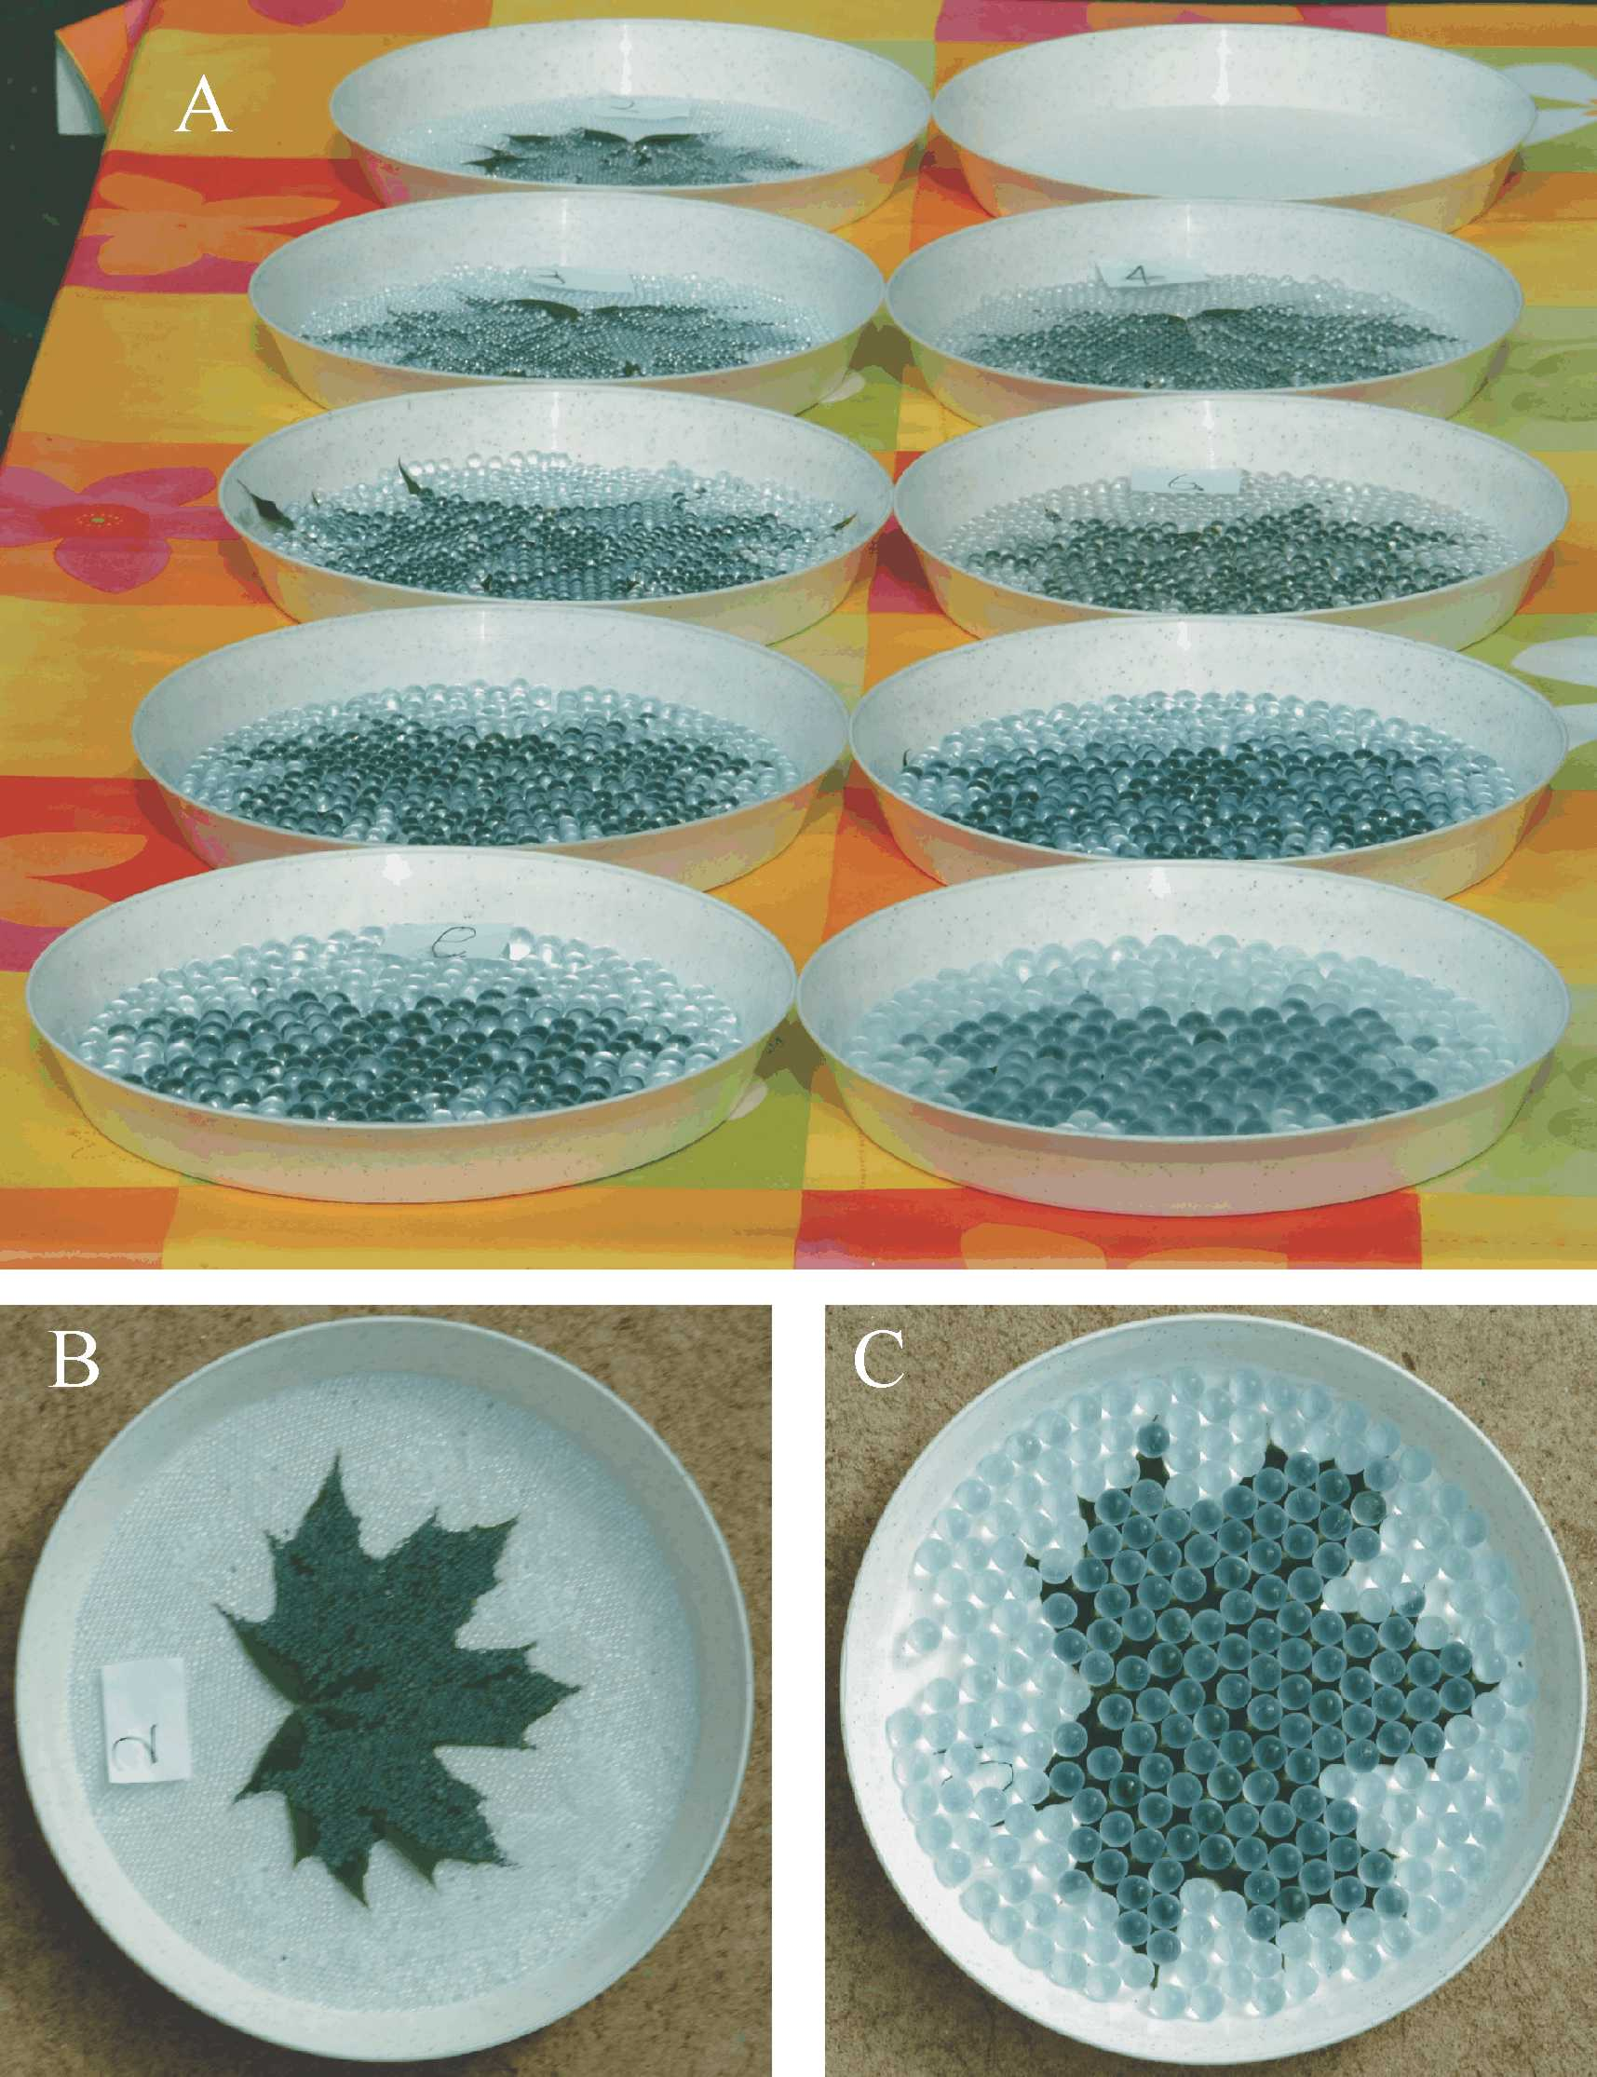

Fig. S1 (A) The ten circular grey plastic trays with maple (Acer platanoides) leaves covered by glass spheres used in our 1st experiment. The 10th tray contained a maple leaf without glass spheres (not shown here). (B, C) Two trays with maple leaves covered by glass spheres with a diameter of 2 mm (B) and 10 mm (C).
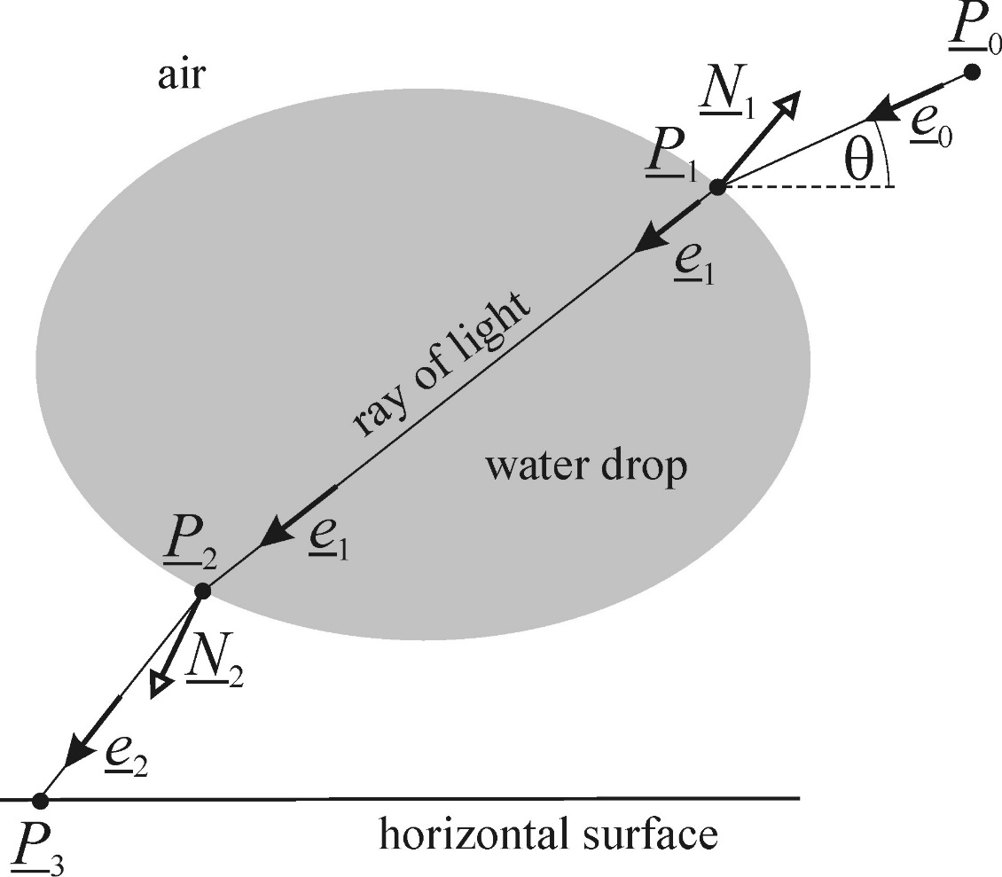

Fig. S2 Ray-tracing geometry of a ray of light incident onto, passing through, and leaving a water drop above a horizontal surface: P₀ and P₃ are the starting and end points, respectively, P₁ and P₂ are points of refraction, e₀, e₁, and e₂ are unit direction vectors, while N₁ and N₂ are unit normal vectors of the drop surface.
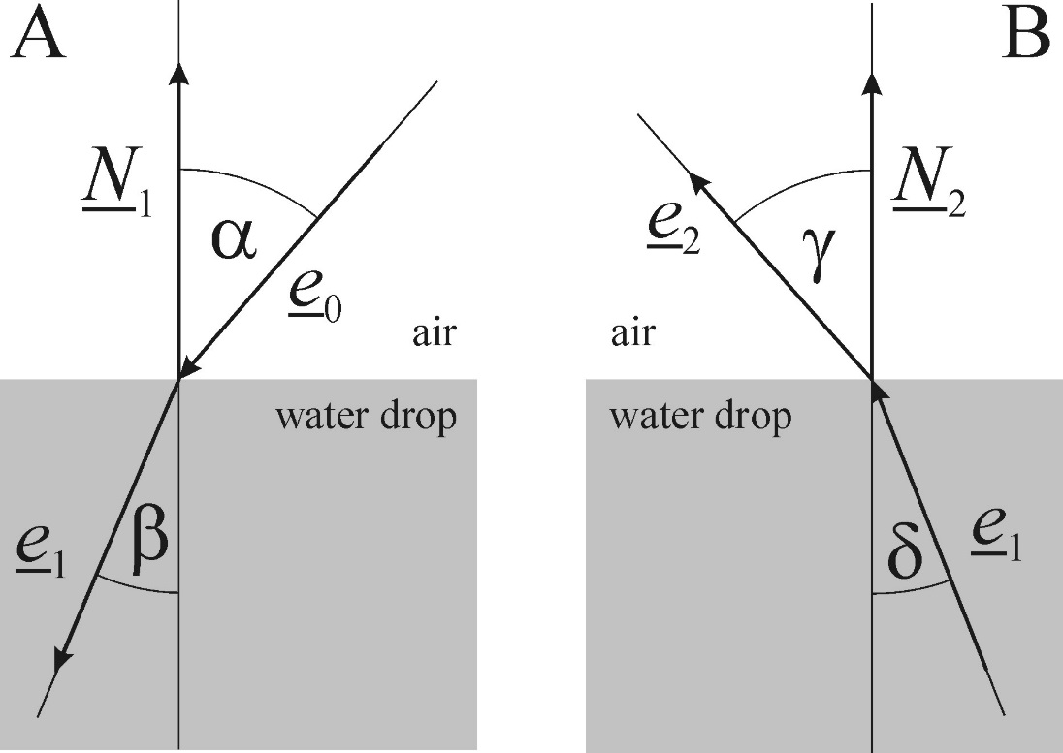

Fig. S3 Angles of incidence (α, δ) and of refraction (β, γ), and unit direction vectors (e₀, e₁, e₂) of incident and refracted rays of light at the air-water interface. N₁ and N₂ are unit normal vectors of the drop surface when light is passing from air to water (A), and from water to air (B), respectively.
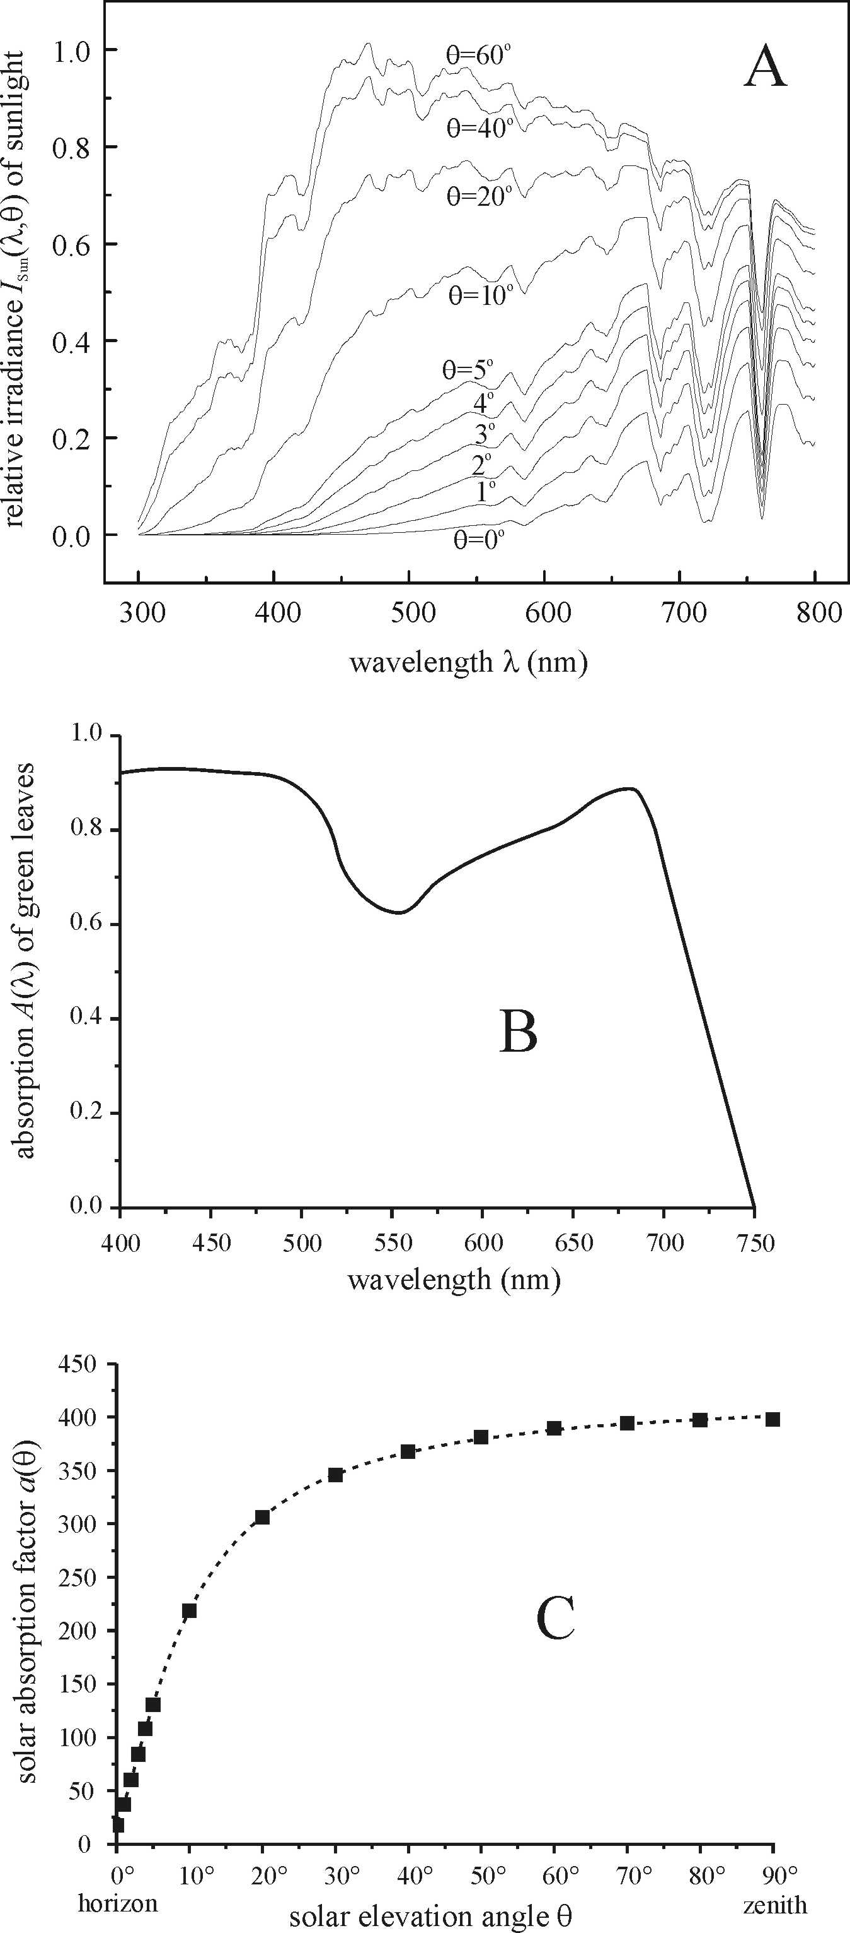

Fig. S4 (A) Relative irradiance I_{Sun}(λ,θ) of unpolarized direct sunlight for solar elevation angles θ = 60º, 40º, 20º, 10º, 5º, 4º, 3º, 2º, 1º and 0º (from top to bottom), computed using the 1976 US Standard Atmosphere. (B) Absorption spectrum A(λ) of green plant leaves averaged for bean, spinach, Swiss chard and tobacco (adapted from Fig. 3 of Moss & Loomis, 1951, p. 375). (C) The solar absorption factor of plant leaves versus θ.
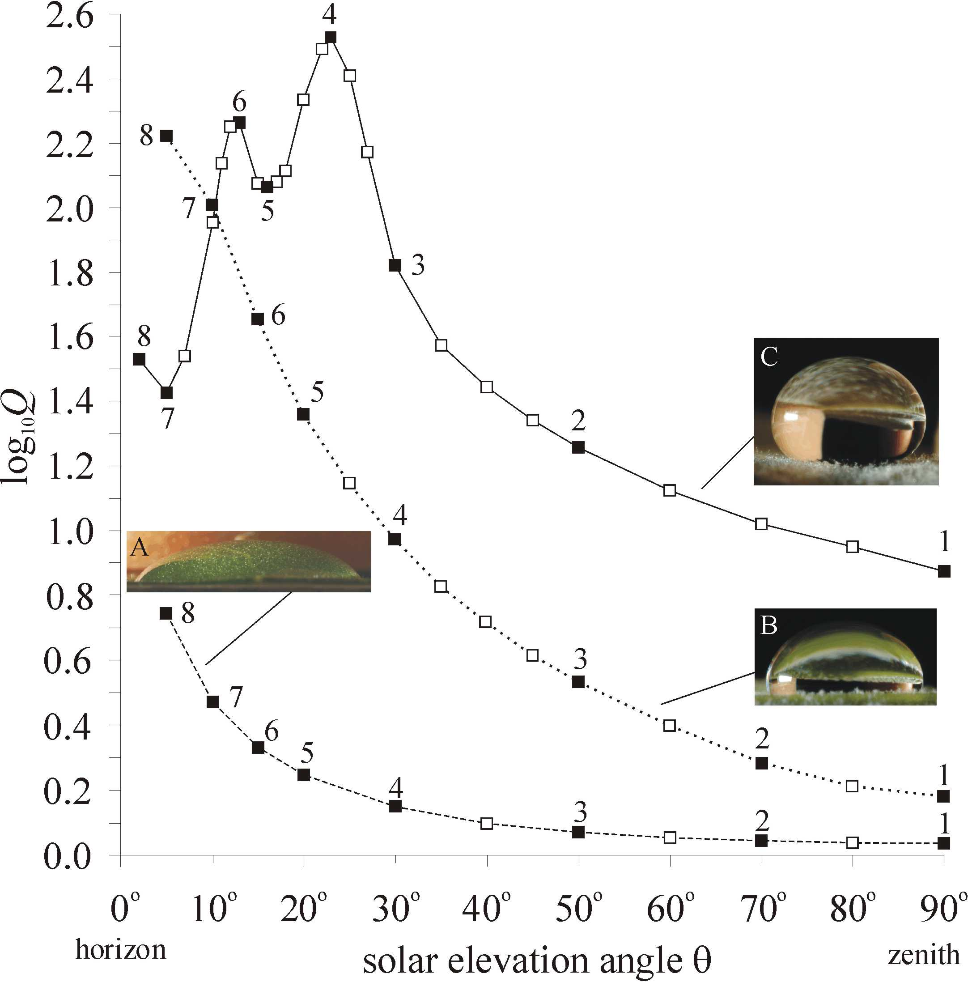

Fig. S5 Log₁₀Q versus solar elevation angle θ computed for a water drop on a horizontal maple (A), plane tree (B) and rowan (C) leaf with decreasing wettabilities from A to C. Q(n_{water}=1.33,θ) is the maximum light-collecting efficiency of water drops in the focal region. Insets show the side-view photograph of water drops. Data corresponding to rows 1, 2, … 7, 8 in Figs. 4-6 are marked by filled squares.
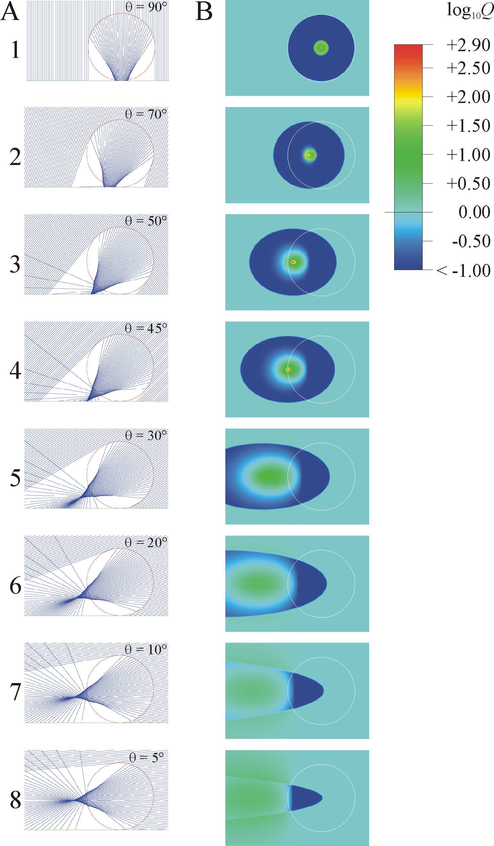

Fig. S6 Same as Fig. 4 but for a glass sphere with a refractive index of n_{glass} = 1.5. In panel A the side-view contour of the glass sphere is shown by a red circle, while in panel B the contour of the sphere as seen from above is indicated by a white circle.
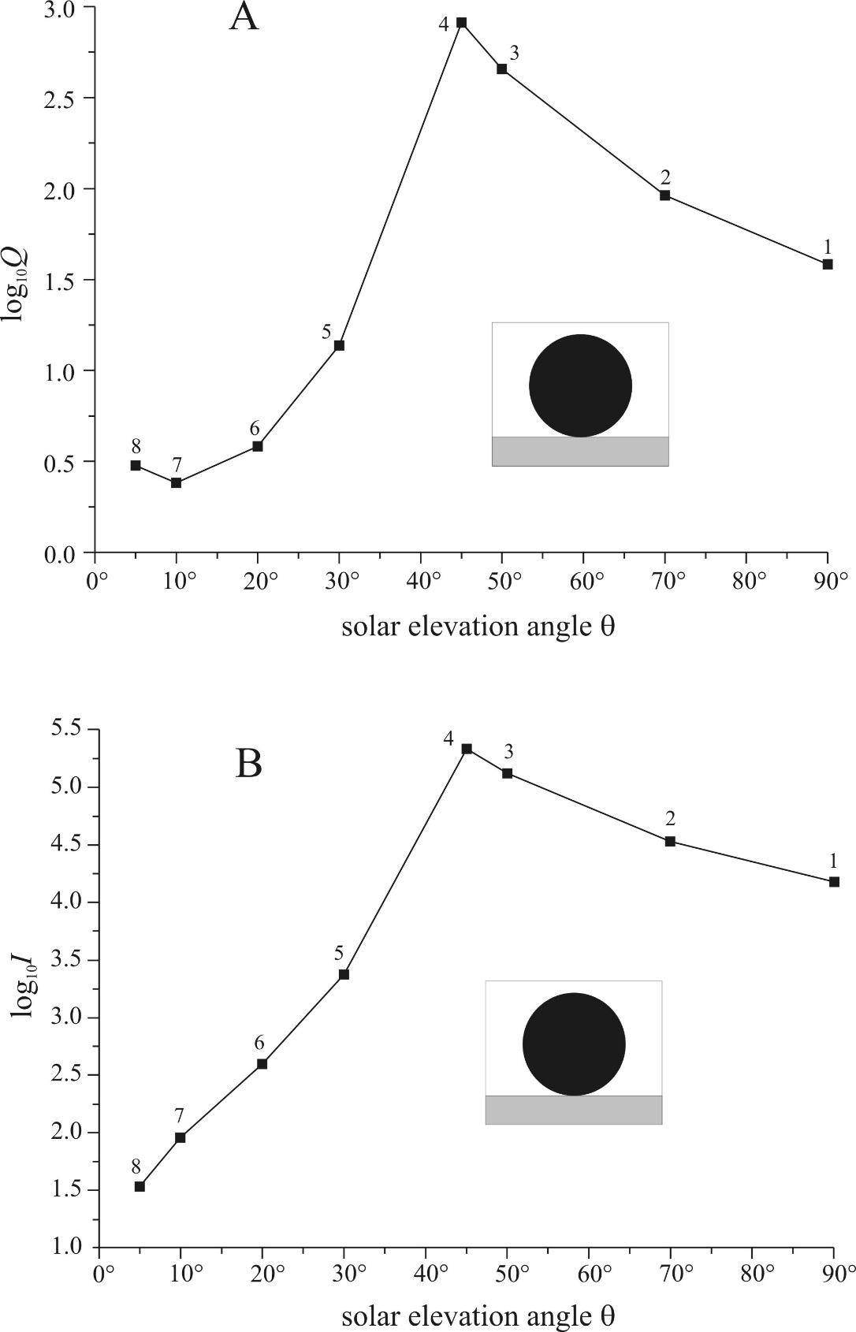

Fig. S7 (A) Log₁₀Q versus solar elevation angle θ computed for a glass sphere contacting a horizontal surface in Fig. S6, where Q is the maximum light-collecting efficiency in the focal region. The black circle in the inset shows the shape of the vertical main cross-section of the glass sphere. Data belonging to rows 1, 2, … 7, 8 in Fig. S6 are marked by black squares. (B) Logarithm of the maximum intensity I(θ) = Q(n_{glass}=1.5,θ)⋅a(θ) of sunlight absorbed by a green leaf tissue in the focal region of a glass sphere on a horizontal leaf surface in Fig. S6. Here, a(θ) is the solar absorption factor of the leaf tissue (Fig. S4C). Data corresponding (vagy referring) to rows 1, 2, … 7, 8 in Fig. S6 are marked by black squares.
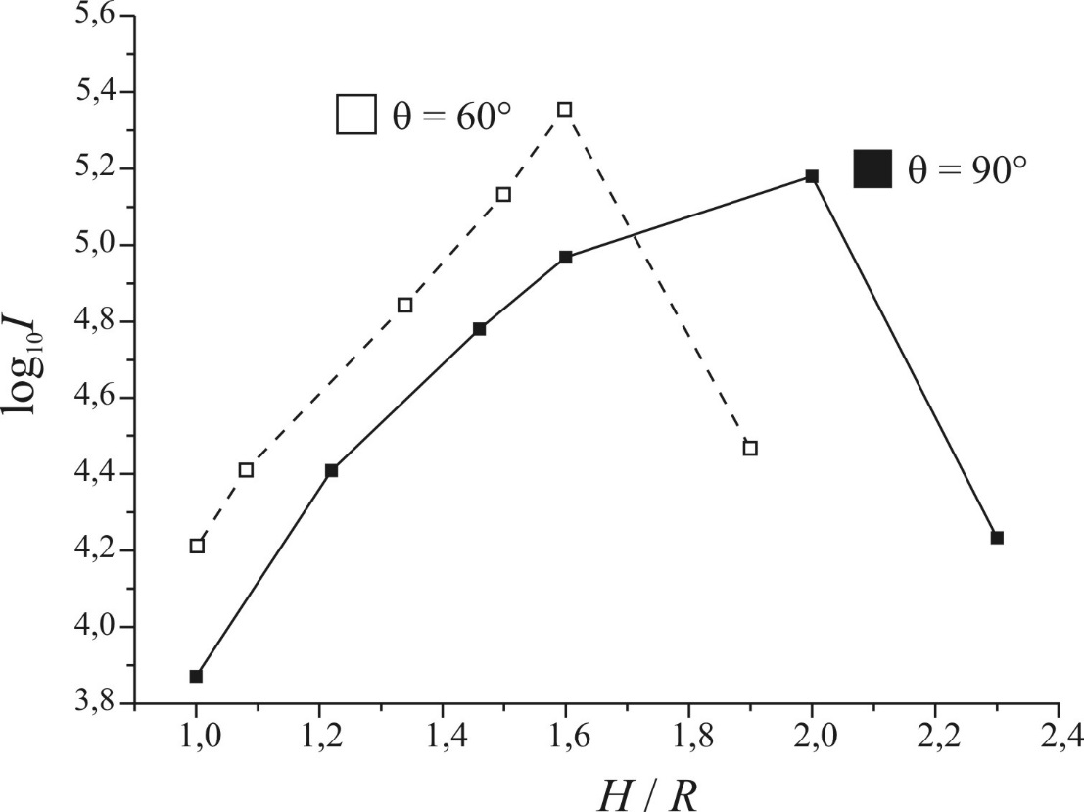

Fig. S8 Logarithm of light intensity I absorbed by the leaf tissue as a function of the ratio H/R, computed for incident angles θ = 60º and 90º in the focal region of a spherical water drop with radius R placed at distance H from the leaf surface.

