Electronic Supplementary Material

for

How the morning-afternoon cloudiness asymmetry affects the energy-maximizing azimuth direction of fixed-tilt monofacial solar panels

Péter Takács, Judit Slíz-Balogh, Ákos Horváth, Dániel Horváth, Imre M. Jánosi, Gábor Horváth*

*: correspondig author: Environmental Optics Laboratory, Department of Biological Physics,
ELTE Eötvös Loránd University, H-1117 Budapest, Pázmány sétány 1, Hungary,
e-mail: gh@arago.elte.hu

Péter Takács, Judit Slíz-Balogh, Ákos Horváth, Dániel Horváth, Imre M. Jánosi, Gábor Horváth (2022) How the morning-afternoon cloudiness asymmetry affects the energy-maximizing azimuth direction of fixed-tilt monofacial solar panels. Royal Society Open Science 9 (4): 211948 (13 pages, doi: 10.1098/rsos.211948) + electronic supplement
(https://royalsocietypublishing.org/doi/10.1098/rsos.211948)

This file contains the following:

Supplementary Tables S1-S16

Supplementary Figures S1-S14

Supplementary Table S1. Daily hourly change of the mean ± standard deviation of the power flux W_{Sun} ± ΔW_{Sun} (W/m²) of direct sunlight from January to December averaged for the period 2009-2019 in Boone County (39.0° N, -84.75° E) between sunrise and sunset (UTC - 5 hour).

time W_{Sun} ΔW_{Sun}
(UTC - 5 h) (W/m²) (W/m²)

January
8:30 18.276 17.279
9:30 76.482 67.624
10:30 142.814 122.801
11:30 195.436 163.982
12:30 222.702 184.048
13:30 214.861 175.325
14:30 178.059 149.078
15:30 119.633 107.155
16:30 53.076 51.256
17:30 6.566 8.588

February
7:30 2.662 4.274
8:30 45.752 44.269
9:30 122.924 108.264
10:30 198.977 168.860
11:30 261.861 212.799
12:30 299.605 231.088
13:30 288.322 215.543
14:30 247.631 193.199
15:30 184.863 147.755
16:30 104.522 89.627
17:30 30.436 29.445
18:30 0.489 1.073

March
6:30 0.534 1.287
7:30 29.445 29.937
8:30 111.686 94.170
9:30 210.970 165.167
10:30 294.315 224.295
11:30 354.453 260.925
12:30 385.423 277.705
13:30 372.187 271.895
14:30 325.083 238.208
15:30 252.337 190.890
16:30 156.968 129.726
17:30 68.185 60.069
18:30 8.788 10.058

April
5:30 0.014 0.052
6:30 15.951 16.107
7:30 91.351 72.622
8:30 201.941 148.497
9:30 311.414 214.050
10:30 397.782 265.072
11:30 451.781 296.893
12:30 463.472 305.628
13:30 445.009 294.886
14:30 395.440 258.771
15:30 310.182 216.301
16:30 213.456 155.210
17:30 111.325 85.565
18:30 30.039 25.012
19:30 0.346 0.667

May
5:30 2.160 2.343
6:30 43.439 33.791
7:30 134.320 95.245
8:30 239.597 159.434
9:30 340.217 219.927
10:30 421.089 267.051
11:30 473.704 289.096
12:30 468.246 295.379
13:30 432.390 274.341
14:30 384.393 247.627
15:30 320.005 202.814
16:30 227.342 153.432
17:30 134.869 96.727
18:30 54.125 41.265
19:30 5.546 5.151

June
5:30 5.271 3.425
6:30 58.593 36.968
7:30 160.314 94.027
8:30 272.356 158.309
9:30 382.437 212.815
10:30 478.504 246.241
11:30 528.323 265.104
12:30 529.343 268.311
13:30 480.907 260.858
14:30 440.826 230.644
15:30 368.437 201.815
16:30 288.758 153.388
17:30 187.380 99.921
18:30 88.122 47.542
19:30 17.363 9.490

July
5:30 2.069 1.990
6:30 46.869 28.110
7:30 146.071 80.601
8:30 264.616 141.822
9:30 381.632 193.593
10:30 465.874 230.178
11:30 507.038 249.031
12:30 519.739 244.565
13:30 458.121 228.459
14:30 414.173 209.279
15:30 347.358 184.173
16:30 265.136 147.627
17:30 173.625 98.031
18:30 80.115 48.164
19:30 15.197 9.578

August
5:30 0.039 0.094
6:30 23.724 13.962
7:30 111.680 58.686
8:30 231.860 113.656
9:30 361.911 161.670
10:30 460.730 196.635
11:30 508.754 217.821
12:30 522.816 227.592
13:30 460.538 225.015
14:30 408.800 205.150
15:30 341.159 165.084
16:30 250.631 122.289
17:30 146.439 75.066
18:30 49.754 29.372
19:30 3.061 3.718

September
6:30 5.167 5.024
7:30 63.042 43.439
8:30 167.323 106.534
9:30 279.378 165.844
10:30 378.632 211.098
11:30 434.355 242.870
12:30 447.252 251.473
13:30 387.299 234.630
14:30 344.886 205.710
15:30 267.207 162.064
16:30 173.603 107.495
17:30 74.041 51.312
18:30 10.430 10.983

October
6:30 0.171 0.355
7:30 28.621 22.279
8:30 111.695 77.084
9:30 211.483 134.668
10:30 292.590 183.308
11:30 338.100 214.001
12:30 348.684 220.814
13:30 313.372 212.425
14:30 252.399 177.005
15:30 175.133 128.887
16:30 87.494 69.596
17:30 18.224 17.902
18:30 0.044 0.140

November
7:30 5.312 5.928
8:30 58.972 45.746
9:30 143.503 102.285
10:30 217.209 149.965
11:30 267.111 178.621
12:30 281.428 187.885
13:30 247.802 172.671
14:30 194.108 136.636
15:30 118.348 87.049
16:30 41.161 32.734
17:30 1.4180 1.837

December
7:30 0.047 0.137
8:30 17.463 18.420
9:30 64.733 67.563
10:30 115.361 117.643
11:30 154.791 152.806
12:30 172.168 164.741
13:30 159.941 148.931
14:30 124.190 118.810
15:30 73.528 74.426
16:30 22.910 24.095
17:30 0.277 0.454

Supplementary Table S2. Daily hourly change of the mean ± standard deviation of the power flux W_{Sun} ± ΔW_{Sun} (W/m²) of direct sunlight from January to December averaged for the period 2009-2019 in Tennessee (35.5° N, -88.25° E) between sunrise and sunset (UTC - 5 hour). Although this site of Tennessee state is in the time zone UTC - 6 h, but here the data are given in UTC - 5 h.

time W_{Sun} ΔW_{Sun}
(UTC - 5 h) (W/m²) (W/m²)

January
8:30 18.457 16.311
9:30 87.972 75.194
10:30 170.475 137.012
11:30 238.437 185.669
12:30 277.278 214.023
13:30 288.219 208.548
14:30 258.081 187.134
15:30 191.534 141.584
16:30 104.680 80.013
17:30 25.294 21.755
18:30 0.079 0.202

February
7:30 1.057 1.875
8:30 41.082 37.404
9:30 126.912 104.917
10:30 218.909 169.201
11:30 288.056 221.093
12:30 331.467 248.217
13:30 321.346 256.032
14:30 294.438 232.225
15:30 232.179 188.426
16:30 147.872 121.052
17:30 57.349 51.329
18:30 4.117 5.125

March
6:30 0.025 0.096
7:30 17.135 19.227
8:30 88.876 79.586
9:30 184.641 151.856
10:30 277.303 220.775
11:30 347.083 267.530
12:30 382.886 293.515
13:30 372.186 283.452
14:30 345.637 257.744
15:30 280.144 216.157
16:30 194.862 155.739
17:30 100.556 81.150
18:30 21.246 17.964

April
6:30 6.228 7.433
7:30 70.628 52.626
8:30 188.221 123.285
9:30 308.376 192.011
10:30 419.764 246.163
11:30 483.731 283.100
12:30 504.501 303.401
13:30 481.355 300.844
14:30 433.525 277.724
15:30 353.251 233.543
16:30 253.105 172.261
17:30 145.530 99.101
18:30 47.190 33.329
19:30 1.516 1.820

May
5:30 0.054 0.103
6:30 24.145 18.240
7:30 107.028 75.339
8:30 223.054 144.253
9:30 338.062 211.530
10:30 439.752 261.239
11:30 500.000 288.555
12:30 521.754 292.609
13:30 484.273 277.182
14:30 432.906 249.653
15:30 379.319 212.655
16:30 281.055 165.671
17:30 173.382 107.521
18:30 73.240 47.496
19:30 9.872 7.106

June
5:30 0.326 0.231
6:30 35.689 19.299
7:30 134.831 68.243
8:30 261.729 126.138
9:30 392.645 179.104
10:30 500.657 218.546
11:30 560.298 235.857
12:30 590.641 243.665
13:30 528.989 247.613
14:30 494.428 214.451
15:30 436.202 179.247
16:30 336.079 141.093
17:30 215.077 99.682
18:30 103.050 51.181
19:30 23.011 11.826

July
5:30 0.033 0.064
6:30 24.852 14.201
7:30 114.871 58.492
8:30 241.840 114.845
9:30 367.148 166.559
10:30 468.052 207.922
11:30 526.580 233.584
12:30 557.786 242.471
13:30 493.908 225.011
14:30 453.020 208.629
15:30 405.580 176.793
16:30 315.928 140.255
17:30 204.995 96.138
18:30 100.122 47.987
19:30 22.264 10.958

August
6:30 9.403 6.666
7:30 81.998 42.849
8:30 204.470 98.459
9:30 331.216 153.933
10:30 439.657 198.044
11:30 509.297 216.800
12:30 534.697 216.031
13:30 461.167 221.615
14:30 425.837 202.495
15:30 364.845 172.815
16:30 273.086 131.908
17:30 167.462 81.998
18:30 63.251 36.114
19:30 6.099 5.842

September
6:30 1.301 1.503
7:30 51.072 31.035
8:30 165.742 90.809
9:30 296.709 151.850
10:30 407.589 198.852
11:30 464.744 232.606
12:30 482.485 243.991
13:30 428.301 233.141
14:30 374.433 214.248
15:30 299.239 174.208
16:30 203.047 119.370
17:30 100.488 62.371
18:30 20.557 16.629
19:30 0.042 0.113

October
7:30 22.206 16.422
8:30 112.467 71.127
9:30 228.607 134.393
10:30 330.085 185.461
11:30 393.302 217.332
12:30 420.392 230.079
13:30 387.664 227.229
14:30 329.646 198.114
15:30 245.700 151.583
16:30 139.405 90.725
17:30 41.596 31.351
18:30 0.985 1.765

November
7:30 3.051 3.738
8:30 53.459 41.854
9:30 143.786 104.243
10:30 230.455 159.606
11:30 292.695 196.280
12:30 321.827 211.170
13:30 308.539 201.838
14:30 252.486 171.451
15:30 170.767 119.166
16:30 77.991 55.690
17:30 9.821 8.244

December
7:30 0.016 0.054
8:30 18.947 17.951
9:30 80.214 72.276
10:30 146.742 128.822
11:30 198.139 169.065
12:30 225.767 189.067
13:30 221.261 182.815
14:30 185.896 154.888
15:30 124.099 108.112
16:30 54.141 49.674
17:30 5.820 5.769

Supplementary Table S3. Daily hourly change of the mean ± standard deviation of the power flux W_{Sun} ± ΔW_{Sun} (W/m²) of direct sunlight from January to December averaged for the period 2009-2019 in Georgia (31.25° N, -83.25° E) between sunrise and sunset (UTC - 5 hour).

time W_{Sun} ΔW_{Sun}
(UTC - 5 h) (W/m²) (W/m²)

January
7:30 2.408 2.092
8:30 56.980 43.202
9:30 155.974 112.078
10:30 255.416 167.520
11:30 329.103 203.476
12:30 362.064 217.227
13:30 350.008 208.460
14:30 292.476 178.628
15:30 203.032 130.815
16:30 101.988 67.513
17:30 18.677 14.879

February
7:30 10.629 9.828
8:30 84.306 64.789
9:30 192.020 137.573
10:30 298.135 198.197
11:30 377.243 241.163
12:30 413.425 257.513
13:30 394.217 246.063
14:30 335.915 218.337
15:30 245.532 171.324
16:30 141.790 102.966
17:30 44.954 33.651
18:30 0.798 1.136

March
6:30 1.136 2.012
7:30 48.330 35.782
8:30 163.839 104.541
9:30 291.788 176.799
10:30 406.813 228.848
11:30 488.687 258.543
12:30 510.322 274.354
13:30 476.159 270.405
14:30 405.324 247.166
15:30 313.053 195.901
16:30 196.265 128.842
17:30 80.666 54.672
18:30 7.898 6.426

April
6:30 19.699 15.026
7:30 116.093 70.985
8:30 257.498 140.400
9:30 400.008 204.762
10:30 514.091 249.374
11:30 573.386 279.202
12:30 587.468 286.688
13:30 527.892 286.426
14:30 457.836 265.625
15:30 356.518 216.886
16:30 242.359 150.028
17:30 121.899 73.911
18:30 24.729 15.433

May
5:30 0.664 0.708
6:30 45.228 24.866
7:30 162.194 82.139
8:30 303.579 145.494
9:30 444.568 199.203
10:30 547.004 240.225
11:30 588.591 268.257
12:30 607.050 265.891
13:30 529.813 256.854
14:30 459.270 234.918
15:30 367.521 193.269
16:30 258.638 140.932
17:30 135.390 80.546
18:30 38.772 23.716
19:30 0.621 0.746

June
5:30 1.497 0.887
6:30 49.016 24.467
7:30 160.011 74.506
8:30 284.793 131.134
9:30 412.379 180.867
10:30 510.161 209.100
11:30 571.875 220.641
12:30 568.775 232.653
13:30 490.224 215.208
14:30 415.238 200.676
15:30 338.857 172.583
16:30 238.417 131.806
17:30 132.649 76.837
18:30 45.556 28.042
19:30 2.761 2.004

July
5:30 0.337 0.401
6:30 36.154 18.386
7:30 135.409 63.859
8:30 259.733 116.367
9:30 387.823 160.644
10:30 487.221 191.830
11:30 545.768 208.546
12:30 565.882 212.050
13:30 513.446 208.634
14:30 443.891 192.989
15:30 346.293 165.335
16:30 240.119 120.601
17:30 130.251 71.922
18:30 43.300 27.558
19:30 2.672 2.022

August
6:30 18.008 10.840
7:30 98.591 56.220
8:30 214.595 112.625
9:30 343.810 166.727
10:30 450.179 198.874
11:30 509.259 214.741
12:30 527.429 207.161
13:30 469.070 199.326
14:30 402.245 186.337
15:30 312.349 152.380
16:30 201.899 110.568
17:30 99.629 61.838
18:30 25.728 17.277
19:30 0.225 0.397

September
6:30 7.557 5.138
7:30 80.460 46.079
8:30 204.005 107.787
9:30 331.104 165.519
10:30 433.947 204.954
11:30 490.527 222.723
12:30 486.904 228.307
13:30 437.835 208.377
14:30 361.666 184.384
15:30 266.209 144.332
16:30 159.102 96.823
17:30 62.311 41.526
18:30 5.668 6.095

October
6:30 1.405 1.585
7:30 58.472 33.295
8:30 184.801 93.801
9:30 321.223 149.943
10:30 426.963 196.093
11:30 487.508 219.203
12:30 490.999 220.991
13:30 425.322 219.391
14:30 346.521 183.058
15:30 244.223 131.477
16:30 121.562 70.201
17:30 25.913 18.029
18:30 0.034 0.106

November
7:30 22.991 17.181
8:30 114.118 71.553
9:30 228.774 128.814
10:30 330.269 173.511
11:30 391.309 198.252
12:30 397.518 205.800
13:30 353.440 196.218
14:30 275.928 160.645
15:30 174.606 108.376
16:30 68.375 45.076
17:30 4.765 3.937

December
7:30 3.814 4.144
8:30 51.366 46.533
9:30 131.378 110.775
10:30 207.996 162.961
11:30 261.673 195.647
12:30 287.345 205.133
13:30 265.990 192.913
14:30 215.579 156.417
15:30 137.119 102.841
16:30 53.696 41.275
17:30 3.179 2.947

Supplementary Table S4. Daily hourly change of the mean ± standard deviation of the power flux W_{Sun} ± ΔW_{Sun} (W/m²) of direct sunlight from January to December averaged for the period 2009-2019 in Central Italy (41.0° N, 15.0° E) between sunrise and sunset (UTC + 1 hour). Although Italy is in the time zone UTC + 1 h, but here the data are given in UTC.

time W_{Sun} ΔW_{Sun}
(UTC + 1 h) (W/m²) (W/m²)

January
6:30 2.318 2.535
7:30 29.110 27.542
8:30 79.000 64.236
9:30 132.714 96.553
10:30 167.624 117.542
11:30 169.153 122.281
12:30 146.274 109.041
13:30 104.147 79.815
14:30 52.541 41.984
15:30 10.879 10.405

February
5:30 0.043 0.135
6:30 12.299 13.269
7:30 56.496 51.272
8:30 123.115 97.831
9:30 187.823 136.947
10:30 225.668 157.890
11:30 222.633 160.051
12:30 201.934 145.694
13:30 156.886 116.128
14:30 95.761 73.849
15:30 37.161 29.848
16:30 2.633 3.434

March
5:30 8.520 11.600
6:30 56.268 54.475
7:30 146.502 108.395
8:30 241.865 158.589
9:30 321.261 198.121
10:30 353.694 218.711
11:30 344.512 222.581
12:30 307.418 208.740
13:30 246.277 171.922
14:30 170.739 120.527
15:30 91.039 66.089
16:30 22.253 18.069
17:30 0.094 0.222

April
4:30 3.639 4.860
5:30 45.190 37.683
6:30 134.489 89.172
7:30 261.537 136.044
8:30 381.968 177.505
9:30 456.737 209.033
10:30 481.879 231.571
11:30 466.248 231.627
12:30 414.700 215.584
13:30 337.664 182.871
14:30 248.213 141.997
15:30 150.650 87.202
16:30 55.429 34.422
17:30 4.302 3.889

May
3:30 0.113 0.194
4:30 18.931 13.965
5:30 88.663 54.882
6:30 197.791 98.655
7:30 332.520 133.473
8:30 442.945 171.091
9:30 500.511 204.544
10:30 518.195 213.213
11:30 493.944 207.628
12:30 450.578 189.096
13:30 368.415 164.172
14:30 274.173 128.947
15:30 177.646 89.315
16:30 85.069 43.418
17:30 17.576 10.075
18:30 0.038 0.076

June
3:30 0.758 0.491
4:30 32.041 18.011
5:30 119.754 56.369
6:30 254.432 87.344
7:30 400.354 114.040
8:30 520.815 137.020
9:30 581.142 170.982
10:30 604.789 186.895
11:30 579.018 193.880
12:30 514.035 184.392
13:30 435.945 162.074
14:30 328.689 139.057
15:30 224.877 98.388
16:30 122.509 53.888
17:30 37.454 16.525
18:30 1.099 0.686

July
3:30 0.168 0.231
4:30 27.474 12.521
5:30 120.234 45.715
6:30 260.643 71.644
7:30 415.908 91.325
8:30 541.308 114.239
9:30 623.601 137.012
10:30 653.544 154.911
11:30 635.448 160.007
12:30 578.341 158.133
13:30 480.548 146.005
14:30 369.085 121.991
15:30 252.929 86.800
16:30 137.617 47.377
17:30 41.373 13.903
18:30 0.950 0.690

August
4:30 9.305 6.225
5:30 81.549 33.771
6:30 212.529 65.802
7:30 368.378 85.745
8:30 507.058 103.926
9:30 594.774 126.421
10:30 627.618 141.303
11:30 613.745 144.516
12:30 552.370 140.447
13:30 446.808 128.327
14:30 328.611 105.481
15:30 203.263 73.163
16:30 90.595 35.910
17:30 14.749 9.909

September
4:30 0.357 0.631
5:30 27.376 19.515
6:30 102.311 64.616
7:30 215.706 110.317
8:30 332.751 148.624
9:30 413.064 174.806
10:30 443.278 182.146
11:30 420.543 177.388
12:30 371.822 160.203
13:30 279.833 133.338
14:30 185.688 96.610
15:30 92.170 53.989
16:30 22.121 17.108
17:30 0.242 0.554

October
5:30 5.907 6.384
6:30 46.715 38.394
7:30 124.328 85.779
8:30 215.570 131.069
9:30 281.901 163.796
10:30 309.741 176.518
11:30 298.114 174.402
12:30 250.890 149.191
13:30 180.416 112.849
14:30 103.748 66.151
15:30 30.901 23.064
16:30 0.879 1.568

November
5:30 0.156 0.403
6:30 14.913 15.601
7:30 60.328 51.167
8:30 127.648 89.600
9:30 190.625 119.944
10:30 218.607 133.649
11:30 210.086 132.697
12:30 171.697 110.109
13:30 111.215 75.704
14:30 47.029 33.344
15:30 4.707 4.608

December
6:30 3.281 3.099
7:30 36.502 28.322
8:30 92.018 63.498
9:30 147.823 90.462
10:30 184.002 104.471
11:30 180.854 106.371
12:30 147.870 91.193
13:30 96.001 59.683
14:30 37.704 23.656
15:30 2.085 1.637

Supplementary Table S5. Daily hourly change of the mean ± standard deviation of the power flux W_{Sun} ± ΔW_{Sun} (W/m²) of direct sunlight from January to December averaged for the period 2009-2019 in Central Hungary (47.0° N, 19.0° E) between sunrise and sunset (UTC + 1 hour). Although Hungary is in the time zone UTC + 1 h, but here the data are given in UTC.

time W_{Sun} ΔW_{Sun}
(UTC + 1 h) (W/m²) (W/m²)

January
6:30 1.460 2.023
7:30 21.709 22.784
8:30 58.787 56.276
9:30 95.927 84.445
10:30 117.252 99.857
11:30 113.242 97.555
12:30 89.656 78.838
13:30 53.349 49.070
14:30 17.272 18.281
15:30 0.678 1.439

February
5:30 0.158 0.467
6:30 12.614 14.842
7:30 51.471 51.024
8:30 101.769 92.797
9:30 143.181 126.134
10:30 163.850 143.039
11:30 156.297 138.260
12:30 126.756 118.235
13:30 88.318 85.539
14:30 45.160 46.744
15:30 11.106 12.992
16:30 0.078 0.235

March
4:30 0.238 0.624
5:30 18.049 19.346
6:30 79.104 61.547
7:30 166.108 112.887
8:30 248.359 157.585
9:30 304.449 188.368
10:30 320.315 200.195
11:30 298.299 197.631
12:30 252.595 178.621
13:30 185.439 139.882
14:30 115.223 91.612
15:30 50.069 42.528
16:30 7.958 8.589

April
3:30 0.104 0.245
4:30 17.351 14.817
5:30 88.904 52.933
6:30 189.234 102.130
7:30 297.699 148.924
8:30 388.791 185.739
9:30 447.589 205.872
10:30 451.614 211.986
11:30 422.649 212.733
12:30 359.746 195.214
13:30 283.963 161.191
14:30 196.136 116.581
15:30 109.727 66.677
16:30 36.151 24.011
17:30 2.007 2.517

May
3:30 5.206 4.517
4:30 49.261 29.448
5:30 136.901 74.199
6:30 226.140 126.472
7:30 322.926 172.193
8:30 394.227 210.172
9:30 429.411 230.281
10:30 436.378 232.490
11:30 418.943 224.062
12:30 374.277 200.226
13:30 314.350 161.935
14:30 231.716 123.665
15:30 145.440 80.341
16:30 65.024 38.993
17:30 13.801 9.228
18:30 0.065 0.127

June
3:30 11.792 6.047
4:30 66.070 33.634
5:30 157.308 75.684
6:30 250.034 125.778
7:30 336.548 169.435
8:30 408.841 204.477
9:30 451.473 219.430
10:30 459.141 216.882
11:30 443.056 211.418
12:30 391.750 200.352
13:30 333.451 172.177
14:30 255.749 135.244
15:30 169.952 93.747
16:30 89.388 49.832
17:30 27.673 15.832
18:30 1.281 0.947

July
3:30 6.900 4.659
4:30 56.661 27.389
5:30 150.155 67.602
6:30 249.653 111.999
7:30 354.481 150.669
8:30 439.566 177.134
9:30 495.719 195.148
10:30 506.398 197.630
11:30 481.646 195.473
12:30 436.567 181.294
13:30 374.757 156.059
14:30 287.655 121.820
15:30 192.309 80.741
16:30 99.710 43.402
17:30 29.260 14.259
18:30 1.050 0.926

August
3:30 0.351 0.555
4:30 26.306 13.481
5:30 109.440 44.344
6:30 213.758 89.840
7:30 327.388 127.370
8:30 425.364 157.043
9:30 484.587 180.971
10:30 502.191 182.185
11:30 477.278 182.792
12:30 430.828 167.342
13:30 349.349 138.921
14:30 252.854 107.429
15:30 153.657 69.368
16:30 62.042 31.267
17:30 8.678 7.622

September
4:30 3.186 3.850
5:30 43.983 29.670
6:30 121.579 74.037
7:30 212.691 120.105
8:30 291.429 160.179
9:30 346.271 183.485
10:30 360.176 191.234
11:30 337.389 179.034
12:30 283.338 160.296
13:30 213.447 127.344
14:30 135.795 86.667
15:30 59.714 42.268
16:30 10.297 11.149
17:30 0.025 0.083

October
5:30 10.525 11.066
6:30 56.052 46.230
7:30 122.356 92.529
8:30 185.905 133.069
9:30 226.643 158.321
10:30 240.498 166.135
11:30 224.313 157.497
12:30 179.087 129.864
13:30 116.879 90.795
14:30 53.770 47.529
15:30 10.149 12.213
16:30 0.032 0.106

November
5:30 0.253 0.532
6:30 14.246 14.913
7:30 52.610 47.909
8:30 98.967 81.084
9:30 135.379 104.417
10:30 147.970 110.835
11:30 137.523 105.025
12:30 99.777 82.313
13:30 53.804 47.555
14:30 13.879 13.500
15:30 0.090 0.232

December
6:30 1.481 1.994
7:30 21.903 21.163
8:30 56.055 51.789
9:30 86.777 74.440
10:30 98.819 83.717
11:30 90.317 78.044
12:30 66.243 57.310
13:30 33.334 29.668
14:30 5.977 5.569

Supplementary Table S6. Daily hourly change of the mean ± standard deviation of the power flux W_{Sun} ± ΔW_{Sun} (W/m²) of direct sunlight from January to December averaged for the period 2009-2019 in South Sweden (58.0° N, 13.0° E) between sunrise and sunset (UTC + 1 hour). Although Sweden is in the time zone UTC + 1 h, but here the data are given in UTC.

time W_{Sun} ΔW_{Sun}
(UTC + 1 h) (W/m²) (W/m²)

January
7:30 0.202 0.656
8:30 5.675 8.573
9:30 17.252 22.048
10:30 28.503 33.742
11:30 31.469 36.913
12:30 26.344 32.638
13:30 14.329 18.801
14:30 3.257 5.685
15:30 0.025 0.093

February
6:30 0.721 1.923
7:30 11.286 17.294
8:30 35.160 43.518
9:30 61.492 69.171
10:30 80.800 87.237
11:30 89.680 93.151
12:30 81.795 85.705
13:30 60.179 66.295
14:30 32.609 38.239
15:30 8.712 13.186
16:30 0.197 0.559

March
5:30 4.504 8.065
6:30 28.110 32.904
7:30 73.259 71.935
8:30 126.362 111.061
9:30 173.037 143.441
10:30 204.460 156.970
11:30 208.011 157.559
12:30 186.630 144.740
13:30 153.651 122.028
14:30 100.735 86.067
15:30 52.695 48.616
16:30 15.168 17.239
17:30 0.529 1.248

April
3:30 0.233 0.586
4:30 11.618 14.026
5:30 52.526 46.793
6:30 114.220 88.358
7:30 180.357 130.239
8:30 244.010 167.617
9:30 293.904 189.634
10:30 314.093 203.496
11:30 316.307 207.454
12:30 292.819 191.274
13:30 257.681 165.144
14:30 203.985 130.590
15:30 139.059 92.104
16:30 72.389 51.720
17:30 21.343 18.818
18:30 0.994 1.830

May
2:30 0.247 0.477
3:30 11.267 10.926
4:30 50.716 38.564
5:30 115.47 77.293
6:30 178.825 120.591
7:30 252.841 160.469
8:30 314.747 195.125
9:30 354.247 221.764
10:30 358.077 230.338
11:30 349.681 226.249
12:30 322.026 212.846
13:30 275.967 186.070
14:30 231.066 153.304
15:30 178.238 114.326
16:30 121.082 77.168
17:30 62.912 40.596
18:30 17.338 13.797
19:30 0.806 1.302

June
2:30 1.976 1.470
3:30 22.806 16.336
4:30 71.159 47.701
5:30 138.608 87.792
6:30 189.255 127.434
7:30 253.003 162.703
8:30 312.209 195.464
9:30 348.474 212.369
10:30 367.053 224.700
11:30 355.157 224.186
12:30 333.559 213.335
13:30 294.511 188.594
14:30 257.071 162.983
15:30 206.136 129.964
16:30 146.351 93.544
17:30 86.282 55.438
18:30 35.238 23.453
19:30 6.018 4.186

July
2:30 0.484 0.776
3:30 13.837 11.572
4:30 52.852 38.402
5:30 114.938 75.423
6:30 165.030 111.296
7:30 229.760 149.250
8:30 283.016 187.396
9:30 320.970 209.585
10:30 339.173 220.082
11:30 336.434 221.454
12:30 316.485 205.965
13:30 280.627 189.690
14:30 236.598 155.803
15:30 188.777 122.589
16:30 133.962 86.026
17:30 76.062 49.594
18:30 28.542 20.086
19:30 3.673 3.504

August
3:30 0.982 1.866
4:30 16.254 16.730
5:30 56.038 47.631
6:30 101.086 81.367
7:30 158.790 117.403
8:30 212.714 147.255
9:30 243.170 169.264
10:30 257.100 176.601
11:30 257.842 181.077
12:30 242.241 169.855
13:30 218.147 153.882
14:30 174.054 127.765
15:30 125.610 93.605
16:30 78.092 59.987
17:30 31.014 27.415
18:30 5.099 6.764
19:30 0.016 0.055

September
4:30 0.739 1.602
5:30 15.493 17.615
6:30 43.472 44.989
7:30 93.298 80.362
8:30 138.402 112.104
9:30 178.314 141.505
10:30 196.740 148.263
11:30 193.376 142.585
12:30 172.002 131.354
13:30 138.327 107.426
14:30 98.539 78.831
15:30 55.664 47.621
16:30 19.430 20.558
17:30 1.993 3.952

October
5:30 0.521 1.229
6:30 10.042 14.536
7:30 35.264 41.777
8:30 65.552 68.858
9:30 94.205 93.380
10:30 110.457 106.702
11:30 110.889 106.765
12:30 94.756 91.429
13:30 68.060 68.763
14:30 35.283 40.908
15:30 9.522 13.882
16:30 0.269 0.789

November
6:30 0.051 0.192
7:30 3.502 6.346
8:30 13.487 20.409
9:30 25.340 34.809
10:30 33.243 42.454
11:30 32.318 42.762
12:30 26.275 34.408
13:30 12.847 17.769
14:30 2.417 4.501

December
7:30 0.045 0.164
8:30 3.998 5.423
9:30 13.340 16.969
10:30 21.324 25.964
11:30 21.738 25.861
12:30 14.422 18.048
13:30 4.756 6.055
14:30 0.053 0.101

Supplementary Table S7. Daily hourly change of the mean ± standard deviation of the power flux W_{diff} ± ΔW_{diff} (W/m²) of diffuse skylight from January to December averaged for the period 2009-2019 in Boone County (39.0° N, -84.75° E) between sunrise and sunset (UTC - 5 hour).

time W_{diff} ΔW_{diff}
(UTC - 5 h) (W/m²) (W/m²)

January
7:30 0.086 0.179
8:30 23.527 9.373
9:30 69.486 25.639
10:30 104.477 40.361
11:30 127.934 53.041
12:30 138.510 60.350
13:30 138.112 59.621
14:30 121.175 50.619
15:30 91.314 36.579
16:30 52.657 21.055
17:30 9.716 6.102

February
7:30 5.154 4.219
8:30 46.545 17.836
9:30 94.242 34.197
10:30 132.101 52.834
11:30 156.692 64.798
12:30 168.938 71.582
13:30 175.324 73.916
14:30 158.212 65.043
15:30 128.285 50.744
16:30 86.490 32.730
17:30 35.468 14.861
18:30 1.592 1.744

March
6:30 1.524 2.225
7:30 31.615 16.040
8:30 80.044 30.368
9:30 119.966 48.255
10:30 154.828 66.784
11:30 181.638 82.365
12:30 192.858 87.410
13:30 188.873 83.537
14:30 175.324 75.074
15:30 147.864 60.235
16:30 111.705 43.055
17:30 63.771 23.743
18:30 13.536 6.978

April
5:30 0.169 0.369
6:30 20.165 10.803
7:30 66.632 21.646
8:30 106.687 37.437
9:30 142.026 55.767
10:30 175.214 73.862
11:30 198.115 88.529
12:30 214.099 93.365
13:30 210.845 93.921
14:30 198.153 83.857
15:30 167.349 63.950
16:30 131.667 46.159
17:30 88.596 29.686
18:30 36.150 13.206
19:30 1.629 1.653

May
5:30 5.907 3.433
6:30 45.936 14.880
7:30 89.527 27.366
8:30 129.657 43.751
9:30 165.750 59.887
10:30 193.334 74.924
11:30 210.663 82.224
12:30 223.728 86.725
13:30 226.585 82.642
14:30 207.137 75.203
15:30 181.720 61.511
16:30 146.095 46.809
17:30 102.508 30.113
18:30 56.390 16.303
19:30 11.192 5.091

June
5:30 10.808 2.744
6:30 54.216 13.047
7:30 95.270 25.738
8:30 130.312 42.729
9:30 159.551 59.727
10:30 182.430 69.183
11:30 201.109 80.893
12:30 214.840 84.199
13:30 224.270 81.482
14:30 210.016 73.394
15:30 184.117 58.868
16:30 148.795 43.903
17:30 109.755 27.101
18:30 69.051 13.715
19:30 22.826 4.968
20:30 0.036 0.044

July
5:30 5:300 2.672
6:30 44.535 10.884
7:30 84.904 20.897
8:30 119.118 35.579
9:30 149.160 52.211
10:30 173.584 62.185
11:30 197.586 70.844
12:30 209.391 74.107
13:30 226.845 78.652
14:30 210.468 69.903
15:30 184.899 60.466
16:30 150.825 46.733
17:30 109.775 29.841
18:30 66.663 14.962
19:30 20.309 5.613
20:30 0.013 0.027

August
5:30 0.366 0.558
6:30 26.073 7.934
7:30 73.976 16.136
8:30 113.482 32.341
9:30 141.592 46.187
10:30 165.761 59.625
11:30 187.825 69.414
12:30 199.601 74.449
13:30 205.503 70.645
14:30 193.988 65.252
15:30 168.290 53.229
16:30 132.928 39.935
17:30 93.084 22.048
18:30 48.038 13.207
19:30 6.166 4.431

September
6:30 8.677 4.546
7:30 52.335 16.320
8:30 92.910 28.611
9:30 124.695 43.808
10:30 148.610 57.317
11:30 161.776 65.673
12:30 170.627 67.936
13:30 176.653 65.404
14:30 157.653 56.205
15:30 131.491 43.635
16:30 98.005 27.596
17:30 57.112 16.223
18:30 12.882 7.823

October
6:30 0.810 1.075
7:30 29.297 11.868
8:30 74.077 23.168
9:30 106.908 37.220
10:30 133.762 51.512
11:30 149.343 61.629
12:30 156.299 65.790
13:30 148.692 58.482
14:30 132.920 50.688
15:30 103.892 36.327
16:30 66.120 22.028
17:30 20.826 10.664
18:30 0.294 0.593

November
7:30 7.907 5.136
8:30 47.262 16.912
9:30 81.090 27.770
10:30 106.216 40.894
11:30 120.150 49.435
12:30 123.685 53.160
13:30 121.383 51.341
14:30 105.762 41.741
15:30 77.847 28.978
16:30 39.551 14.761
17:30 3.418 2.471

December
7:30 0.346 0.532
8:30 23.702 10.410
9:30 64.097 25.225
10:30 96.029 38.521
11:30 114.992 49.890
12:30 124.620 53.120
13:30 122.617 51.425
14:30 102.885 42.462
15:30 72.635 28.608
16:30 32.324 12.250
17:30 1.380 0.870

Supplementary Table S8. Daily hourly change of the mean ± standard deviation of the power flux W_{diff} ± ΔW_{diff} (W/m²) of diffuse skylight from January to December averaged for the period 2009-2019 in Tennessee (35.5° N, -88.25° E) between sunrise and sunset (UTC - 5 hour). Although this site of Tennessee state is in the time zone UTC - 6 h, but here the data are given in UTC - 5 h.

time W_{diff} ΔW_{diff}
(UTC - 5 h) (W/m²) (W/m²)

January
8:30 18.422 7.277
9:30 60.541 22.682
10:30 92.120 36.942
11:30 114.756 48.326
12:30 125.634 56.064
13:30 125.849 57.469
14:30 113.163 50.912
15:30 94.595 40.320
16:30 65.595 25.602
17:30 24.159 11.611
18:30 0.342 0.596

February
7:30 2.523 2.529
8:30 38.565 15.444
9:30 83.828 33.242
10:30 118.852 49.417
11:30 145.869 63.700
12:30 160.867 74.132
13:30 160.695 75.326
14:30 147.575 69.339
15:30 123.599 54.841
16:30 91.398 34.231
17:30 50.317 18.492
18:30 7.077 4.364

March
6:30 0.225 0.505
7:30 20.940 12.112
8:30 69.946 26.168
9:30 114.562 42.769
10:30 148.792 58.974
11:30 174.694 72.238
12:30 192.079 86.695
13:30 203.231 88.597
14:30 187.111 79.249
15:30 158.001 64.278
16:30 117.274 44.805
17:30 72.840 24.305
18:30 23.316 10.155
19:30 0.117 0.235

April
6:30 10.249 6.530
7:30 56.890 18.183
8:30 100.234 32.702
9:30 139.464 52.157
10:30 169.668 69.766
11:30 196.533 86.035
12:30 213.046 95.348
13:30 213.572 96.618
14:30 196.662 83.721
15:30 171.308 67.619
16:30 134.623 47.181
17:30 94.138 27.792
18:30 45.897 13.268
19:30 4.288 2.673

May
5:30 0.672 0.708
6:30 29.650 10.648
7:30 77.108 23.659
8:30 117.678 37.325
9:30 152.659 56.402
10:30 180.383 71.195
11:30 203.744 82.850
12:30 218.333 84.942
13:30 228.143 88.810
14:30 219.620 79.344
15:30 187.395 66.888
16:30 152.282 48.701
17:30 110.078 29.457
18:30 64.196 15.834
19:30 15.755 5.533

June
5:30 2.184 0.636
6:30 38.423 8.378
7:30 83.279 20.370
8:30 118.463 34.987
9:30 148.882 48.402
10:30 171.313 61.167
11:30 190.869 71.164
12:30 201.780 76.750
13:30 215.230 78.173
14:30 200.554 66.823
15:30 180.334 61.584
16:30 151.984 45.430
17:30 115.336 29.274
18:30 74.984 14.180
19:30 27.853 5.228
20:30 0.225 0.177

July
5:30 0.442 0.509
6:30 27.931 7.567
7:30 74.724 16.506
8:30 111.015 30.606
9:30 141.389 46.421
10:30 166.826 58.081
11:30 187.695 68.320
12:30 201.507 72.472
13:30 223.137 75.555
14:30 211.324 70.912
15:30 185.758 58.912
16:30 152.462 44.355
17:30 115.008 27.187
18:30 72.940 14.749
19:30 25.354 5.622
20:30 0.148 0.163

August
6:30 13.040 4.394
7:30 61.235 12.621
8:30 101.878 24.607
9:30 134.730 40.520
10:30 162.006 56.183
11:30 184.321 66.770
12:30 197.903 70.790
13:30 219.809 74.599
14:30 202.561 64.671
15:30 172.367 52.852
16:30 139.040 38.883
17:30 100.094 23.214
18:30 55.971 13.903
19:30 10.047 5.456

September
6:30 3.322 2.221
7:30 42.030 11.957
8:30 84.030 22.912
9:30 116.005 36.601
10:30 137.840 48.310
11:30 157.063 58.133
12:30 169.128 61.059
13:30 184.637 69.009
14:30 169.841 60.320
15:30 141.969 47.934
16:30 109.098 31.294
17:30 68.685 18.678
18:30 21.754 10.635
19:30 0.292 0.574

October
6:30 0.064 0.143
7:30 21.303 7.939
8:30 66.450 18.892
9:30 99.054 32.886
10:30 122.986 45.924
11:30 140.703 55.703
12:30 145.298 55.614
13:30 146.242 58.043
14:30 132.558 48.470
15:30 109.980 36.575
16:30 77.098 22.906
17:30 34.927 13.875
18:30 2.193 2.595

November
7:30 5.621 4.048
8:30 43.690 17.271
9:30 79.804 30.107
10:30 105.771 41.156
11:30 121.994 50.125
12:30 125.970 52.246
13:30 121.823 49.402
14:30 109.869 42.790
15:30 88.750 31.989
16:30 55.480 18.690
17:30 12.563 5.255

December
7:30 0.148 0.295
8:30 21.614 9.917
9:30 61.309 23.505
10:30 91.885 35.622
11:30 112.941 43.916
12:30 123.994 49.888
13:30 121.451 52.801
14:30 108.739 44.934
15:30 86.419 34.242
16:30 50.842 18.874
17:30 9.381 4.014

Supplementary Table S9. Daily hourly change of the mean ± standard deviation of the power flux W_{diff} ± ΔW_{diff} (W/m²) of diffuse skylight from January to December averaged for the period 2009-2019 in Georgia (31.25° N, -83.25° E) between sunrise and sunset (UTC - 5 hour).

time W_{diff} ΔW_{diff}
(UTC - 5 h) (W/m²) (W/m²)

January
7:30 4.719 1.895
8:30 44.948 14.600
9:30 83.789 29.433
10:30 113.462 45.217
11:30 132.847 55.394
12:30 142.270 61.351
13:30 138.957 61.377
14:30 125.872 50.142
15:30 100.669 37.019
16:30 64.870 21.199
17:30 17.969 7.614

February
7:30 13.908 6.602
8:30 63.841 20.656
9:30 106.031 37.413
10:30 137.697 53.611
11:30 155.596 67.342
12:30 164.933 73.976
13:30 163.689 70.310
14:30 152.009 60.984
15:30 125.396 46.511
16:30 88.642 27.194
17:30 41.285 13.582
18:30 2.530 2.039

March
6:30 2.875 3.122
7:30 41.928 15.985
8:30 90.735 26.465
9:30 131.851 46.124
10:30 161.801 63.378
11:30 180.063 74.409
12:30 189.597 80.119
13:30 187.671 79.530
14:30 173.325 69.403
15:30 146.399 54.098
16:30 110.823 35.500
17:30 63.394 16.679
18:30 11.796 4.556

April
5:30 0.044 0.111
6:30 21.108 8.983
7:30 72.993 20.196
8:30 113.811 35.423
9:30 142.967 50.879
10:30 166.513 64.919
11:30 183.778 70.715
12:30 196.374 79.277
13:30 200.037 82.986
14:30 177.960 72.280
15:30 154.373 56.327
16:30 120.270 38.972
17:30 77.821 21.117
18:30 25.630 7.683
19:30 0.076 0.149

May
5:30 3.029 1.669
6:30 43.869 10.520
7:30 90.948 22.207
8:30 128.393 37.844
9:30 155.934 52.761
10:30 178.603 69.129
11:30 200.303 82.033
12:30 206.919 82.009
13:30 210.671 76.796
14:30 196.404 64.765
15:30 167.017 53.889
16:30 130.510 36.648
17:30 90.439 20.980
18:30 42.197 9.843
19:30 2.785 1.624

June
5:30 5.391 1.139
6:30 49.878 9.575
7:30 95.609 21.014
8:30 133.584 36.870
9:30 162.489 50.702
10:30 183.118 59.044
11:30 198.925 65.903
12:30 211.650 68.998
13:30 219.896 68.392
14:30 205.146 62.993
15:30 178.270 52.827
16:30 142.896 38.053
17:30 101.129 24.231
18:30 52.523 11.256
19:30 7.708 2.049

July
5:30 2.085 1.263
6:30 40.119 8.060
7:30 90.163 17.408
8:30 130.236 32.651
9:30 160.694 46.188
10:30 181.974 58.392
11:30 199.840 65.765
12:30 205.049 66.938
13:30 212.680 63.828
14:30 196.181 57.127
15:30 172.084 47.689
16:30 140.894 35.695
17:30 101.040 21.459
18:30 52.327 10.138
19:30 7.483 2.060

August
5:30 0.034 0.073
6:30 24.115 5.802
7:30 80.311 16.348
8:30 126.956 32.021
9:30 159.184 49.589
10:30 183.945 66.454
11:30 199.767 70.727
12:30 205.037 69.041
13:30 208.659 61.782
14:30 191.519 54.010
15:30 167.084 47.934
16:30 130.086 33.609
17:30 83.544 20.750
18:30 33.178 10.708
19:30 1.323 1.408

September
6:30 11.926 4.109
7:30 63.309 15.018
8:30 107.215 29.270
9:30 139.477 44.101
10:30 161.325 54.802
11:30 175.953 62.632
12:30 187.411 64.566
13:30 188.897 61.101
14:30 171.118 49.978
15:30 140.322 38.828
16:30 102.746 25.938
17:30 55.908 16.041
18:30 9.438 5.885

October
6:30 3.421 2.128
7:30 44.126 10.590
8:30 85.562 21.763
9:30 112.837 36.067
10:30 131.523 49.602
11:30 144.081 57.811
12:30 149.171 56.833
13:30 150.558 59.860
14:30 135.218 48.870
15:30 106.926 32.323
16:30 71.536 17.703
17:30 23.310 9.065
18:30 0.234 0.476

November
6:30 0.058 0.133
7:30 21.931 8.687
8:30 68.229 19.544
9:30 100.912 30.292
10:30 120.840 44.332
11:30 132.080 52.672
12:30 135.461 55.472
13:30 133.702 53.703
14:30 117.071 40.164
15:30 89.652 26.951
16:30 52.438 13.318
17:30 7.596 2.825

December
7:30 6.781 3.486
8:30 47.134 16.488
9:30 83.579 27.813
10:30 111.946 41.281
11:30 131.543 51.418
12:30 135.732 54.987
13:30 128.815 52.303
14:30 109.816 41.771
15:30 81.729 28.346
16:30 45.842 14.703
17:30 5.940 2.512

Supplementary Table S10. Daily hourly change of the mean ± standard deviation of the power flux W_{diff} ± ΔW_{diff} (W/m²) of diffuse skylight from January to December averaged for the period 2009-2019 in Central Italy (41.0° N, 15.0° E) between sunrise and sunset (UTC + 1 hour). Although Italy is in the time zone UTC + 1 h, but here the data are given in UTC.

time W_{diff} ΔW_{diff}
(UTC + 1 h) (W/m²) (W/m²)

January
6:30 7.095 2.977
7:30 49.245 15.232
8:30 91.740 27.682
9:30 118.870 34.812
10:30 132.290 39.170
11:30 135.555 40.252
12:30 123.553 35.241
13:30 99.851 27.401
14:30 62.789 17.194
15:30 17.898 8.715
16:30 0.090 0.209

February
5:30 0.493 0.890
6:30 25.177 12.584
7:30 78.589 24.383
8:30 122.031 34.366
9:30 152.294 42.687
10:30 170.167 46.551
11:30 174.962 47.304
12:30 163.638 43.038
13:30 136.196 33.351
14:30 98.181 23.715
15:30 50.640 14.601
16:30 6.742 4.687

March
4:30 0.069 0.197
5:30 15.769 10.770
6:30 68.031 23.300
7:30 117.431 33.967
8:30 154.511 44.677
9:30 178.178 53.956
10:30 193.618 62.682
11:30 196.658 63.024
12:30 183.848 56.578
13:30 158.708 46.922
14:30 122.119 33.867
15:30 79.533 22.866
16:30 28.683 11.691
17:30 0.650 0.976

April
4:30 9.445 6.676
5:30 58.233 17.719
6:30 114.032 29.175
7:30 152.971 42.646
8:30 179.657 53.939
9:30 199.670 66.217
10:30 209.069 70.569
11:30 212.939 72.420
12:30 203.205 66.583
13:30 179.719 52.555
14:30 145.532 38.634
15:30 103.447 24.077
16:30 57.302 14.531
17:30 9.925 5.094

May
3:30 1.573 1.437
4:30 35.747 10.408
5:30 90.289 18.887
6:30 139.628 31.876
7:30 169.797 40.332
8:30 190.687 48.495
9:30 213.748 60.945
10:30 230.994 67.370
11:30 234.836 66.807
12:30 222.222 59.979
13:30 197.036 44.658
14:30 168.388 34.940
15:30 126.445 23.520
16:30 82.198 13.749
17:30 30.954 8.749
18:30 0.783 0.943

June
3:30 4.840 0.856
4:30 47.755 5.876
5:30 98.116 18.106
6:30 135.866 29.862
7:30 159.470 38.674
8:30 174.950 44.031
9:30 193.752 55.200
10:30 206.157 61.961
11:30 210.062 57.948
12:30 203.894 54.583
13:30 186.130 44.832
14:30 161.274 33.448
15:30 127.851 21.975
16:30 91.757 13.578
17:30 47.568 6.260
18:30 5.402 1.365

July
3:30 1.568 1.274
4:30 35.412 7.354
5:30 82.621 13.930
6:30 116.146 22.712
7:30 135.468 24.625
8:30 153.551 31.826
9:30 167.570 39.949
10:30 177.541 44.537
11:30 182.329 46.437
12:30 178.287 43.681
13:30 168.399 38.719
14:30 150.380 32.791
15:30 120.245 19.366
16:30 85.360 10.257
17:30 43.689 6.007
18:30 4.374 1.824

August
4:30 15.080 5.366
5:30 64.238 9.489
6:30 104.027 19.586
7:30 126.542 24.033
8:30 142.310 31.746
9:30 156.222 40.753
10:30 165.695 42.555
11:30 169.197 46.215
12:30 164.694 40.246
13:30 153.595 33.856
14:30 133.957 26.357
15:30 102.433 16.277
16:30 66.255 10.444
17:30 19.908 8.513
18:30 0.128 0.270

September
4:30 2.173 2.060
5:30 39.878 11.016
6:30 92.909 21.304
7:30 130.934 31.733
8:30 152.364 38.927
9:30 168.654 48.051
10:30 177.740 52.032
11:30 182.842 48.792
12:30 170.847 43.981
13:30 151.436 37.474
14:30 119.025 25.869
15:30 79.418 16.967
16:30 29.789 13.168
17:30 1.284 1.886

October
5:30 12.761 6.620
6:30 61.499 18.516
7:30 106.311 29.223
8:30 132.566 35.952
9:30 149.697 42.283
10:30 155.221 44.118
11:30 154.983 42.475
12:30 140.710 37.434
13:30 115.370 29.456
14:30 80.289 19.891
15:30 36.185 14.011
16:30 2.707 3.206

November
5:30 1.036 1.386
6:30 28.801 12.275
7:30 76.367 22.629
8:30 110.011 29.892
9:30 127.848 32.818
10:30 132.483 33.862
11:30 129.161 34.120
12:30 113.761 28.648
13:30 88.299 21.298
14:30 51.738 12.867
15:30 9.632 4.581

December
6:30 8.935 3.522
7:30 51.252 12.527
8:30 89.167 21.731
9:30 110.847 27.260
10:30 119.664 29.933
11:30 118.726 31.219
12:30 105.607 23.525
13:30 80.278 16.183
14:30 44.730 8.371
15:30 5.687 1.710

Supplementary Table S11. Daily hourly change of the mean ± standard deviation of the power flux W_{diff} ± ΔW_{diff} (W/m²) of diffuse skylight from January to December averaged for the period 2009-2019 in Central Hungary (47.0° N, 19.0° E) between sunrise and sunset (UTC + 1 hour). Although Hungary is in the time zone UTC + 1 h, but here the data are given in UTC.

time W_{diff} ΔW_{diff}
(UTC + 1 h) (W/m²) (W/m²)

January
6:30 5.553 2.943
7:30 40.820 12.905
8:30 75.847 22.006
9:30 99.795 29.681
10:30 110.622 33.494
11:30 110.912 33.518
12:30 98.018 29.261
13:30 71.377 20.891
14:30 33.073 13.453
15:30 2.730 3.036

February
5:30 1.093 1.683
6:30 27.190 13.438
7:30 72.714 22.803
8:30 109.353 33.698
9:30 136.498 41.413
10:30 151.951 46.432
11:30 152.398 47.029
12:30 140.736 43.964
13:30 112.207 34.986
14:30 71.487 22.055
15:30 24.417 12.000
16:30 0.653 1.083

March
4:30 1.071 1.764
5:30 25.409 14.418
6:30 72.734 21.586
7:30 112.596 32.239
8:30 143.717 44.429
9:30 165.600 55.524
10:30 178.525 59.790
11:30 182.225 59.369
12:30 169.086 52.195
13:30 146.287 40.573
14:30 108.890 27.910
15:30 62.232 17.497
16:30 14.837 8.282
17:30 0.023 0.074

April
3:30 0.775 1.274
4:30 24.352 12.775
5:30 70.821 16.774
6:30 109.629 27.592
7:30 141.695 39.857
8:30 165.688 50.234
9:30 185.223 58.686
10:30 200.725 66.751
11:30 203.465 64.923
12:30 193.617 58.156
13:30 170.543 48.042
14:30 137.724 35.331
15:30 95.588 20.587
16:30 47.599 12.664
17:30 6.189 4.469

May
3:30 13.282 6.063
4:30 57.590 12.388
5:30 99.129 20.093
6:30 134.789 33.621
7:30 163.933 46.570
8:30 186.747 55.240
9:30 208.061 62.322
10:30 219.042 62.872
11:30 220.834 62.340
12:30 209.072 57.785
13:30 187.138 46.600
14:30 154.458 35.072
15:30 116.415 22.950
16:30 73.195 15.056
17:30 27.490 9.423
18:30 0.958 1.168

June
2:30 0.113 0.069
3:30 22.921 4.796
4:30 65.803 12.329
5:30 103.130 20.955
6:30 135.776 29.250
7:30 166.303 41.794
8:30 188.974 49.792
9:30 208.197 56.429
10:30 220.224 57.370
11:30 221.577 57.256
12:30 211.045 52.070
13:30 187.436 45.411
14:30 160.468 36.326
15:30 125.259 25.586
16:30 86.745 15.516
17:30 43.952 8.150
18:30 6.261 1.854

July
3:30 13.835 5.067
4:30 55.411 10.343
5:30 92.091 16.717
6:30 124.473 27.687
7:30 150.775 38.077
8:30 172.312 44.937
9:30 186.055 52.420
10:30 200.130 58.316
11:30 201.824 55.854
12:30 192.588 52.812
13:30 174.034 43.717
14:30 150.785 34.722
15:30 119.405 24.046
16:30 83.184 14.164
17:30 40.932 8.257
18:30 4.701 2.310

August
3:30 1.831 2.013
4:30 31.803 9.851
5:30 74.004 12.567
6:30 104.912 19.585
7:30 130.458 27.843
8:30 149.963 35.929
9:30 164.067 44.792
10:30 174.824 48.606
11:30 177.443 49.549
12:30 168.296 44.088
13:30 153.028 35.884
14:30 130.528 29.216
15:30 97.199 19.319
16:30 58.607 13.417
17:30 15.208 8.375
18:30 0.084 0.202

September
4:30 7.837 5.329
5:30 48.798 14.766
6:30 89.492 22.811
7:30 119.276 33.683
8:30 141.588 40.205
9:30 159.031 47.392
10:30 167.220 49.852
11:30 166.608 47.521
12:30 156.577 43.418
13:30 134.623 36.443
14:30 102.687 27.392
15:30 62.771 19.376
16:30 18.033 11.776
17:30 0.321 0.686

October
4:30 0.127 0.294
5:30 17.200 9.507
6:30 58.715 18.154
7:30 93.833 26.740
8:30 117.715 35.082
9:30 133.784 40.353
10:30 138.731 40.246
11:30 134.675 38.367
12:30 120.334 32.674
13:30 93.500 24.556
14:30 58.015 18.143
15:30 16.879 11.534
16:30 0.296 0.643

November
5:30 1.212 1.712
6:30 25.112 13.068
7:30 63.273 21.225
8:30 90.651 28.102
9:30 107.287 32.290
10:30 113.566 34.709
11:30 105.870 31.141
12:30 89.104 25.848
13:30 61.334 18.555
14:30 23.136 10.815
15:30 0.663 1.060

December
6:30 5.412 2.835
7:30 38.188 10.954
8:30 69.175 17.201
9:30 90.895 23.227
10:30 101.089 25.465
11:30 97.377 25.358
12:30 79.407 19.965
13:30 51.198 13.144
14:30 13.706 4.129

Supplementary Table S12. Daily hourly change of the mean ± standard deviation of the power flux W_{diff} ± ΔW_{diff} (W/m²) of diffuse skylight from January to December averaged for the period 2009-2019 in South Sweden (58.0° N, 13.0° E) between sunrise and sunset (UTC + 1 hour). Although Sweden is in the time zone UTC + 1 h, but here the data are given in UTC.

time W_{diff} ΔW_{diff}
(UTC + 1 h) (W/m²) (W/m²)

January
7:30 1.269 1.732
8:30 18.476 9.008
9:30 41.494 15.414
10:30 55.325 19.265
11:30 57.805 19.690
12:30 50.047 18.040
13:30 32.636 14.532
14:30 9.647 7.943
15:30 0.212 0.504

February
6:30 2.333 3.302
7:30 23.287 13.704
8:30 56.319 19.812
9:30 83.094 26.855
10:30 99.064 31.695
11:30 103.390 32.442
12:30 94.480 29.787
13:30 75.696 24.878
14:30 47.727 19.117
15:30 16.076 11.648
16:30 0.750 1.363

March
4:30 0.082 0.254
5:30 8.415 9.262
6:30 39.411 21.072
7:30 76.142 26.305
8:30 107.526 32.683
9:30 129.119 40.841
10:30 142.100 45.512
11:30 147.463 47.031
12:30 139.281 44.330
13:30 119.326 37.946
14:30 94.862 30.955
15:30 61.403 22.387
16:30 24.009 14.880
17:30 1.830 2.673

April
3:30 1.035 1.748
4:30 17.810 12.981
5:30 53.957 20.001
6:30 87.668 28.612
7:30 118.421 39.946
8:30 142.808 51.999
9:30 160.406 58.942
10:30 170.727 61.415
11:30 171.975 60.975
12:30 168.012 59.271
13:30 148.950 49.814
14:30 124.231 39.077
15:30 95.179 29.614
16:30 62.610 20.256
17:30 26.656 13.457
18:30 2.662 3.296

May
2:30 1.194 1.549
3:30 19.139 9.349
4:30 51.758 14.513
5:30 84.946 23.213
6:30 116.662 37.297
7:30 142.401 46.573
8:30 165.832 56.568
9:30 183.408 65.121
10:30 194.302 69.128
11:30 195.751 67.712
12:30 192.617 62.964
13:30 176.689 55.201
14:30 149.813 43.159
15:30 118.956 31.121
16:30 88.998 23.934
17:30 56.814 15.116
18:30 24.665 10.405
19:30 2.674 2.933

June
2:30 6.507 2.137
3:30 33.367 9.526
4:30 63.835 16.972
5:30 92.401 26.916
6:30 125.319 35.251
7:30 153.897 47.894
8:30 175.630 57.629
9:30 193.605 65.227
10:30 203.925 66.909
11:30 205.486 66.952
12:30 197.895 63.686
13:30 180.193 57.216
14:30 155.213 47.616
15:30 128.082 36.293
16:30 99.308 27.518
17:30 71.006 18.691
18:30 41.147 11.098
19:30 12.888 4.160
20:30 0.050 0.052

July
2:30 2.123 2.086
3:30 22.914 9.046
4:30 54.497 15.022
5:30 84.064 23.042
6:30 114.350 36.112
7:30 143.251 46.022
8:30 164.648 54.876
9:30 179.373 61.705
10:30 189.058 65.622
11:30 189.015 65.044
12:30 183.424 64.279
13:30 166.403 53.288
14:30 149.315 43.648
15:30 121.476 36.026
16:30 95.185 27.083
17:30 66.342 18.042
18:30 36.121 10.384
19:30 8.244 4.424

August
3:30 3.053 3.560
4:30 26.014 12.580
5:30 61.478 19.327
6:30 94.493 28.062
7:30 125.224 36.438
8:30 150.489 46.113
9:30 170.451 55.614
10:30 181.926 57.750
11:30 182.277 55.775
12:30 174.518 53.514
13:30 158.099 47.741
14:30 133.286 43.117
15:30 103.123 32.582
16:30 71.630 22.539
17:30 39.054 16.296
18:30 9.540 8.523
19:30 0.159 0.388

September
4:30 2.413 3.185
5:30 25.218 14.205
6:30 60.650 22.923
7:30 92.609 30.106
8:30 119.667 36.612
9:30 135.531 43.252
10:30 148.542 46.950
11:30 148.470 47.185
12:30 139.139 40.857
13:30 119.884 36.172
14:30 93.402 29.961
15:30 61.791 21.733
16:30 27.915 16.630
17:30 4.247 5.475

October
5:30 1.792 2.682
6:30 20.260 14.900
7:30 49.457 23.019
8:30 75.687 30.867
9:30 91.591 36.100
10:30 98.940 38.582
11:30 97.875 38.144
12:30 87.820 34.644
13:30 69.171 28.502
14:30 43.842 20.837
15:30 15.322 13.380
16:30 0.982 1.834

November
6:30 0.480 0.888
7:30 11.395 8.970
8:30 34.003 16.044
9:30 52.240 20.444
10:30 61.673 22.631
11:30 60.473 22.195
12:30 48.862 19.068
13:30 29.791 13.780
14:30 7.369 6.449
15:30 0.051 0.161

December
7:30 0.311 0.574
8:30 12.422 6.113
9:30 31.090 11.523
10:30 41.028 14.539
11:30 41.683 14.658
12:30 32.518 12.005
13:30 14.830 5.857
14:30 0.506 0.346

Supplementary Table S13. Ideal azimuth angle α*_{n} and percent energy gain ΔZ_{ms}(θ*_{n}) = (e_{max} - e_{south})/e_{south} of a smooth, Fresnel-reflecting, fixed-tilt solar panel with reflectivity R(λ) > 0, elevation angle θ*_{n} (= 90º - β, where β is the tilt angle measured from the horizontal in the solar panel literature) compared to a panel with the same θ*_{n} but facing south as a function of θ*_{n} in Boone County (39.0° N, -84.75° E), Tennessee (35.5° N, -88.25° E) and Georgia (31.25° N, -83.25° E), where e_{max} = e(θ*_{n}, α*_{n}) and e_{south} = e(θ*_{n}, α_{n} = 0º).

R(λ) > 0
 | Boone County |  | Tennessee |  | Georgia
θ*_{n} | α*_{n} | ΔZ_{ms} (%) | α*_{n} | ΔZ_{ms} (%) | α*_{n} | ΔZ_{ms} (%)
0º | -31º | 1.815 | -36º | 2.793 | -42º | 4.977
5º | -24º | 0.919 | -29º | 1.385 | -37º | 2.986
10º | -16º | 0.469 | -21º | 0.596 | -30º | 1.639
15º | -12º | 0.275 | -15º | 0.280 | -23º | 0.871
20º | -9º | 0.203 | -9º | 0.152 | -16º | 0.501
25º | -7º | 0.150 | -8º | 0.084 | -12º | 0.337
30º | -6º | 0.113 | -5º | 0.078 | -10º | 0.268
35º | -5º | 0.100 | -5º | 0.078 | -9º | 0.204
40º | -5º | 0.090 | -5º | 0.076 | -7º | 0.149
45º | -4º | 0.078 | -5º | 0.065 | -6º | 0.121
50º | -4º | 0.056 | -4º | 0.037 | -6º | 0.104
55º | -4º | 0.034 | -3º | 0.023 | -6º | 0.093
60º | -4º | 0.026 | -2º | 0.015 | -6º | 0.085
65º | -3º | 0.025 | -2º | 0.011 | -6º | 0.070
70º | -3º | 0.022 | -2º | 0.010 | -6º | 0.053
75º | -3º | 0.018 | -2º | 0.010 | -5º | 0.039
80º | -3º | 0.012 | -2º | 0.007 | -5º | 0.026
85º | -3º | 0.006 | -2º | 0.003 | -5º | 0.013

Supplementary Table S14. Ideal azimuth angle α*_{n} and percent energy gain ΔZ_{ms}(θ*_{n}) = (e_{max} - e_{south})/e_{south} of a smooth, Fresnel-reflecting, fixed-tilt solar panel with reflectivity R(λ) > 0, elevation angle θ*_{n} (= 90º - β, where β is the tilt angle measured from the horizontal in the solar panel literature) compared to a panel with the same θ*_{n} but facing south as a function of θ*_{n} in Central Italy (41.0° N, 15.0° E), Central Hungary (47.0° N, 19.0° E) and South Sweden (58.0° N, 13.0° E), where e_{max} = e(θ*_{n}, α*_{n}) and e_{south} = e(θ*_{n}, α_{n} = 0º).

R(λ) > 0
 | Central Italy |  | Central Hungary |  | South Sweden
θ*_{n} | α*_{n} | ΔZ_{ms} (%) | α*_{n} | ΔZ_{ms} (%) | α*_{n} | ΔZ_{ms} (%)
0º | -25º | 0.649 | -21º | 0.805 | +1º | 0.001
5º | -17º | 0.186 | -15º | 0.480 | 0º | 0
10º | -6º | 0.044 | -11º | 0.321 | +2º | 0.004
15º | -2º | 0.012 | -9º | 0.242 | +3º | 0.033
20º | -2º | 0.009 | -8º | 0.188 | +3º | 0.037
25º | -2º | 0.007 | -6º | 0.170 | +3º | 0.015
30º | -2º | 0.005 | -6º | 0.162 | 0º | 0
35º | -2º | 0.005 | -5º | 0.144 | 0º | 0
40º | -1º | 0.002 | -5º | 0.110 | -1º | 0
45º | -1º | 0.001 | -5º | 0.069 | -1º | 0
50º | -1º | 0.001 | -4º | 0.047 | 0º | 0
55º | -1º | 0.001 | -4º | 0.046 | +1º | 0.002
60º | -1º | 0.001 | -4º | 0.046 | +1º | 0.001
65º | -1º | 0.001 | -4º | 0.046 | +1º | 0
70º | 0º | 0 | -4º | 0.041 | 0º | 0
75º | 0º | 0 | -4º | 0.030 | +1º | 0
80º | 0º | 0 | -4º | 0.019 | +1º | 0
85º | 0º | 0 | -4º | 0.001 | 0º | 0

Supplementary Table S15. Ideal azimuth angle α*_{n} and percent energy gain ΔZ_{ms}(θ*_{n}) = (e_{max} - e_{south})/e_{south} of a smooth, Fresnel-reflecting, fixed-tilt solar panel with reflectivity R(λ) = 0, elevation angle θ*_{n} (= 90º - β, where β is the tilt angle measured from the horizontal in the solar panel literature) compared to a panel with the same θ*_{n} but facing south as a function of θ*_{n} in Boone County (39.0° N, -84.75° E), Tennessee (35.5° N, -88.25° E) and Georgia (31.25° N, -83.25° E), where e_{max} = e(θ*_{n}, α*_{n}) and e_{south} = e(θ*_{n}, α_{n} = 0º).

R(λ) = 0
 | Boone County |  | Tennessee |  | Georgia
θ*_{n} | α*_{n} | ΔZ_{ms} (%) | α*_{n} | ΔZ_{ms} (%) | α*_{n} | ΔZ_{ms} (%)
0º | -22º | 0.904 | -27º | 1.299 | -34º | 2.684
5º | -14º | 0.458 | -20º | 0.556 | -27º | 1.502
10º | -13º | 0.259 | -15º | 0.300 | -22º | 0.870
15º | -9º | 0.214 | -10º | 0.159 | -15º | 0.488
20º | -8º | 0.154 | -9º | 0.078 | -13º | 0.326
25º | -4º | 0.112 | -6º | 0.054 | -9º | 0.288
30º | -4º | 0.094 | -6º | 0.100 | -8º | 0.213
35º | -4º | 0.091 | -5º | 0.100 | -7º | 0.141
40º | -4º | 0.078 | -5º | 0.066 | -5º | 0.114
45º | -4º | 0.047 | -2º | 0.010 | -6º | 0.107
50º | -4º | 0.041 | -1º | 0.008 | -7º | 0.105
55º | -3º | 0.035 | -1º | 0.007 | -8º | 0.114
60º | -3º | 0.030 | -2º | 0.006 | -8º | 0.099
65º | -3º | 0.030 | -2º | 0.006 | -6º | 0.058
70º | -3º | 0.026 | -3º | 0.020 | -5º | 0.044
75º | -3º | 0.019 | -4º | 0.017 | -5º | 0.033
80º | -3º | 0.007 | -2º | 0.004 | -5º | 0.022
85º | -3º | 0.004 | -2º | 0.002 | -5º | 0.011

Supplementary Table S16. Ideal azimuth angle α*_{n} and percent energy gain ΔZ_{ms}(θ*_{n}) = (e_{max} - e_{south})/e_{south} of a smooth, Fresnel-reflecting, fixed-tilt solar panel with reflectivity R(λ) = 0, elevation angle θ*_{n} (= 90º - β, where β is the tilt angle measured from the horizontal in the solar panel literature) compared to a panel with the same θ*_{n} but facing south as a function of θ*_{n} in Central Italy (41.0° N, 15.0° E), Central Hungary (47.0° N, 19.0° E) and South Sweden (58.0° N, 13.0° E), where e_{max} = e(θ*_{n}, α*_{n}) and e_{south} = e(θ*_{n}, α_{n} = 0º).

R(λ) = 0
 | Central Italy |  | Central Hungary |  | South Sweden
θ*_{n} | α*_{n} | ΔZ_{ms} (%) | α*_{n} | ΔZ_{ms} (%) | α*_{n} | ΔZ_{ms} (%)
0º | -15º | 0.121 | -15º | 0.479 | 0º | 0
5º | -6º | 0.077 | -10º | 0.320 | +4º | 0.038
10º | -4º | 0.009 | -9º | 0.247 | +4º | 0.094
15º | -1º | 0.006 | -8º | 0.188 | +4º | 0.061
20º | -1º | 0.005 | -5º | 0.194 | +2º | 0.005
25º | -1º | 0.004 | -5º | 0.173 | -1º | 0.010
30º | -4º | 0.013 | -5º | 0.141 | -1º | 0.009
35º | -1º | 0.001 | -6º | 0.087 | -1º | 0.008
40º | -1º | 0.001 | -8º | 0.023 | -1º | 0.008
45º | -1º | 0.001 | -2º | 0.010 | +1º | 0.002
50º | -1º | 0.001 | -5º | 0.037 | +3º | 0.016
55º | -1º | 0.001 | -5º | 0.066 | +3º | 0.018
60º | -1º | 0.001 | -5º | 0.070 | +1º | 0.002
65º | 0º | 0 | -5º | 0.060 | +1º | 0.002
70º | 0º | 0 | -4º | 0.038 | +1º | 0.002
75º | 0º | 0 | -4º | 0.022 | +2º | 0.005
80º | 0º | 0 | -4º | 0.014 | +1º | 0
85º | 0º | 0 | -4º | 0.007 | 0º | 0

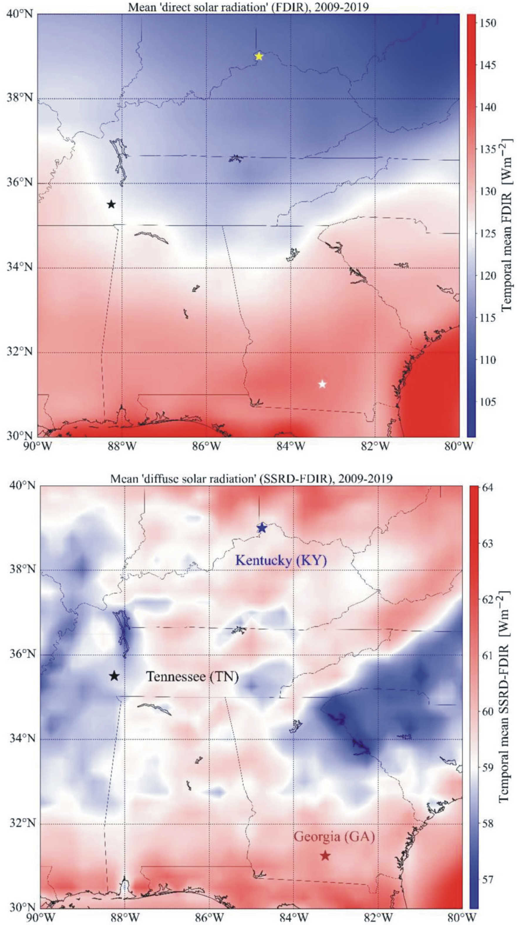

Supplementary Figure S1. North-American maps of the 10-year mean power flux (W/m²) of direct sunlight (A) and diffuse skylight (B) averaged for the period 2009-2019. The three sites – Boone County (Kentucky, 39.0° N, -84.75° E), Tennessee (35.5° N, -88.25° E) and Georgia (31.25° N, -83.25° E) – for which our computations were performed, are marked by asterix.

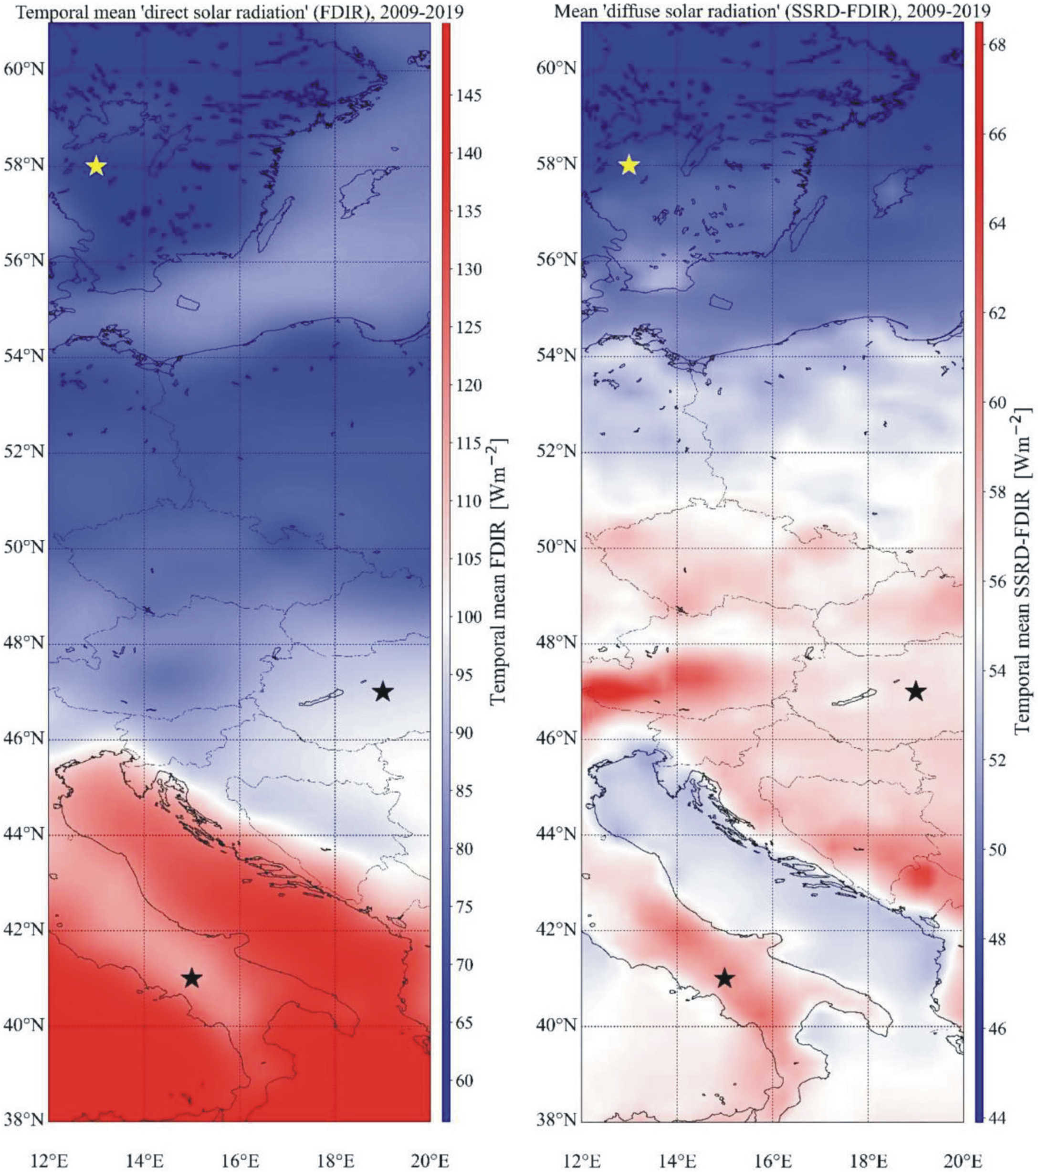

Supplementary Figure S2. European maps of the 10-year mean power flux (W/m²) of direct sunlight (A) and diffuse skylight (B) averaged for the period 2009-2019. The three European sites – Central Italy (41.0° N, 15.0° E), Central Hungary (47.0° N, 19.0° E) and South Sweden (58.0° N, 13.0° E) – for which our computations were performed, are marked by asterix.

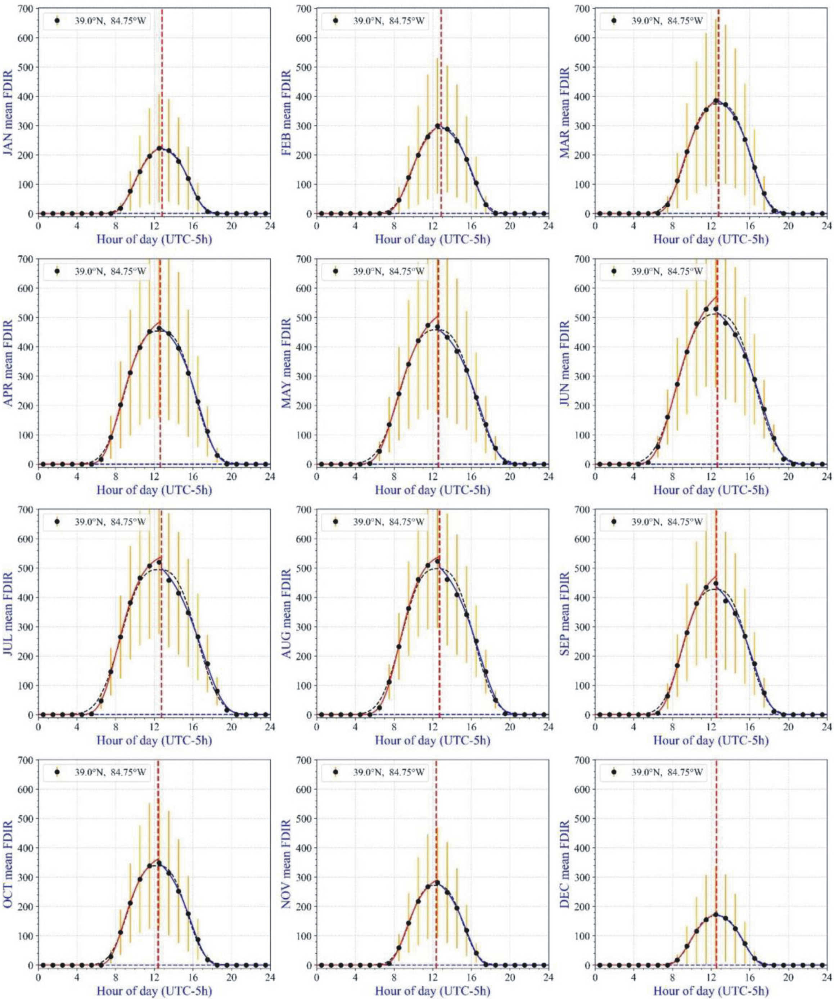

Supplementary Figure S3. Daily hourly change of the mean (black dots) ± standard deviation (orange vertical bars) of the power flux W_{Sun} ± ΔW_{Sun} (W/m²) of direct sunlight from January to December averaged for the period 2009-2019 in Boone County (39.0° N, -84.75° E) between sunrise and sunset (UTC - 5 hour).
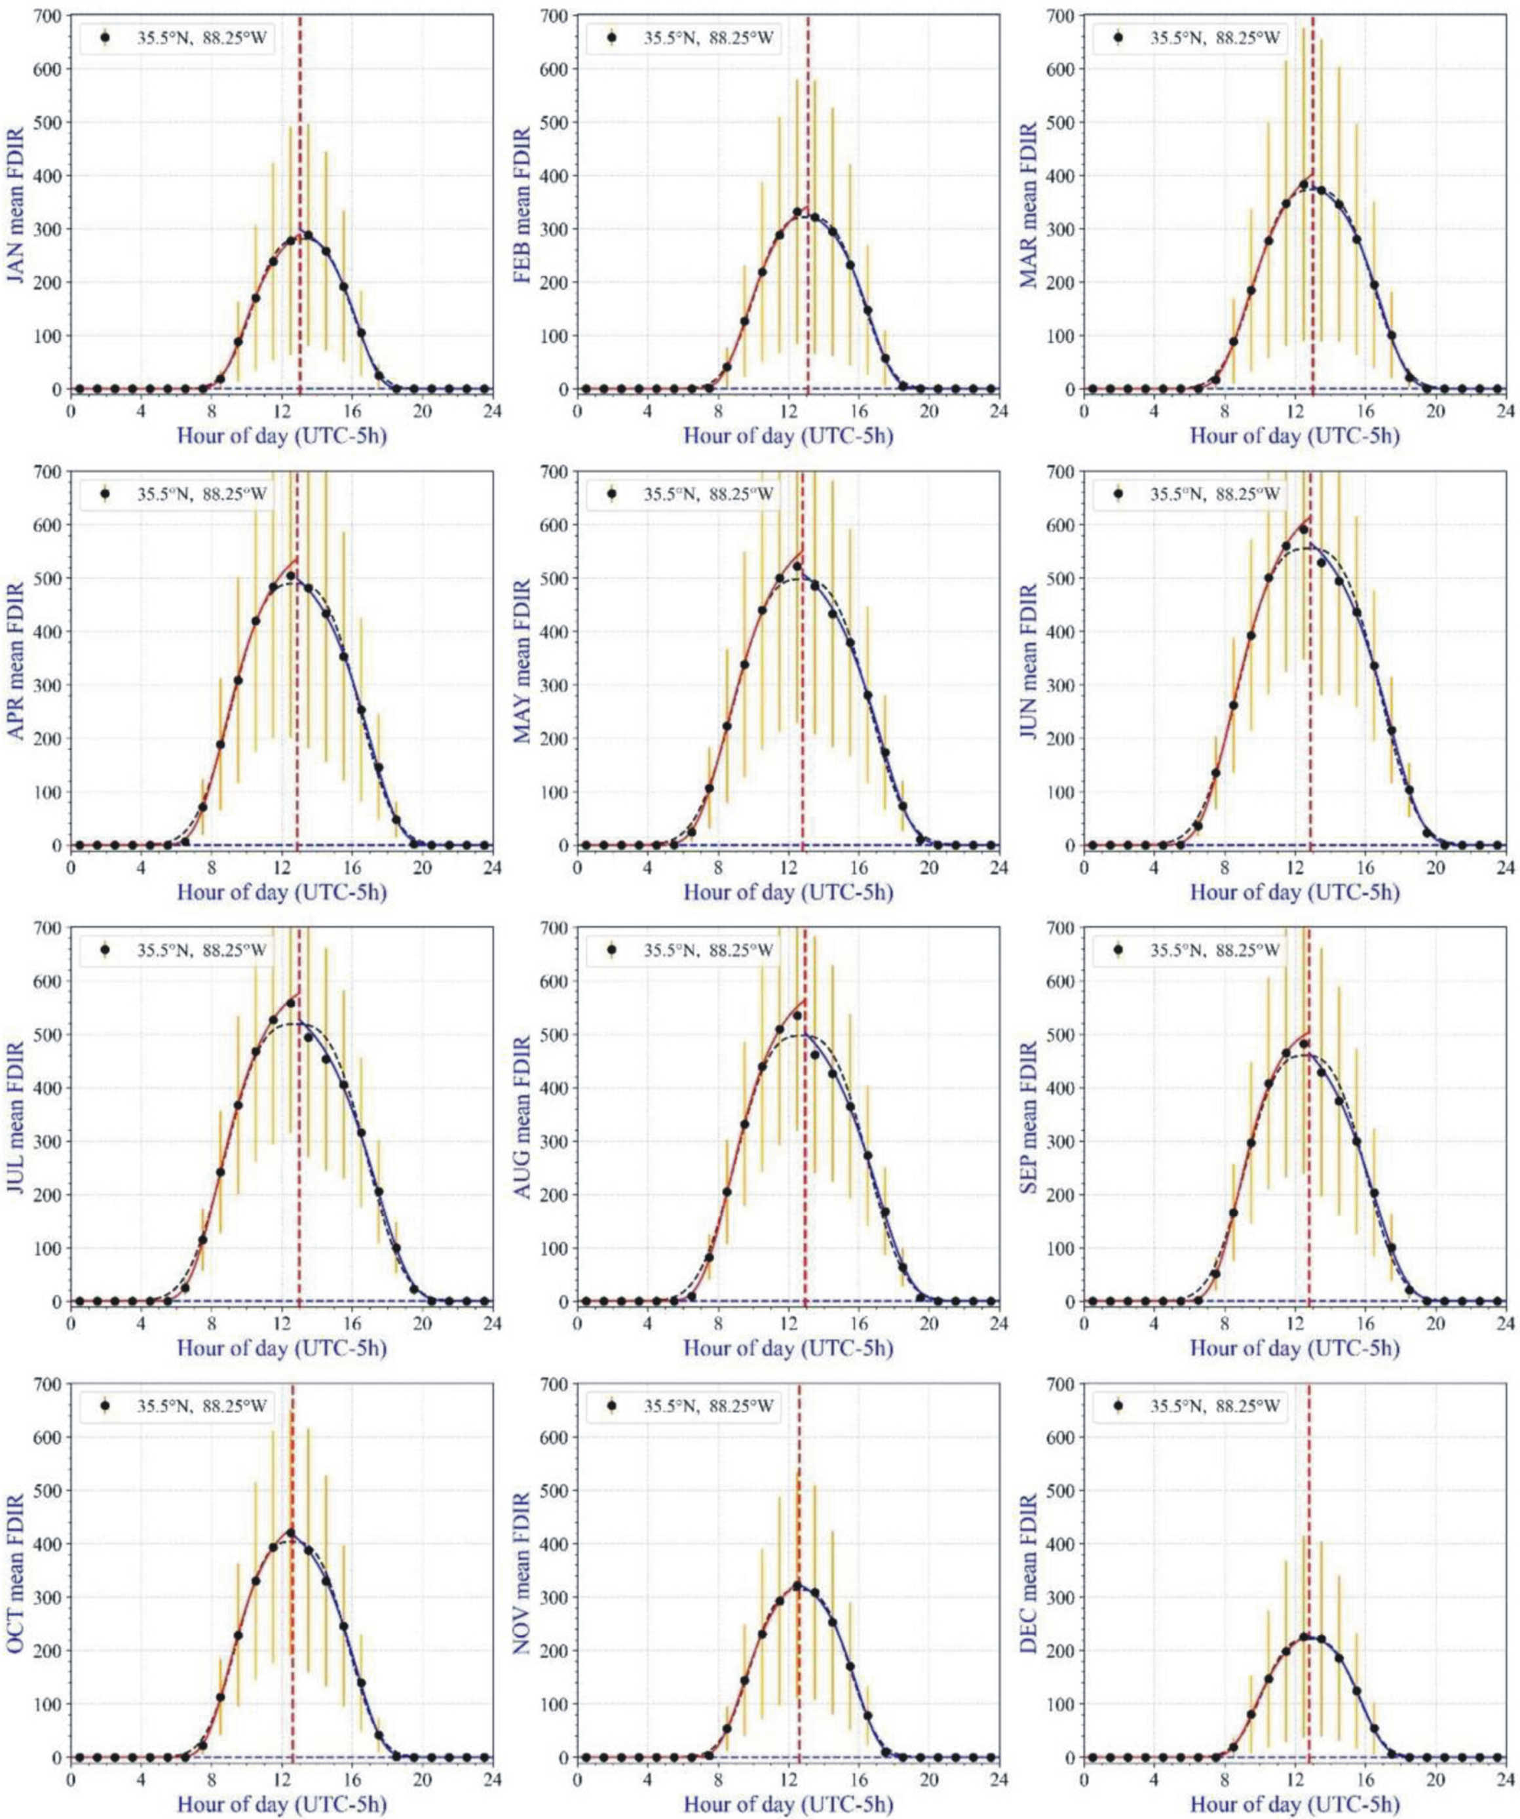

Supplementary Figure S4. Daily hourly change of the mean (black dots) ± standard deviation (orange vertical bars) of the power flux W_{Sun} ± ΔW_{Sun} (W/m²) of direct sunlight from January to December averaged for the period 2009-2019 in Tennessee (35.5° N, -88.25° E) between sunrise and sunset (UTC - 5 hour).
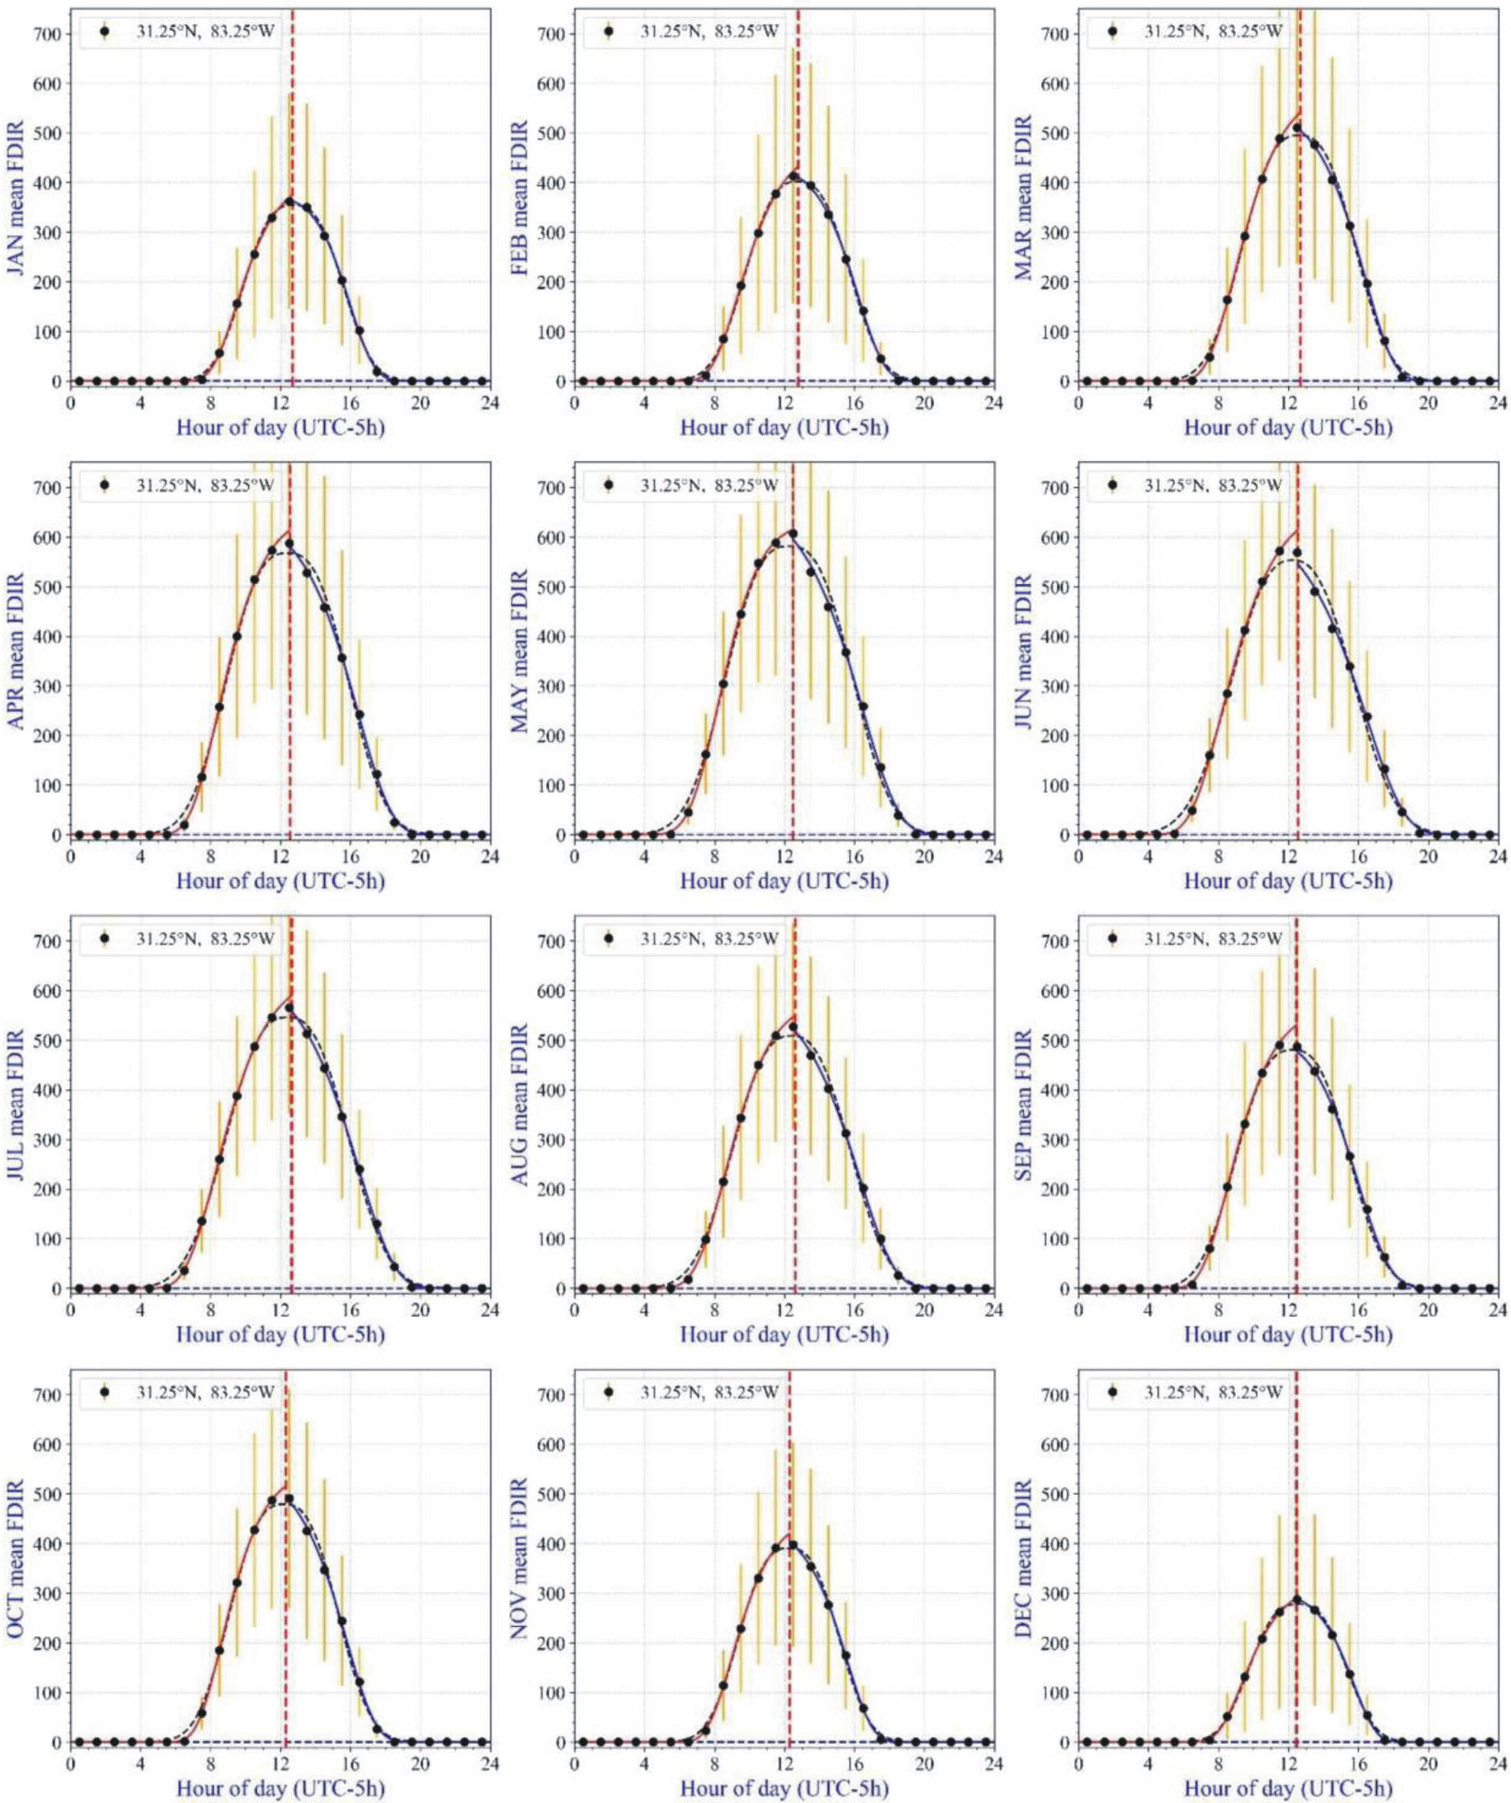

Supplementary Figure S5. Daily hourly change of the mean (black dots) ± standard deviation (orange vertical bars) of the power flux W_{Sun} ± ΔW_{Sun} (W/m²) of direct sunlight from January to December averaged for the period 2009-2019 in Georgia (31.25° N, -83.25° E) between sunrise and sunset (UTC - 5 hour).

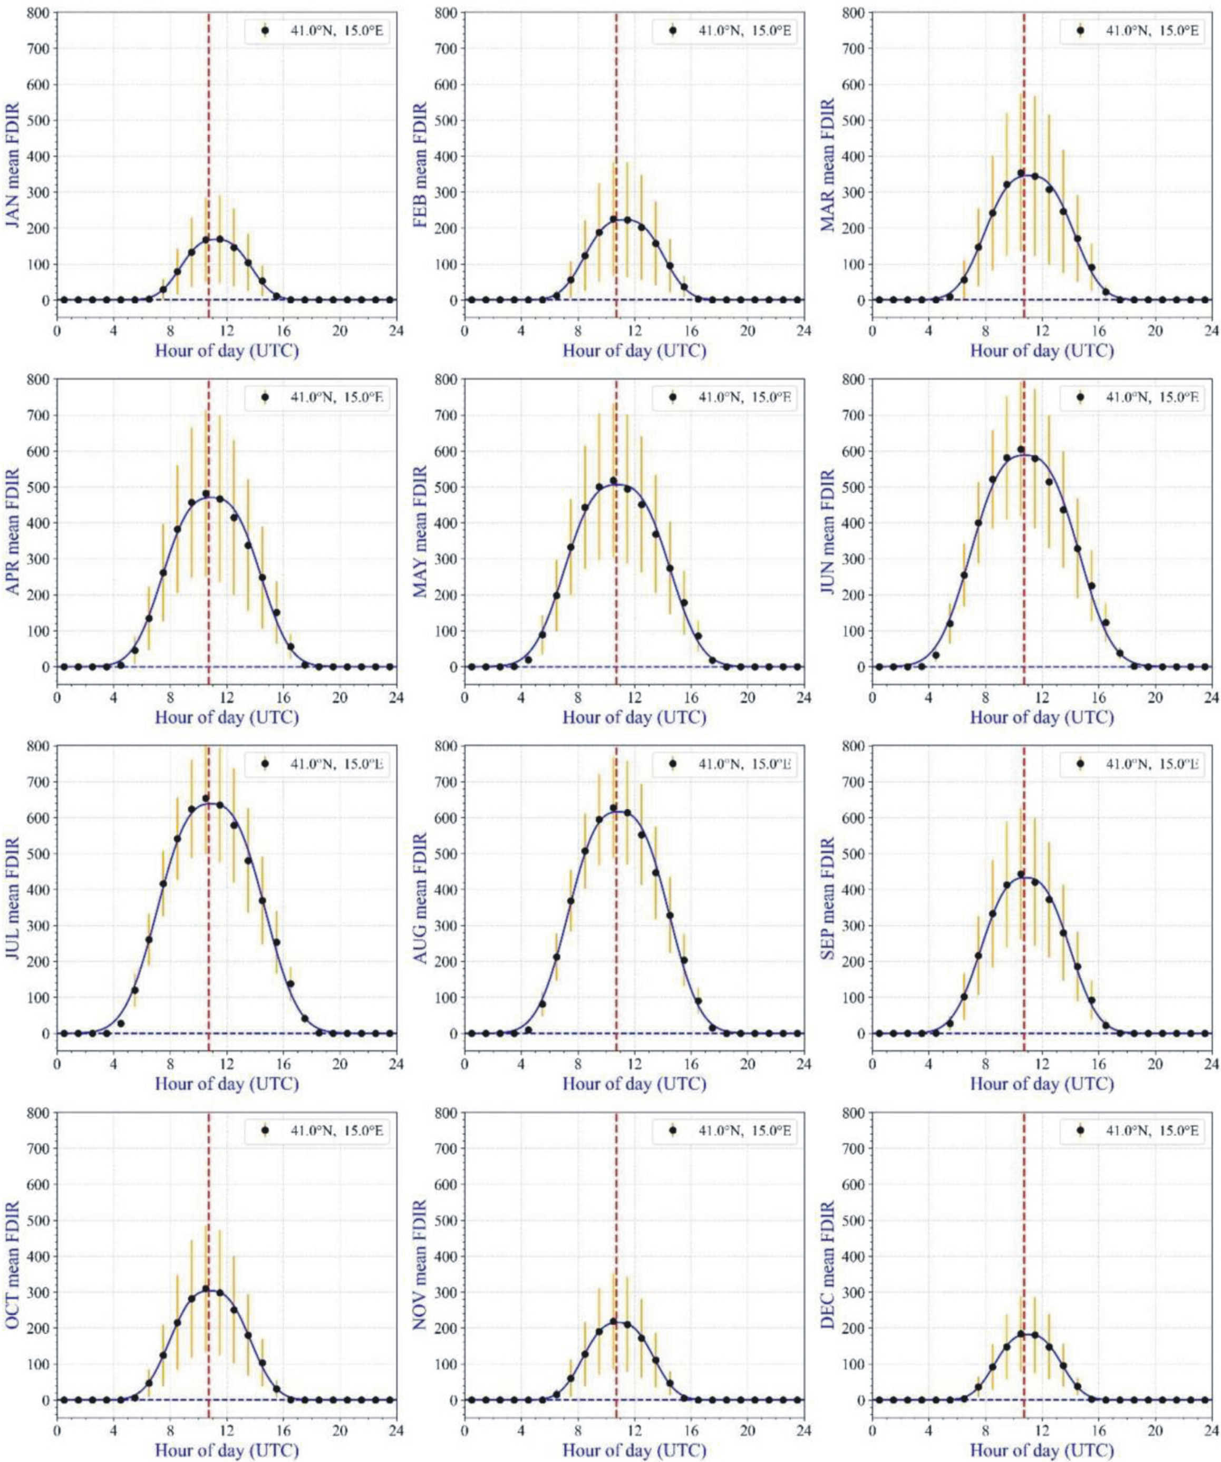

Supplementary Figure S6. Daily hourly change of the mean (black dots) ± standard deviation (orange vertical bars) of the power flux W_{Sun} ± ΔW_{Sun} (W/m²) of direct sunlight from January to December averaged for the period 2009-2019 in Central Italy (41.0° N, 15.0° E) between sunrise and sunset (UTC + 1 hour).
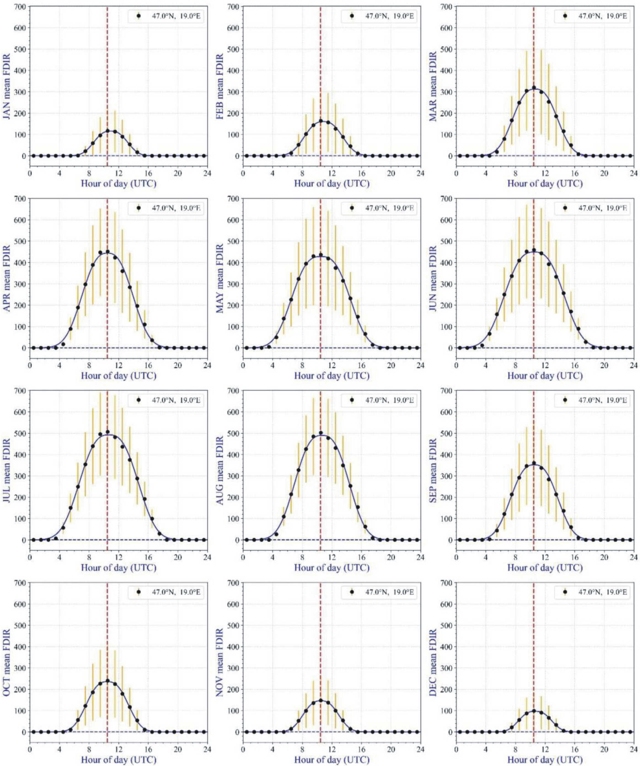

Supplementary Figure S7. Daily hourly change of the mean (black dots) ± standard deviation (orange vertical bars) of the power flux W_{Sun} ± ΔW_{Sun} (W/m²) of direct sunlight from January to December averaged for the period 2009-2019 in Central Hungary (47.0° N, 19.0° E) between sunrise and sunset (UTC + 1 hour).
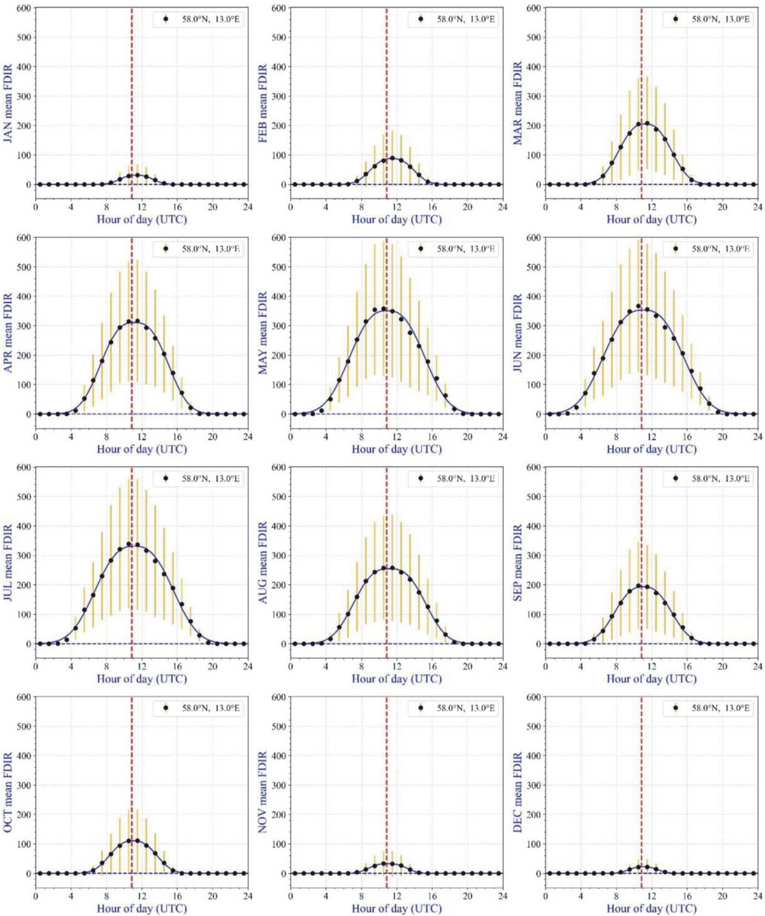

Supplementary Figure S8. Daily hourly change of the mean (black dots) ± standard deviation (orange vertical bars) of the power flux W_{Sun} ± ΔW_{Sun} (W/m²) of direct sunlight from January to December averaged for the period 2009-2019 in South Sweden (58.0° N, 13.0° E) between sunrise and sunset (UTC + 1 hour).
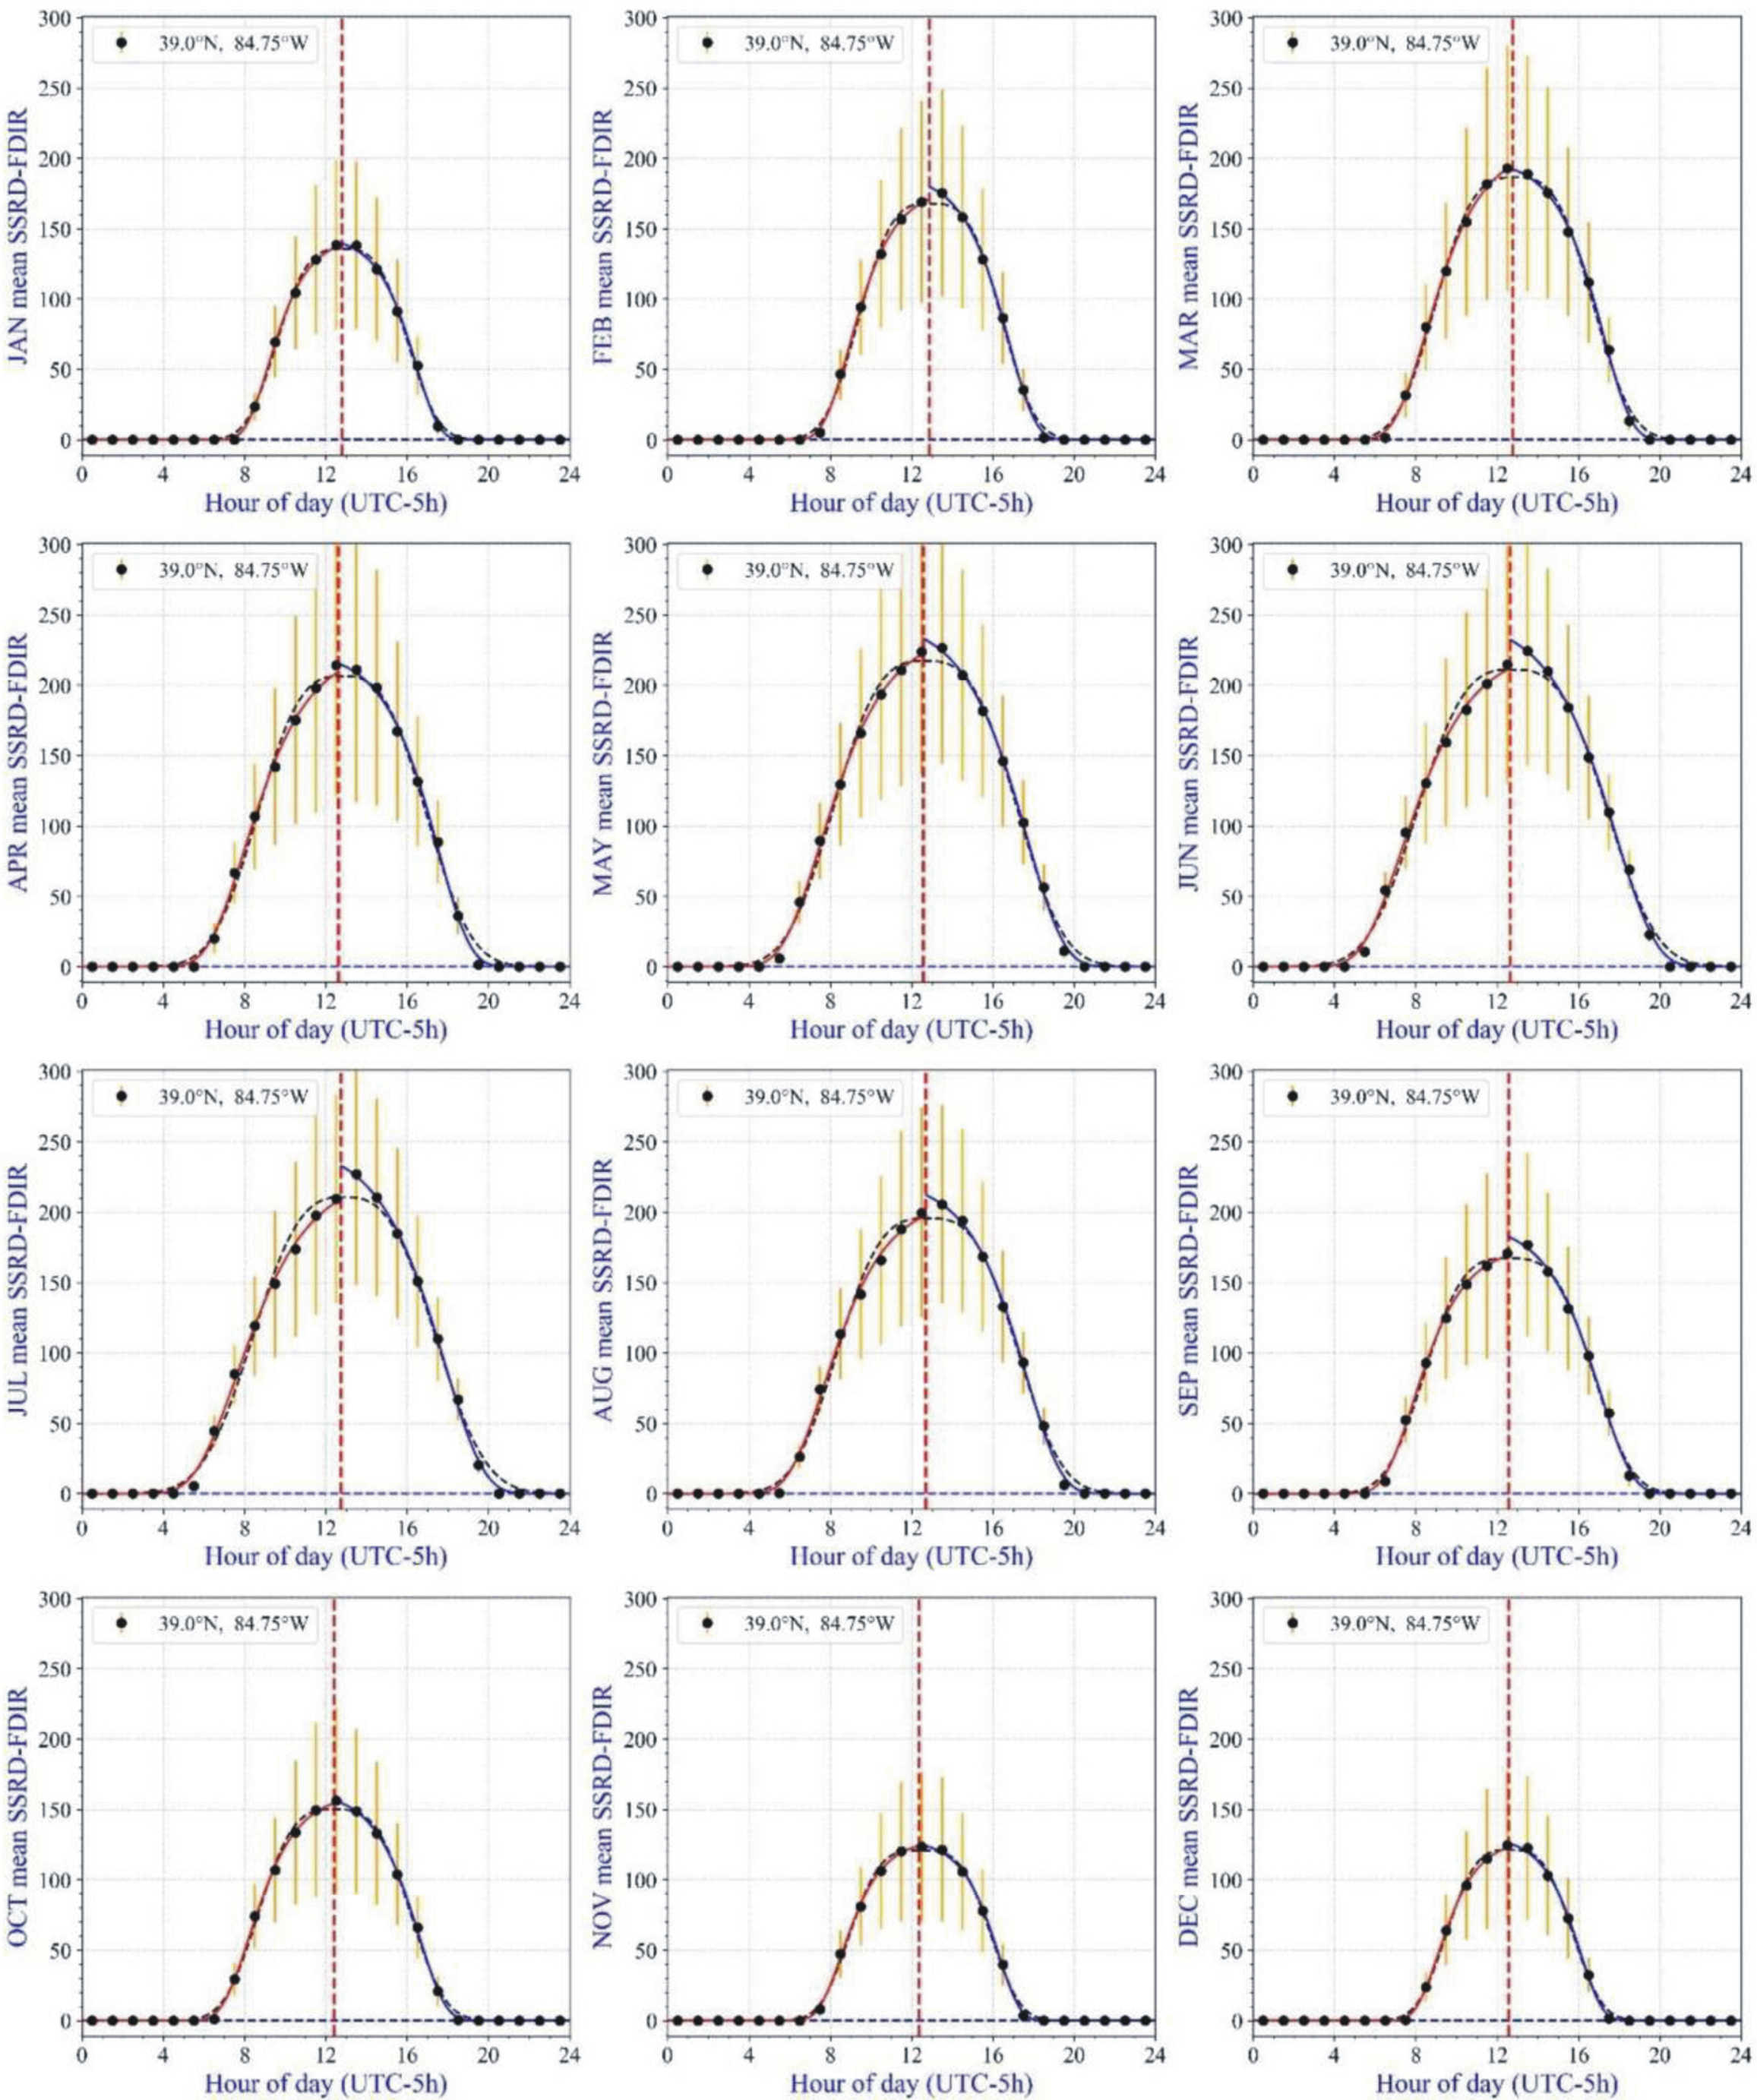

Supplementary Figure S9. Daily hourly change of the mean (black dots) ± standard deviation (orange vertical bars) of the power flux W_{diff} ± ΔW_{diff} (W/m²) of diffuse skylight from January to December averaged for the period 2009-2019 in Boone County (39.0° N, -84.75° E) between sunrise and sunset (UTC - 5 hour).
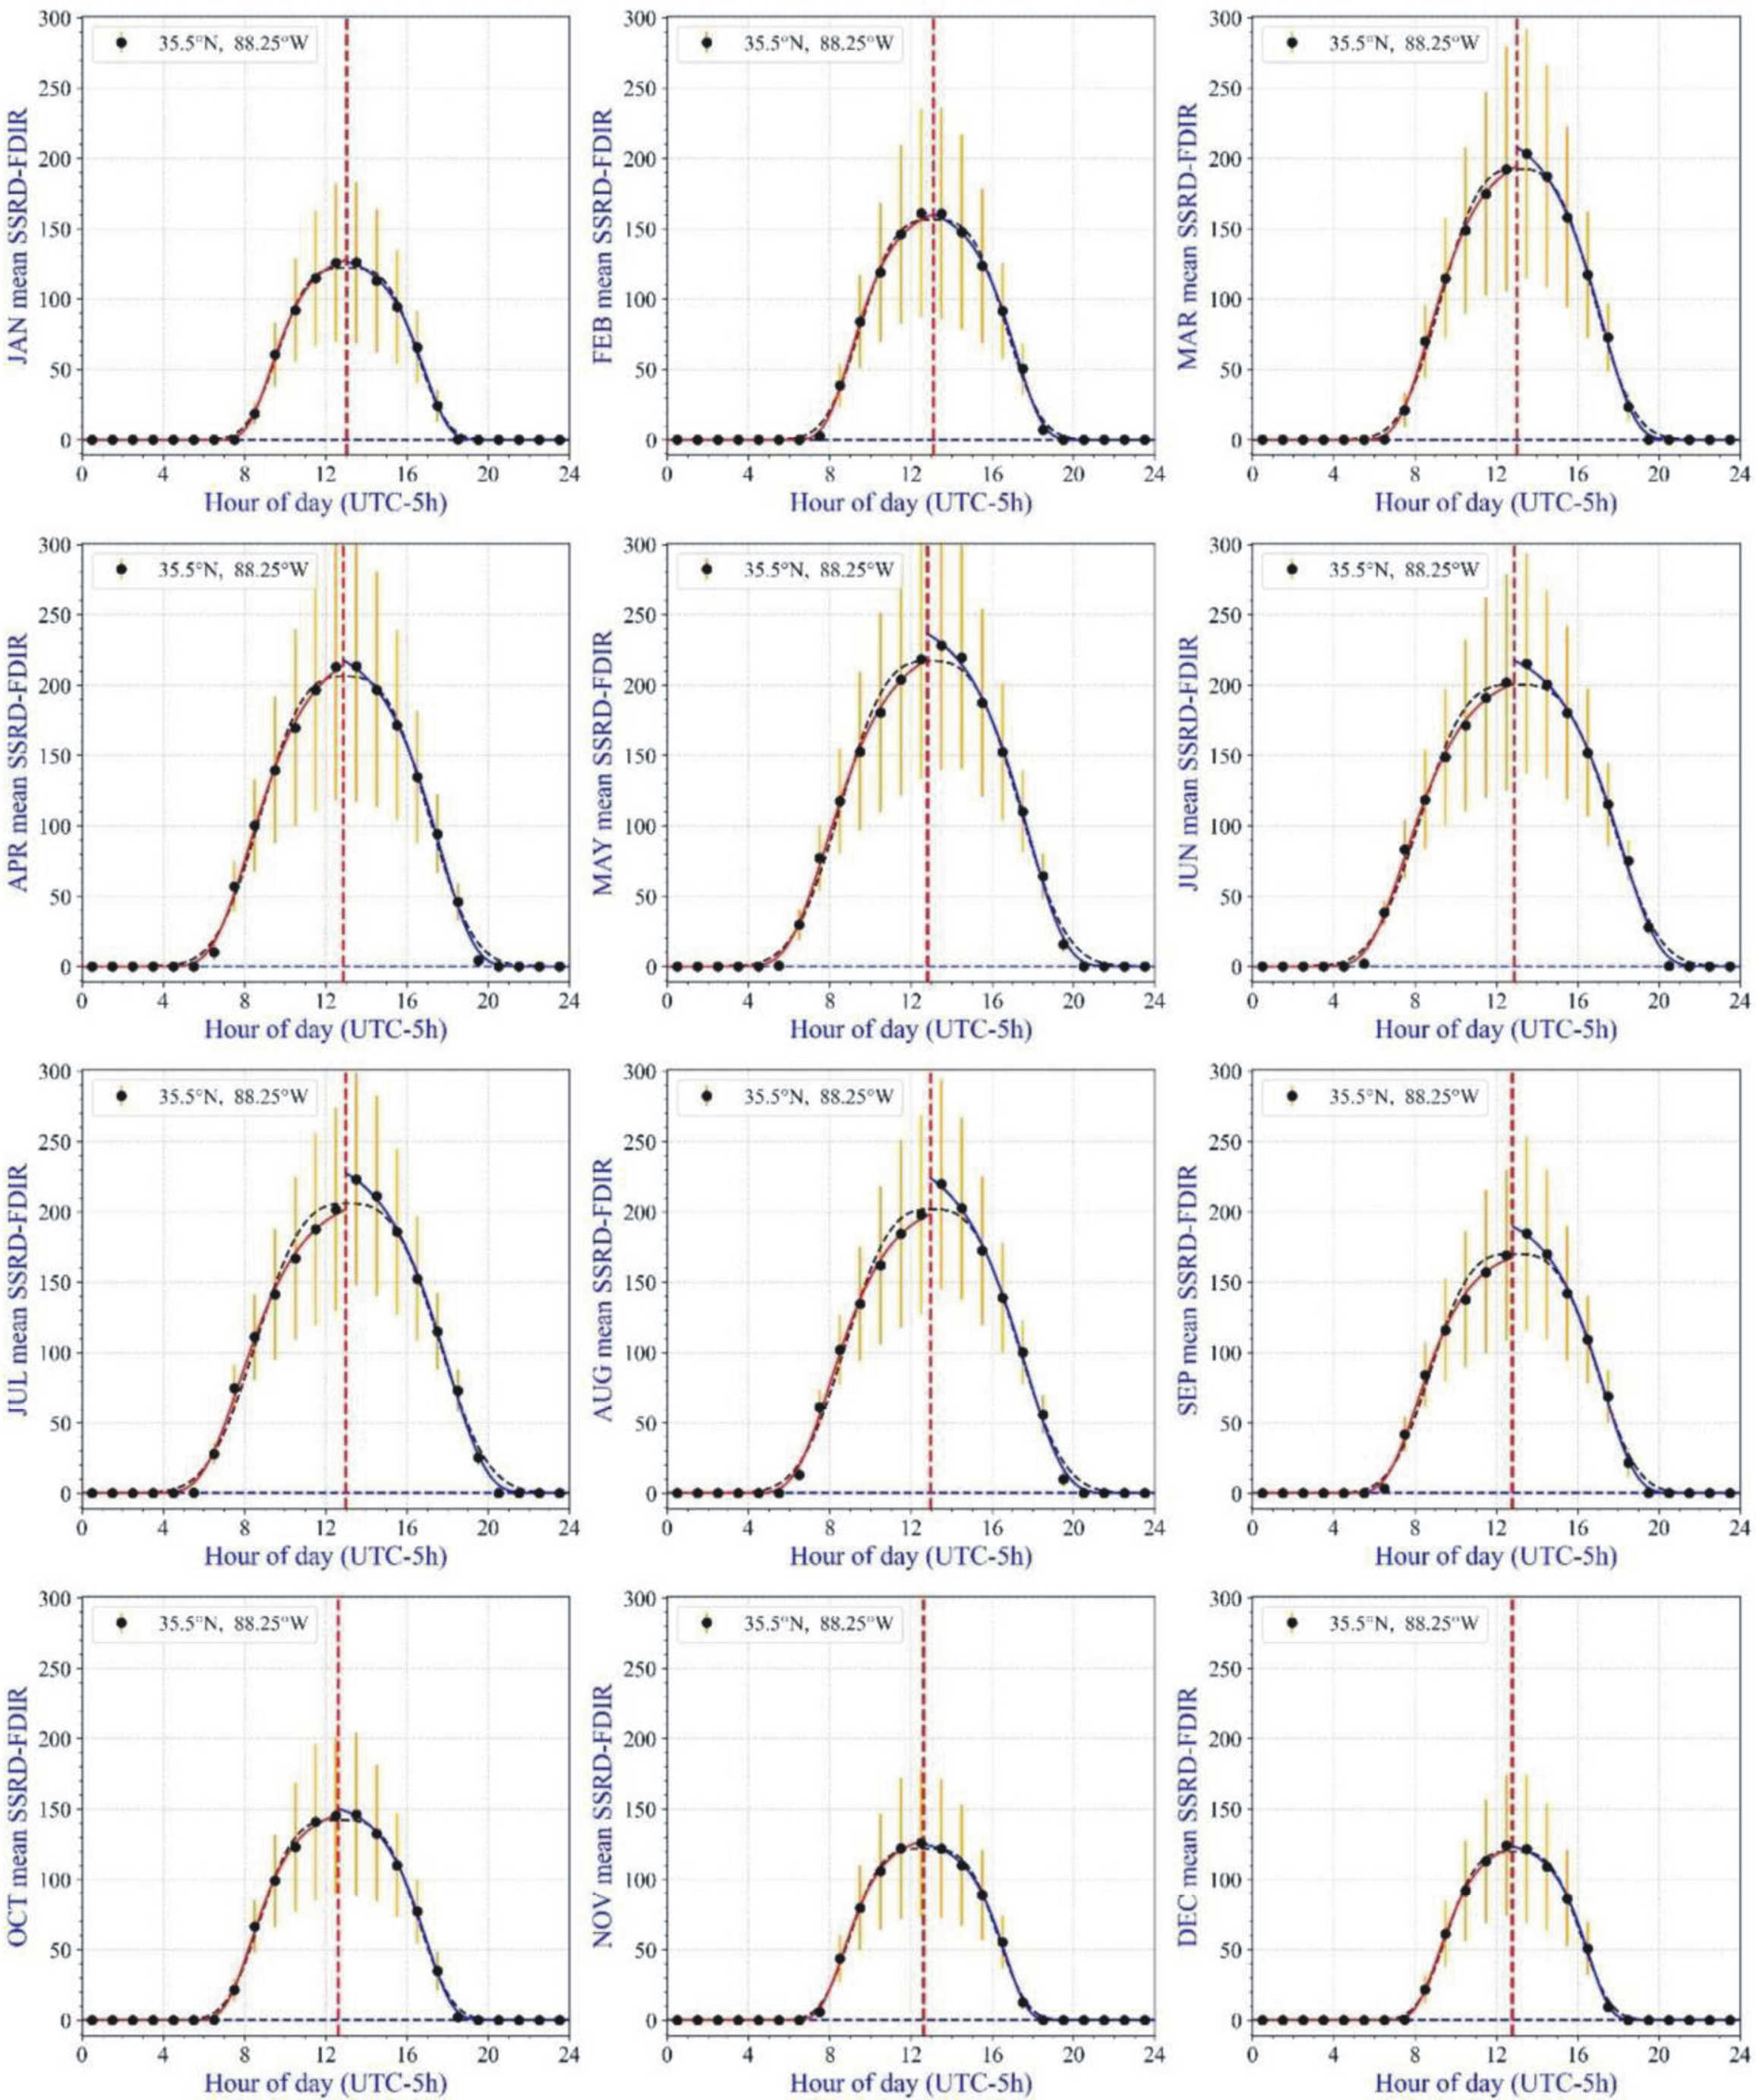

Supplementary Figure S10. Daily hourly change of the mean (black dots) ± standard deviation (orange vertical bars) of the power flux W_{diff} ± ΔW_{diff} (W/m²) of diffuse skylight from January to December averaged for the period 2009-2019 in Tennessee (35.5° N, -88.25° E) between sunrise and sunset (UTC - 5 hour).
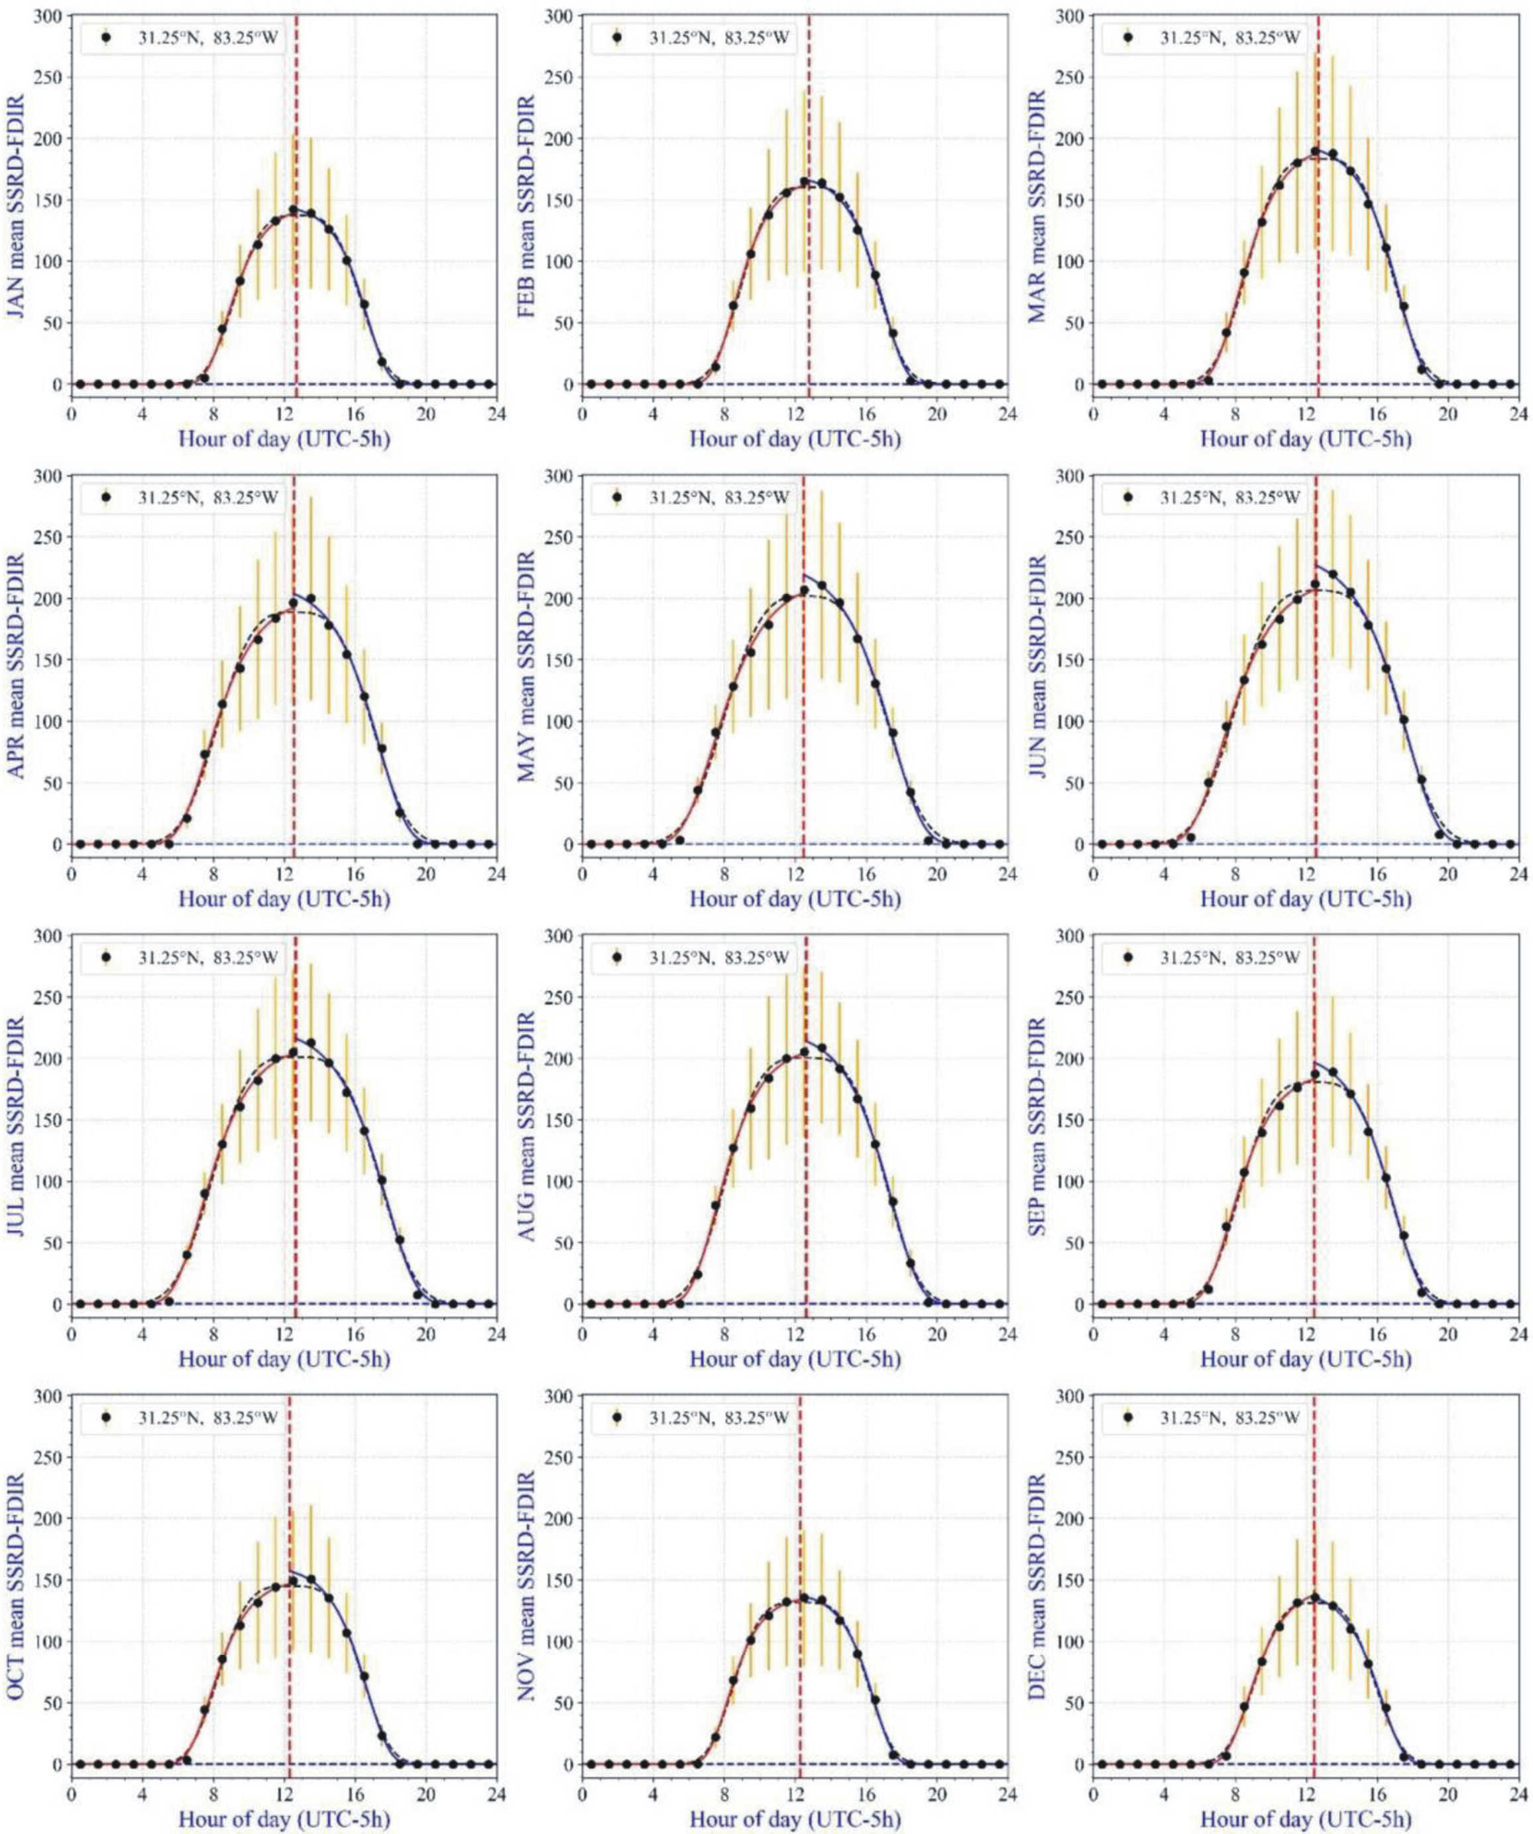

Supplementary Figure S11. Daily hourly change of the mean (black dots) ± standard deviation (orange vertical bars) of the power flux W_{diff} ± ΔW_{diff} (W/m²) of diffuse skylight from January to December averaged for the period 2009-2019 in Georgia (31.25° N, -83.25° E) between sunrise and sunset (UTC - 5 hour).
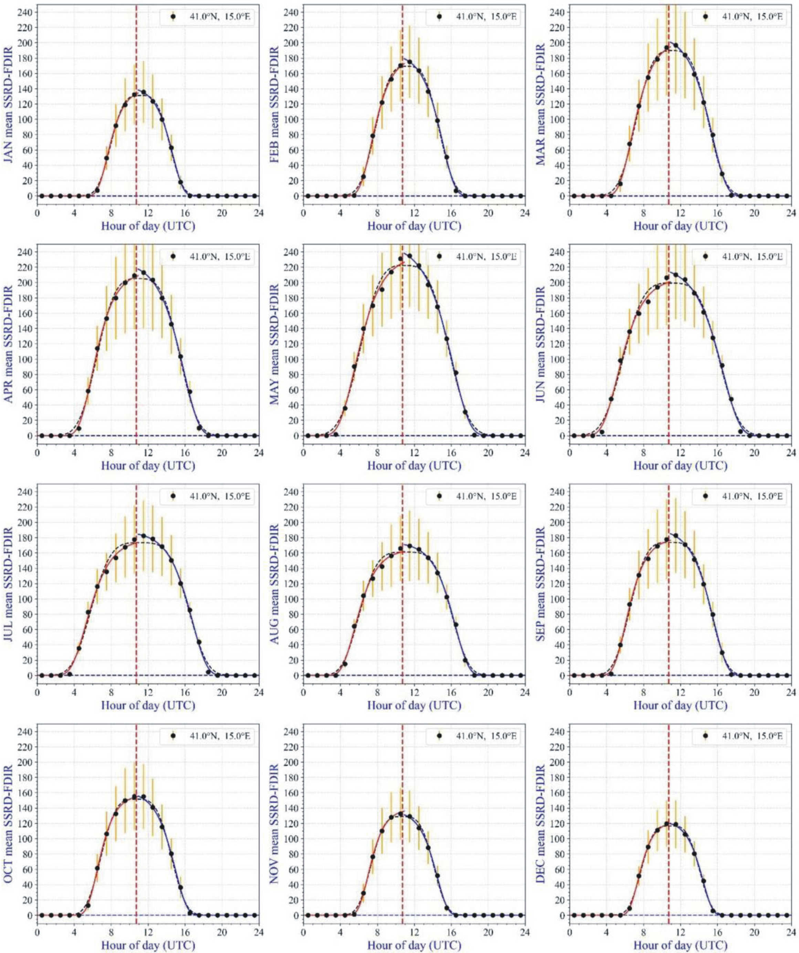

Supplementary Figure S12. Daily hourly change of the mean (black dots) ± standard deviation (orange vertical bars) of the power flux W_{diff} ± ΔW_{diff} (W/m²) of diffuse skylight from January to December averaged for the period 2009-2019 in Central Italy (41.0° N, 15.0° E) between sunrise and sunset (UTC + 1 hour).

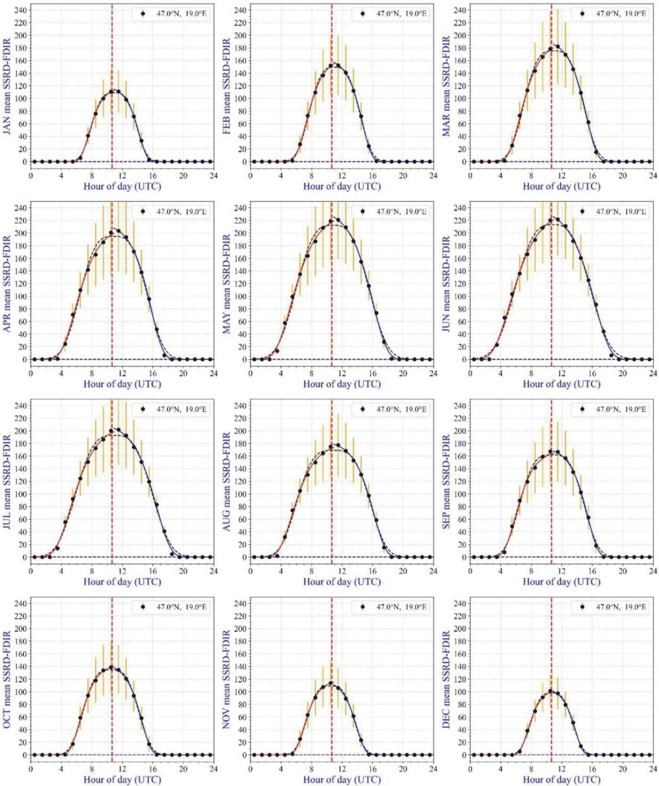

Supplementary Figure S13. Daily hourly change of the mean (black dots) ± standard deviation (orange vertical bars) of the power flux W_{diff} ± ΔW_{diff} (W/m²) of diffuse skylight from January to December averaged for the period 2009-2019 in Central Hungary (47.0° N, 19.0° E) between sunrise and sunset (UTC + 1 hour).

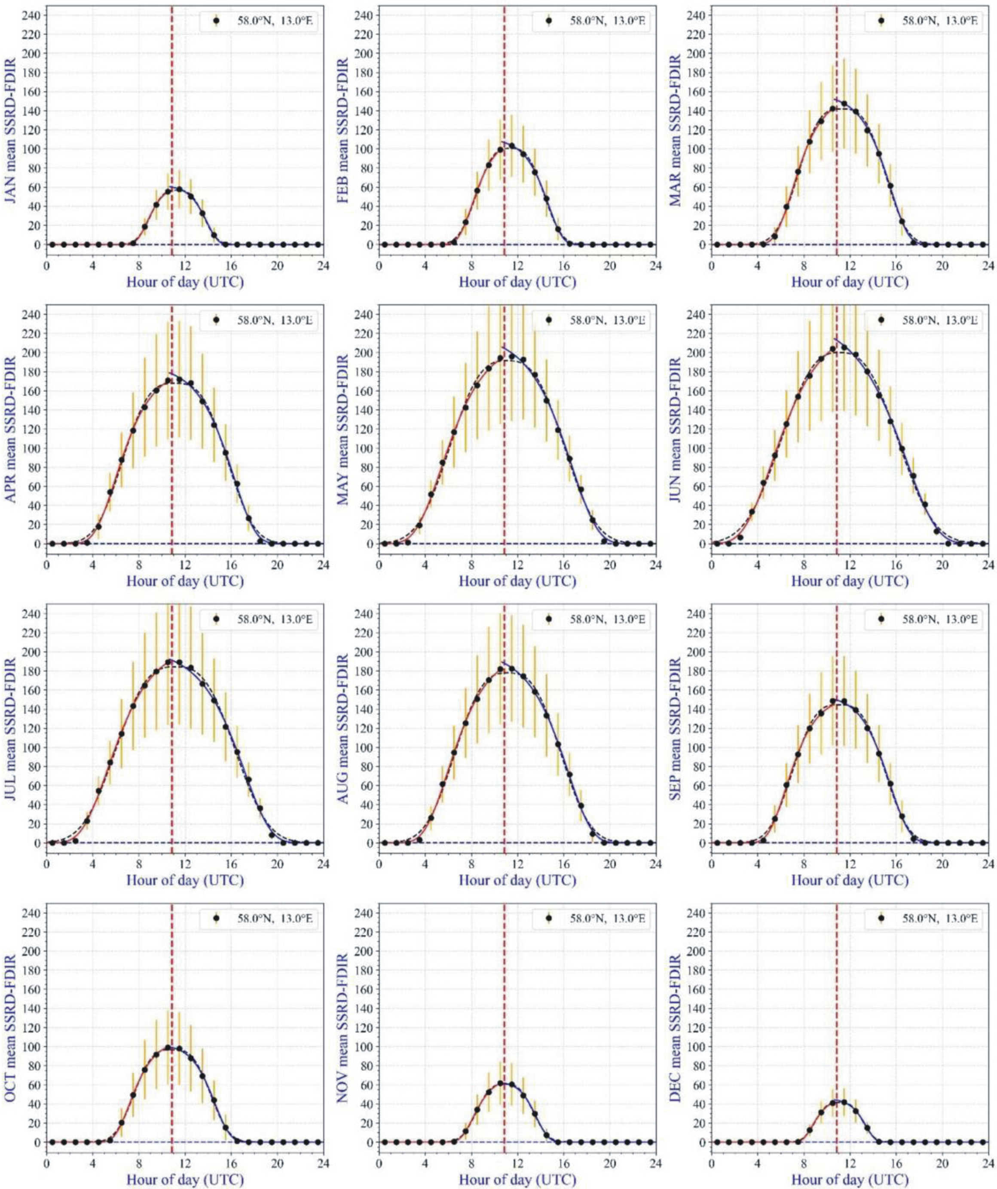

Supplementary Figure S14. Daily hourly change of the mean (black dots) ± standard deviation (orange vertical bars) of the power flux W_{diff} ± ΔW_{diff} (W/m²) of diffuse skylight from January to December averaged for the period 2009-2019 in South Sweden (58.0° N, 13.0° E) between sunrise and sunset (UTC + 1 hour).

