Supplementary Material

for

Why was the Kordylewski dust cloud observed more frequently at the L5 Lagrange point than at L4?

Asymmetry of the particle capture at the triangular Lagrange points of the Earth-Moon system

Judit Slíz-Balogh, Bálint Érdi, Dániel Horváth and Gábor Horváth^{1,}*

1: Environmental Optics Laboratory, Department of Biological Physics,
ELTE Eötvös Loránd University, H-1117 Budapest, Pázmány sétány 1, Hungary

*: Corresponding author, e-mail address: gh@arago.elte.hu

Judit Slíz-Balogh, Bálint Érdi, Dániel Horváth, Gábor Horváth (2022) Why was the Kordylewski dust cloud observed more frequently at the L5 Lagrange point than at L4? Asymmetry of the particle capture at the triangular Lagrange points of the Earth-Moon system. Icarus 374 (1 March 2022): 114814 + supplement (7 pages, doi: 10.1016/j.icarus.2021.114814, Open Access)

https://doi.org/10.1016/j.icarus.2021.114814

This file contains the following: - Supplementary Table S1
- Supplementary Video Clips VC1-inertial, VC2-rotating
- Supplementary Figures S1-S3
- Supplementary Stereo Cubes C1-C42

Supplementary Table S1: Initial positions (x₀, y₀, z₀) and velocities (v_{x0}, v_{y0}, v_{z0}) of the Lagrange points L4 and L5, as well as of the Moon and Earth in the heliocentric ecliptic system of coordinates (Fig. 1). τ₀ is the observation date of the Kordylewski dust cloud in L4 and L5 (Table1).

 | L4 | L5 | Moon | Earth | τ₀
x₀  y₀  z₀  v_{x0}  v_{y0}  v_{z0} | 0.45112986  0.88303920  0.00022217  -0.01542900  0.00758529  -0.00001840 | 0.45548909  0.88420323  -0.00004738  -0.01572365  0.00854753  0.00005153 | 0.45297901  0.88488013  0.00017948  -0.01574888  0.00852213  0.00000084 | 0.45364834  0.88233145  -0.00000218  -0.01529192  0.00815473  -0.00000041 | 6 March 1961  00:00
x₀  y₀  z₀  v_{x0}  v_{y0}  v_{z0} | 0.42026652  0.89764492  0.00016425  0.01542848  0.00703902  -0.00003872 | 0.42361724  0.90054610  0.00005675  -0.01612903  0.00778162  0.00005078 | 0.42110972  0.90006092  0.00022678  -0.01614017  0.00774810  0.00000023 | 0.42279470  0.89810634  -0.00000276  -0.01555875  0.00761861  -0.00000015 | 8 March 1961  00:00
x₀  y₀  z₀  v_{x0}  v_{y0}  v_{z0} | 0.06420938  0.99739225  0.00008200  -0.01681320  -0.00126439  -0.00005088 | -0.06234693  1.00133125  0.00014102  -0.01776598  -0.00084931  0.00004115 | -0.06441146  0.99989593  0.00022371  -0.01776144  -0.00088944  -0.00000037 | -0.06211724  0.99881455  -0.00000272  -0.01716599  -0.00077423  0.00000012 | 6 April 1961  00:00
x₀  y₀  z₀  v_{x0}  v_{y0}  v_{z0} | -0.53498280  -0.85212087  -0.00001986  0.01420134  -0.00842918  0.00005078 | -0.53636741  -0.85648079  -0.00019462  0.01512541  -0.00877532  -0.00003149 | -0.53441890  -0.85469523  -0.00022053  0.01509206  -0.00865434  0.00000043 | -0.53696225  -0.85389647  0.00000268  0.01455995  -0.00887599  -0.00000024 | 3 September 1961  00:00
x₀  y₀  z₀  v_{x0}  v_{y0}  v_{z0} | -0.52074907  -0.86047289  0.00003103  0.01426909  -0.00827703  0.00005058 | -0.52118313  -0.86507118  -0.00022118  0.01523836  -0.00840687  -0.00002147 | -0.51963997  -0.86289170  -0.00019564  0.01517897  -0.00829739  0.00000070 | -0.52232484  -0.86264912  0.00000238  0.01471419  -0.00862881  -0.00000036 | 4 September 1961  00:00
x₀  y₀  z₀  v_{x0}  v_{y0}  v_{z0} | -0.32202827  -0.95412639  0.00006587  0.01663590  -0.00567619  -0.00005155 | -0.31986356  -0.95026277  0.00015732  0.01571899  -0.00522804  0.00003657 | -0.32205812  -0.95157416  0.00022672  0.01574050  -0.00535388  -0.00000058 | -0.31980644  -0.95283030  -0.00000276  0.01631100  -0.00518036  0.00000019 | 16 September 1961  00:00
x₀  y₀  z₀  v_{x0}  v_{y0}  v_{z0} | -0.30528985  -0.95962313  0.00001301  0.01683739  -0.00531240  -0.00005370 | -0.30409238  -0.95542086  0.00018926  0.01582798  -0.00508776  0.00002696 | -0.30590221  -0.95718125  0.00020512  0.01587940  -0.00520659  -0.00000077 | -0.30345038  -0.95787121  -0.00000249  0.01640029  -0.00490123  0.00000033 | 17 September 1961  00:00
x₀  y₀  z₀  v_{x0}  v_{y0}  v_{z0} | -0.28836184  -0.96474193  -0.00004056  0.01701384  -0.00492090  -0.00005292 | -0.28819821  -0.96043618  0.00021060  0.01596507  -0.00494113  0.00001545 | -0.28952224  -0.96254692  0.00017205  0.01604466  -0.00504601  -0.00000091 | -0.28700748  -0.96263233  -0.00000209  0.01648472  -0.00462081  0.00000047 | 18 September 1961  00:00
x₀  y₀  z₀  v_{x0}  v_{y0}  v_{z0} | 0.98157366  0.01410660  0.00018306  -0.00068507  0.01714902  -0.00002949 | 0.98578702  0.01254199  0.00003307  -0.00027007  0.01806568  0.00005212 | 0.98413408  0.01453522  0.00022235  -0.00073732  0.01774039  0.00000066 | 0.98321559  0.01208336  -0.00000270  -0.00020545  0.01748519  -0.00000028 | 4 January 1964  00:00
x₀  y₀  z₀  v_{x0}  v_{y0}  v_{z0} | 0.97978698  0.04821597  0.00010800  0.00109176  0.01697262  -0.00004416 | 0.98438635  0.04857714  0.00013052  -0.00112154  0.01794948  0.00004384 | 0.98198226  0.04971829  0.00024539  -0.00139004  0.01746609  -0.00000001 | 0.98219362  0.04704205  -0.00000298  -0.00081663  0.01746988  0.00000000 | 6 January 1964  00:00
x₀  y₀  z₀  v_{x0}  v_{y0}  v_{z0} | 0.97860138  0.06515722  0.00006163  0.00127828  0.01691318  -0.00004821 | 0.98306247  0.06647914  0.00017093  -0.00152306  0.01785056  0.00003671 | 0.98044904  0.06710012  0.00023926  -0.00167562  0.01732408  -0.00000034 | 0.98122413  0.06450446  -0.00000291  -0.00112236  0.01745402  0.00000014 | 7 January 1964  00:00
x₀  y₀  z₀  v_{x0}  v_{y0}  v_{z0} | 0.73511609  0.65597034  -0.00016984  0.01137440  0.01255275  -0.00003817 | 0.73852198  0.65879041  0.00021902  -0.01197318  0.01337994  -0.00001262 | 0.73600058  0.65836616  0.00004418  -0.01159989  0.01257174  0.00000078 | 0.73765768  0.65637098  -0.00000054  -0.01142965  0.01314227  0.00000061 | 13 February 1966  00:00
x₀  y₀  z₀  v_{x0}  v_{y0}  v_{z0} | 0.53029039  0.83987202  0.00022281  -0.01495483  0.00990218  0.00000642 | 0.52869481  0.83581249  -0.00014738  -0.01396961  0.00958349  0.00004292 | 0.53066709  0.83737733  0.00007393  -0.01478810  0.01000908  -0.00000098 | 0.52828965  0.83831859  -0.00000090  -0.01455534  0.00945205  0.00000059 | 1 March 1966  00:00
x₀  y₀  z₀  v_{x0}  v_{y0}  v_{z0} | 0.51520387  0.84959799  0.00022287  -0.01521394  0.00954485  -0.00000640 | 0.51462967  0.84533754  -0.00010068  -0.01416555  0.00946537  0.00005009 | 0.51614816  0.84729735  0.00011975  -0.01507517  0.00968984  -0.00000090 | 0.51365558  0.84764250  -0.00000146  -0.01471202  0.00919538  -0.00000052 | 2 March 1966  00:00
x₀  y₀  z₀  v_{x0}  v_{y0}  v_{z0} | 0.38896416  0.91320540  -0.00011684  -0.01594370  0.00646785  -0.00004858 | 0.39294695  0.91471859  0.00022117  -0.01626229  0.00748334  0.00000165 | 0.39051421  0.91511321  0.00009882  -0.01613344  0.00654305  0.00000032 | 0.39140796  0.91278318  -0.00000120  -0.01580292  0.00706855  0.00000057 | 10 March 1966  00:00
x₀  y₀  z₀  v_{x0}  v_{y0}  v_{z0} | 0.35713340  0.92558964  -0.00019693  -0.01588869  0.00593749  -0.00003028 | 0.36005224  0.92888238  0.00019926  -0.01660739  0.00667223  -0.00002276 | 0.35763863  0.92808224  -0.00000216  -0.01608508  0.00591993  0.00000070 | 0.35957047  0.92636951  0.00000003  -0.01603151  0.00651638  0.00000064 | 12 March 1966  00:00
x₀  y₀  z₀  v_{x0}  v_{y0}  v_{z0} | 0.67556412  0.72061864  0.00009603  -0.01282378  0.01153659  0.00005084 | 0.67974927  0.72076947  -0.00021696  -0.01284368  0.01261833  -0.00000490 | 0.67760879  0.72190406  -0.00011783  -0.01216296  0.01259428  -0.00000087 | 0.67770598  0.71945480  0.00000143  -0.01251428  0.01208213  -0.00000055 | 18 February 1976  00:00
x₀  y₀  z₀  v_{x0}  v_{y0}  v_{z0} | 0.66270720  0.73201526  0.00014331  -0.01288744  0.01126221  0.00004326 | 0.66674243  0.73323098  -0.00021506  -0.01316496  0.01229931  0.00000864 | 0.66437000  0.73379092  -0.00006953  -0.01250466  0.01243856  -0.00000090 | 0.66508843  0.73142704  0.00000085  -0.01272024  0.01186174  -0.00000062 | 19 February 1976  00:00
x₀  y₀  z₀  v_{x0}  v_{y0}  v_{z0} | 0.64979267  0.74315437  0.00018173  -0.01294075  0.01102166  0.00003324 | 0.65343043  0.74535882  -0.00019996  -0.01345308  0.01195253  0.00002135 | 0.65097204  0.74531056  -0.00001692  -0.01285260  0.01224285  -0.00000093 | 0.65226671  0.74317708  0.00000021  -0.01292259  0.01163772  -0.00000065 | 20 February 1976  00:00
x₀  y₀  z₀  v_{x0}  v_{y0}  v_{z0} | -0.75719548  -0.66831449  0.00000032  0.01095289  -0.01217064  0.00005536 | -0.75838555  -0.67238825  -0.00019065  0.01198113  -0.01245239  -0.00002697 | -0.75661601  -0.67068977  -0.00019557  0.01191453  -0.01229211  0.00000080 | -0.75899390  -0.67000440  0.00000238  0.01138246  -0.01261585  -0.00000035 | 17 August 2017  00:00
x₀  y₀  z₀  v_{x0}  v_{y0}  v_{z0} | -0.74618475  -0.68044480  0.00005515  0.01107287  -0.01209335  0.00005374 | -0.74632000  -0.68467368  -0.00021157  0.01214357  -0.01212004  -0.00001464 | -0.74503180  -0.68259307  -0.00016071  0.01203951  -0.01197974  0.00000109 | -0.74750289  -0.68252430  0.00000195  0.01159905  -0.01242328  -0.00000049 | 18 August 2017  00:00

Caption for Supplementary-Video-Clip-VC1-inertial.mp4: Simulated motion of 441 dust particles (parts of the Kordylewski dust clouds) starting from the vicinity of the triangular Lagrange points L4 (initially 441 red dots) and L5 (initially 441 violet dots) of the Earth-Moon system visualized in an inertial (non-rotating) system of coordinates, the origin of which is the Earth coinciding with the center of the video frame. The simulation was performed in 3 dimensions (x-y-z), but here the visualization happens in the x-y plane of the ecliptic of the Earth orbiting around the Sun. The dust particles started from the square 30 000 km x 30 000 km around the L4 (green spot) and L5 (yellow spot) points with the same initial velocity vector as that of the triangular Lagrange points. The small light blue spot is the Moon orbiting around the Earth. The time (hour:minute:second) is shown in the top left corner. The evolution of the Kordylewski dust clouds is displayed here for one year. A particle disappears from the screen, if it (1) escapes from the shell with minimum and maximum radii r_{min} = 0.5r₀ and r_{max} = 1.5r₀ (where r₀ = 384 400 km is the average distance of the Moon from the Earth) centred at the Earth, or (2) enters into the Hill’s sphere of the Moon.

Caption for Supplementary-Video-Clip-VC2-rotating.mp4: Simulated motion of 441 dust particles (parts of the Kordylewski dust clouds) starting from the vicinity of the triangular Lagrange points L4 (initially 441 red dots) and L5 (initially 441 violet dots) of the Earth-Moon system visualized in a system of coordinates co-rotating with the Moon. The origin of the video frame is the Earth. The simulation was performed in 3 dimensions (x-y-z), but here the visualization happens in the x-y plane of the ecliptic of the Earth orbiting around the Sun. The dust particles started from the square 30 000 km x 30 000 km around the L4 (green spot) and L5 (yellow spot) points with the same initial velocity vector as that of the triangular Lagrange points. The small light blue spot is the Moon oscillating periodically along the x-axis. The time (hour:minute:second) is shown in the top left corner. The evolution of the Kordylewski dust clouds is displayed here for one year. A particle disappears from the screen, if it (1) escapes from the shell with minimum and maximum radii r_{min} = 0.5r₀ and r_{max} = 1.5r₀ (where r₀ = 384 400 km is the average distance of the Moon from the Earth) centred at the Earth, or (2) enters into the Hill’s sphere of the Moon.

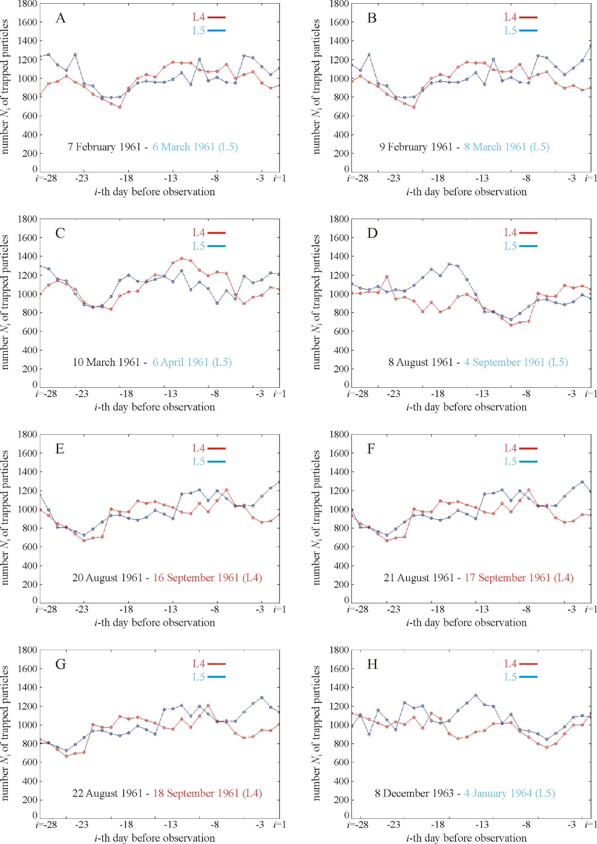

Supplementary Figure S1: Numbers N_{i,L4} (red) and N_{i,L5} (blue) of particles (i = 1, ..., 28) trapped by the Lagrange points L4 and L5 of the Earth-Moon system on the i-th day (= time along the horizontal axis) before the date τ₀ of observation of L4 (red) or L5 (blue) for the days of observation listed in Table 1, apart from 3 September 1961 (see Fig. 3). For the sake of better visualization of the temporal change of N_{i,L4} and N_{i,L5}, the neighbouring data points are connected with a line as the simplest interpolation. (A) 6 March 1961, (B) 8 March 1961, (C) 6 April 1961, (D) 4 September 1961, (E) 16 September 1961, (F) 17 September 1961, (G) 18 September 1961, (H) 4 January 1964.

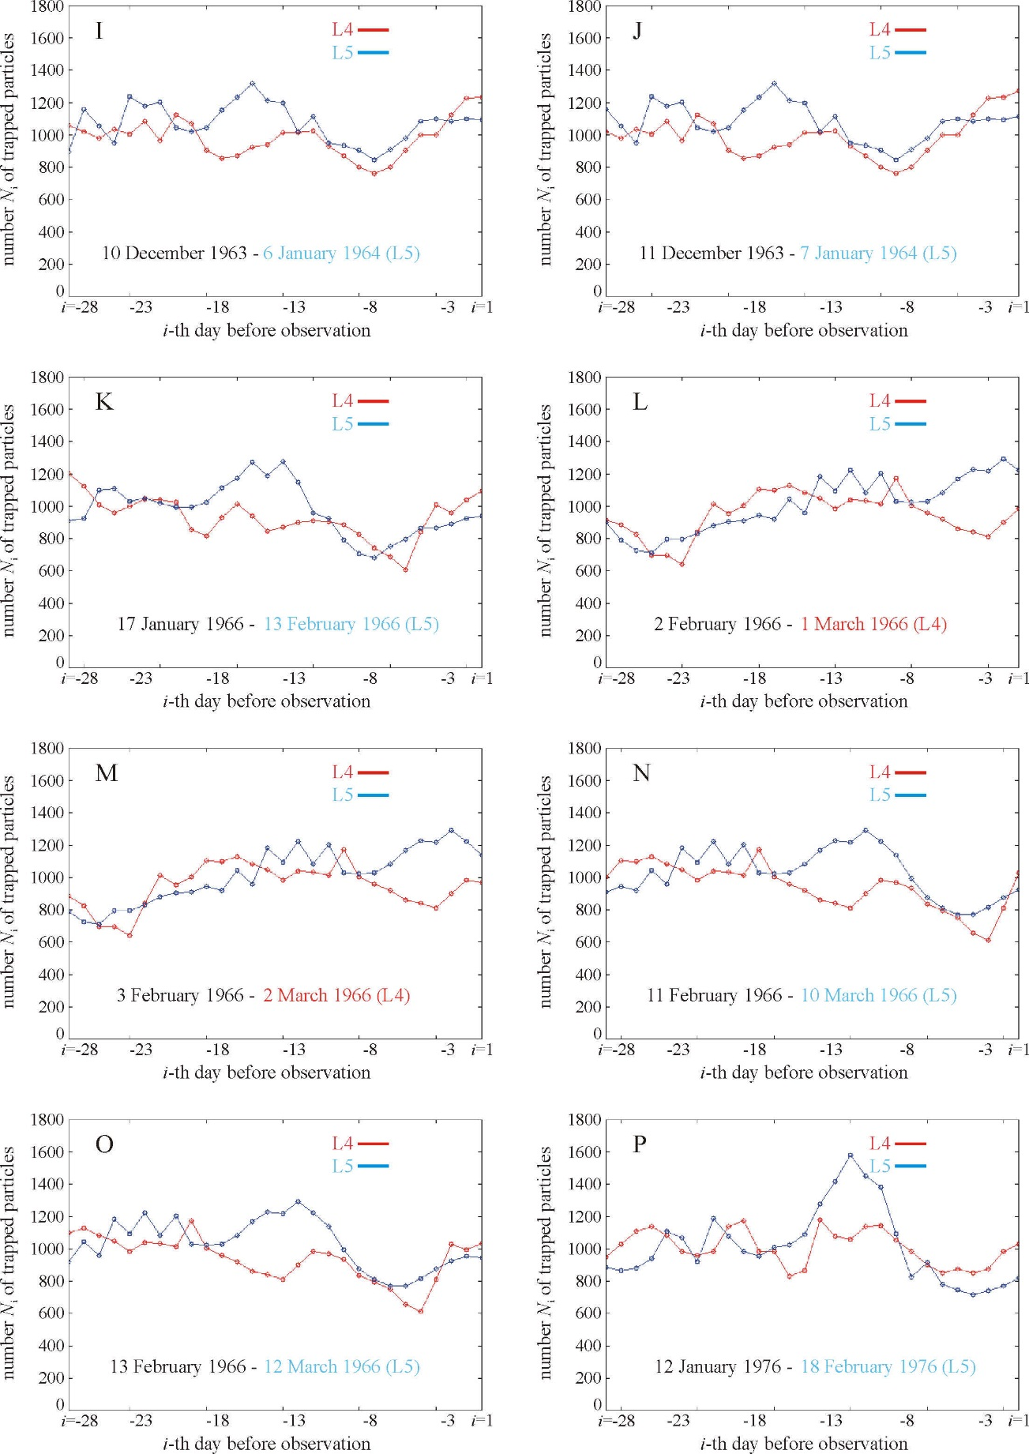

Supplementary Figure S1 (continued): Numbers N_{i,L4} (red) and N_{i,L5} (blue) of particles (i = 1, ..., 28) trapped by the Lagrange points L4 and L5 of the Earth-Moon system on the i-th day (= time along the horizontal axis) before the date τ₀ of observation of L4 (red) or L5 (blue) for the days of observation listed in Table 1, apart from 3 September 1961 (see Fig. 3). For the sake of better visualization of the temporal change of N_{i,L4} and N_{i,L5}, the neighbouring data points are connected with a line as the simplest interpolation. (I) 6 January 1964, (J) 7 January 1964, (K) 13 February 1966, (L) 1 March 1966, (M) 2 March 1966, (N) 10 March 1966, (O) 12 March 1966, (P) 18 February 1976.

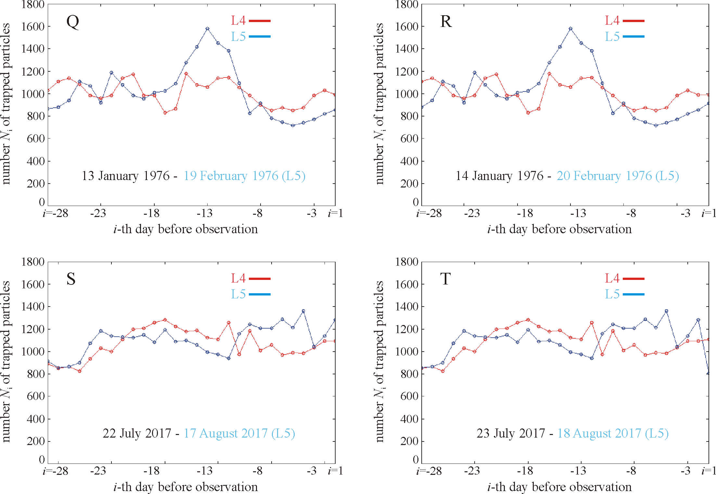

Supplementary Figure S1 (continued): Numbers N_{i,L4} (red) and N_{i,L5} (blue) of particles (i = 1, ..., 28) trapped by the Lagrange points L4 and L5 of the Earth-Moon system on the i-th day (= time along the horizontal axis) before the date τ₀ of observation of L4 (red) or L5 (blue) for the days of observation listed in Table 1, apart from 3 September 1961 (see Fig. 3). For the sake of better visualization of the temporal change of N_{i,L4} and N_{i,L5}, the neighbouring data points are connected with a line as the simplest interpolation. (Q) 19 February 1976, (R) 20 February 1976, (S) 17 August 2017, (T) 18 August 2017.

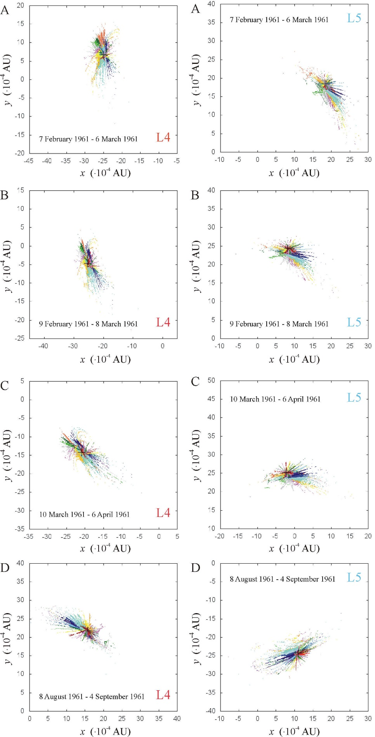

Supplementary Figure S2: The summed dust cloud around the Lagrange points L4 and L5 of the Earth-Moon system cumulated within the 27 days before and on the following dates τ₀ of observation: (A) 6 March 1961, (B) 8 March 1961, (C) 6 April 1961, (D) 4 September 1961 in a geocentric ecliptic coordinate system. The particles trapped on different days are depicted by differently coloured pixels. The black cross shows the position of L4 or L5. The three-dimensional interactive version of these summed dust clouds are available in the Supplementary Stereo Cubes C1-C42.
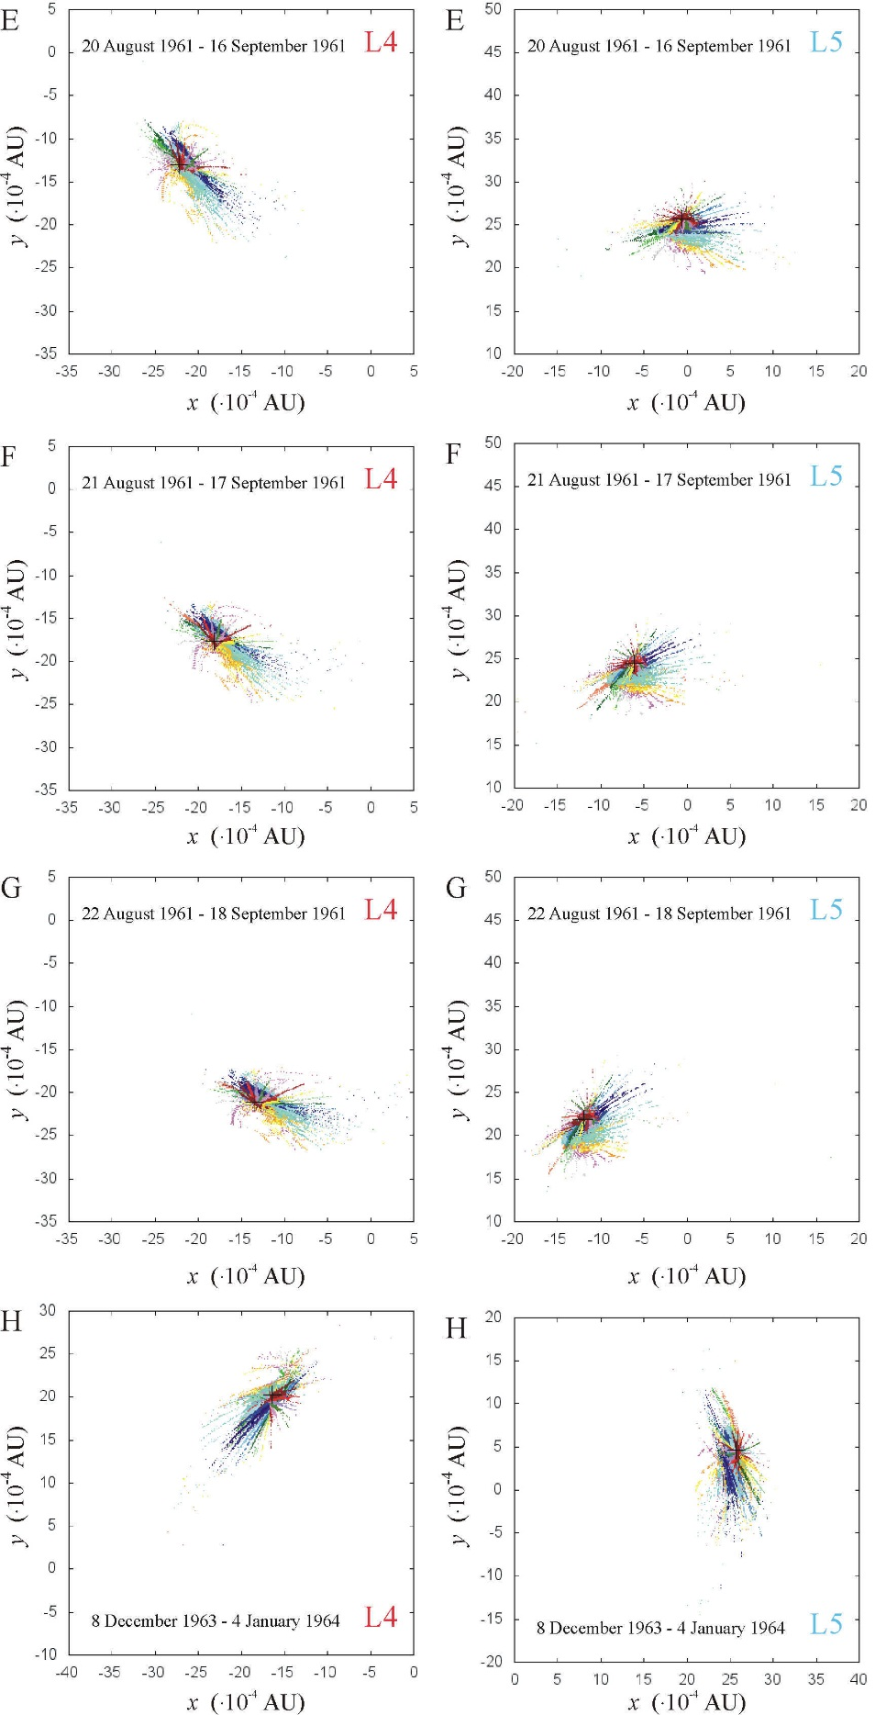

Supplementary Figure S2 (continued): The summed dust cloud around the Lagrange points L4 and L5 of the Earth-Moon system cumulated within the 27 days before and on the following dates τ₀ of observation: (E) 16 September 1961, (F) 17 September 1961, (G) 18 September 1961, (H) 4 January 1964 in a geocentric ecliptic coordinate system. The particles trapped on different days are depicted by differently coloured pixels. The black cross shows the position of L4 or L5. The three-dimensional interactive version of these summed dust clouds are available in the Supplementary Stereo Cubes C1-C42.
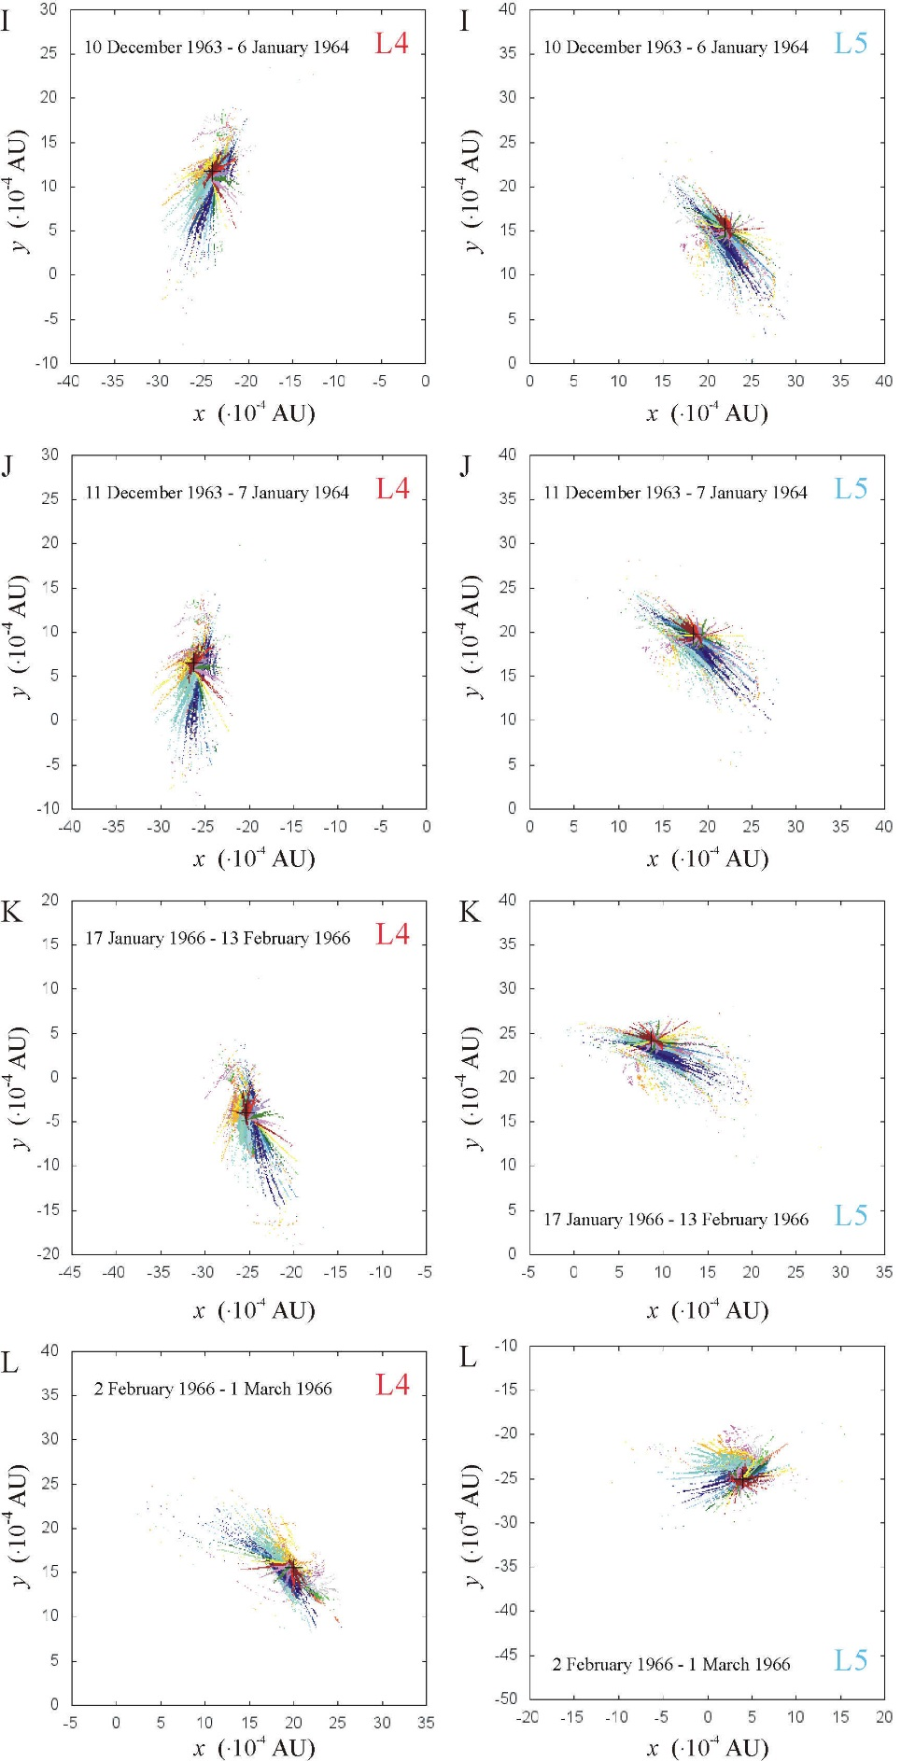

Supplementary Figure S2 (continued): The summed dust cloud around the Lagrange points L4 and L5 of the Earth-Moon system cumulated within the 27 days before and on the following dates τ₀ of observation: (I) 6 January 1964, (J) 7 January 1964, (K) 13 February 1966, (L) 1 March 1966 in a geocentric ecliptic coordinate system. The particles trapped on different days are depicted by differently coloured pixels. The black cross shows the position of L4 or L5. The three-dimensional interactive version of these summed dust clouds are available in the Supplementary Stereo Cubes C1-C42.
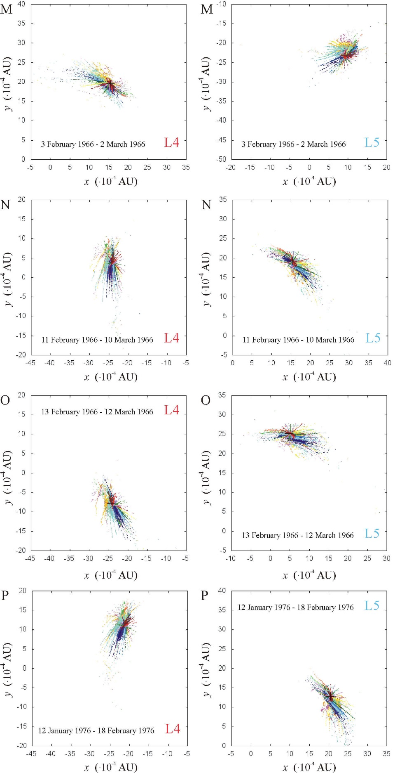

Supplementary Figure S2 (continued): The summed dust cloud around the Lagrange points L4 and L5 of the Earth-Moon system cumulated within the 27 days before and on the following dates τ₀ of observation: (M) 2 March 1966, (N) 10 March 1966, (O) 12 March 1966, (P) 18 February 1976 in a geocentric ecliptic coordinate system. The particles trapped on different days are depicted by differently coloured pixels. The black cross shows the position of L4 or L5. The three-dimensional interactive version of these summed dust clouds are available in the Supplementary Stereo Cubes C1-C42.
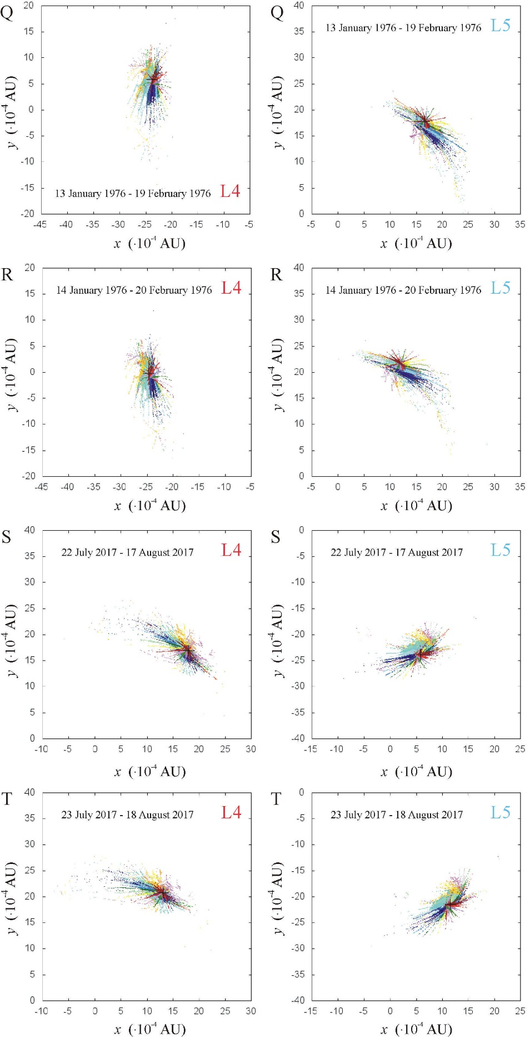

Supplementary Figure S2 (continued): The summed dust cloud around the Lagrange points L4 and L5 of the Earth-Moon system cumulated within the 27 days before and on the following dates τ₀ of observation: (Q) 19 February 1976, (R) 20 February 1976, (S) 17 August 2017, (T) 18 August 2017 in a geocentric ecliptic coordinate system. The particles trapped on different days are depicted by differently coloured pixels. The black cross shows the position of L4 or L5. The three-dimensional interactive version of these summed dust clouds are available in the Supplementary Stereo Cubes C1-C42.
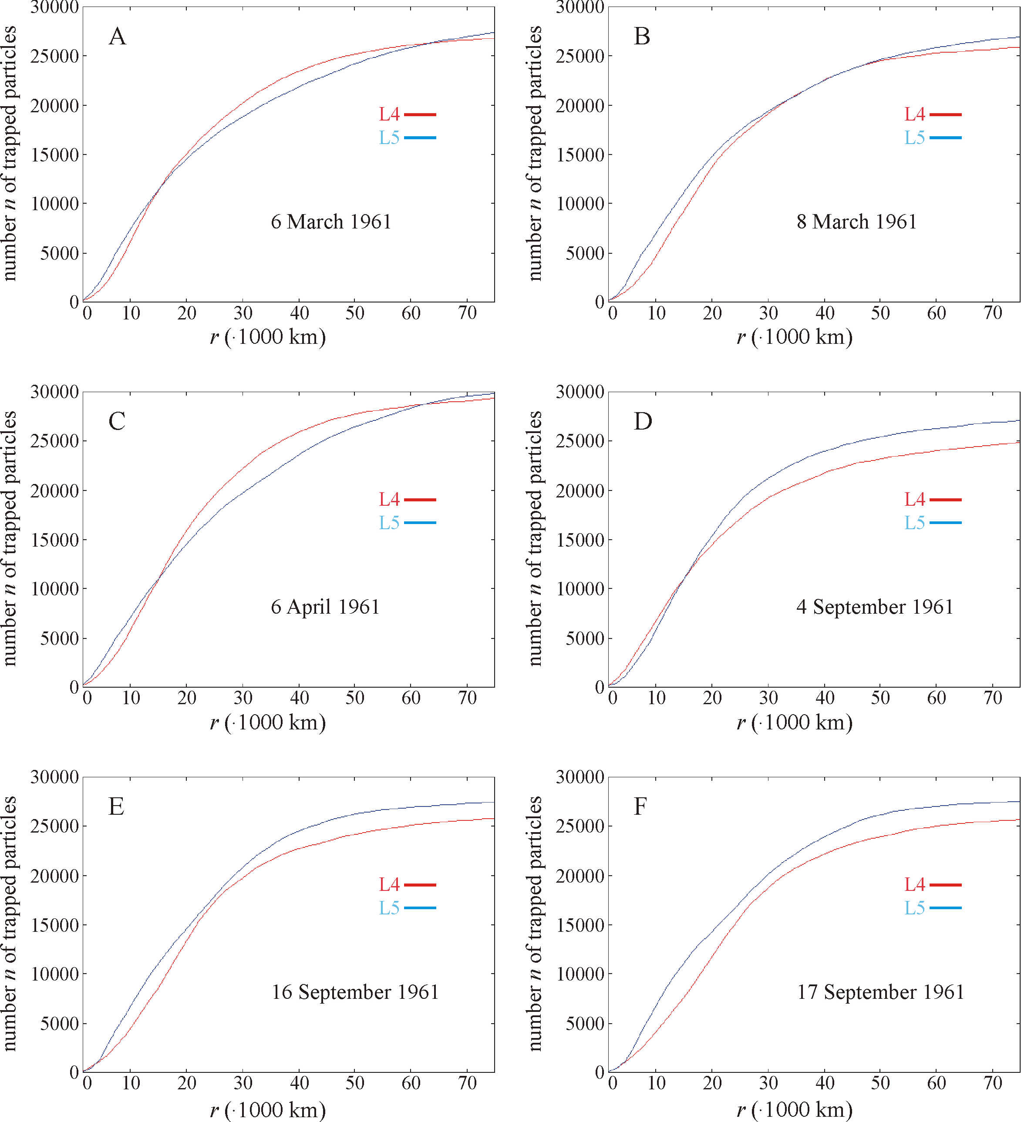

Supplementary Figure S3: Numbers n_{L4} (red) and n_{L5} (blue) of particles of the summed dust clouds around L4 and L5 as a function of the radius r of a sphere centred at L4 and L5 observed on 6 March 1961 (A), 8 March 1961 (B), 6 April 1961 (C), 4 September 1961 (D), 16 September 1961 (E), 17 September 1961 (F).

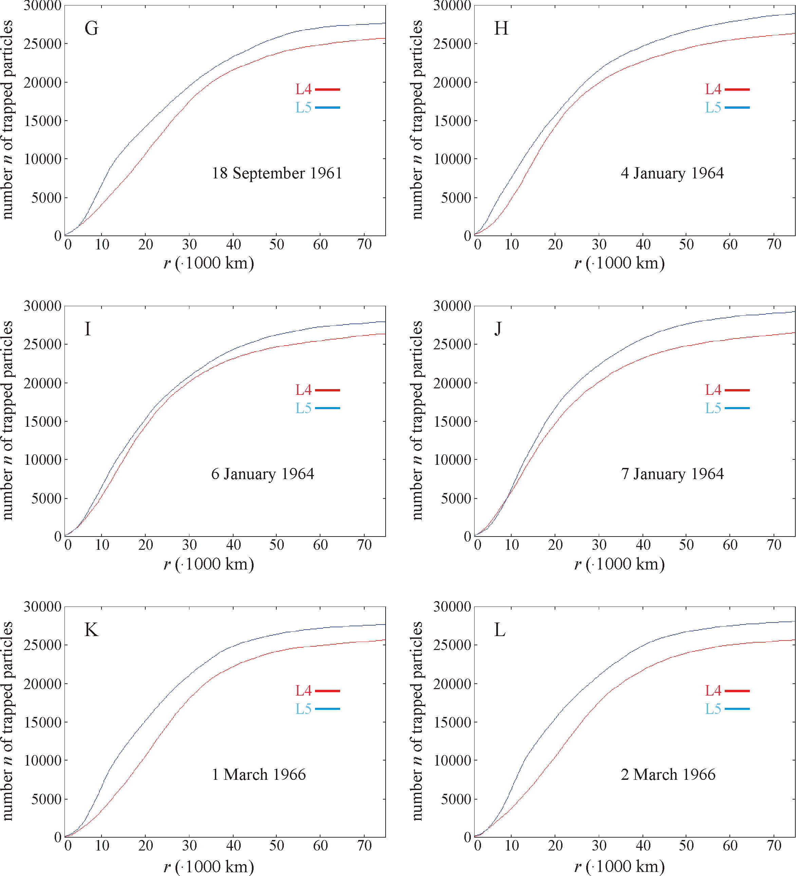

Supplementary Figure S3 (continued): Numbers n_{L4} (red) and n_{L5} (blue) of particles of the summed dust clouds around L4 and L5 as a function of the radius r of a sphere centred at L4 and L5 observed on 18 September 1961 (G), 4 January 1964 (H), 6 January 1964 (I), 7 January 1964 (J), 1 March 1966 (K), 2 March 1966 (L).

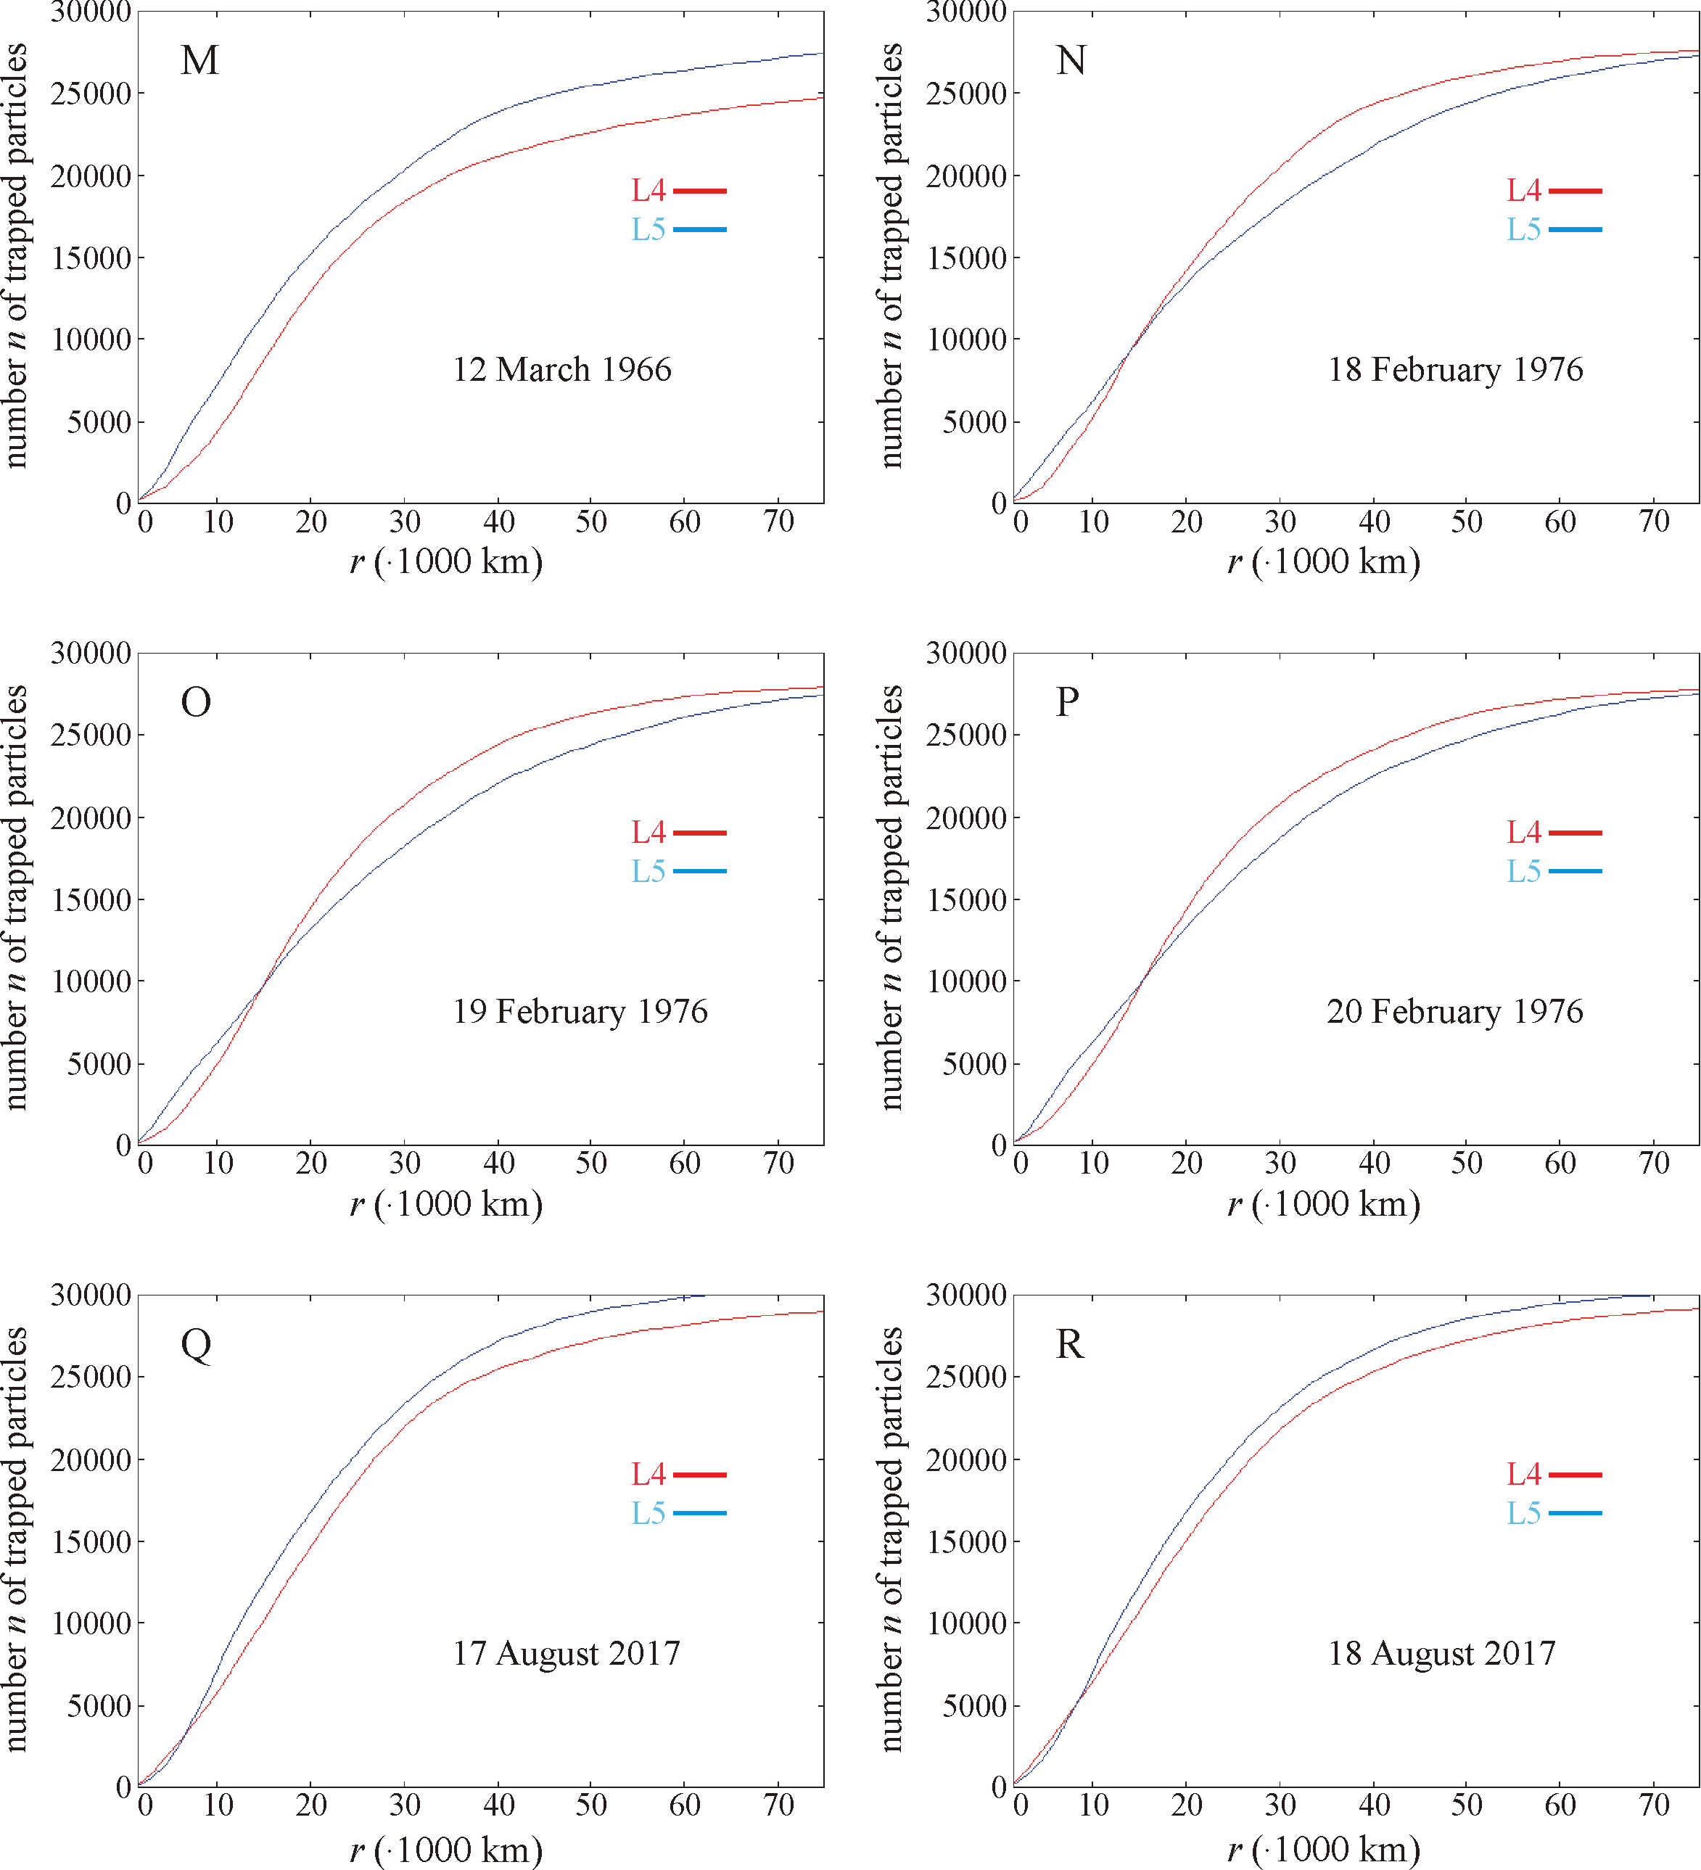

Supplementary Figure S3 (continued): Numbers n_{L4} (red) and n_{L5} (blue) of particles of the summed dust clouds around L4 and L5 as a function of the radius r of a sphere centred at L4 and L5 observed on 12 March 1966 (M), 18 February 1976 (N), 19 February 1976 (O), 20 February 1976 (P), 17 August 2017 (Q), 18 August 2017 (R).

Supplementary Stereo Cube C1: The summed dust cloud around the Lagrange point L4 (black dot) of the Earth-Moon system cumulated within 27 days before and on 6 March 1961 in a geocentric ecliptic coordinate system. The particles trapped on different days are depicted by differently coloured pixels as in Fig. 4.

Supplementary Stereo Cube C2: The summed dust cloud around the Lagrange point L5 (black dot) of the Earth-Moon system cumulated within the 27 days before and on 6 March 1961 in a geocentric ecliptic coordinate system. The particles trapped on different days are depicted by differently coloured pixels as in Fig. 4.

Supplementary Stereo Cube C3: The summed dust cloud around the Lagrange point L4 (black dot) of the Earth-Moon system cumulated within the 27 days before and on 8 March 1961 in a geocentric ecliptic coordinate system. The particles trapped on different days are depicted by differently coloured pixels as in Fig. 4.

Supplementary Stereo Cube C4: The summed dust cloud around the Lagrange point L5 (black dot) of the Earth-Moon system cumulated within the 27 days before and on 8 March 1961 in a geocentric ecliptic coordinate system. The particles trapped on different days are depicted by differently coloured pixels as in Fig. 4.

Supplementary Stereo Cube C5: The summed dust cloud around the Lagrange point L4 (black dot) (black dot) of the Earth-Moon system cumulated within the 27 days before and on 6 April 1961 in a geocentric ecliptic coordinate system. The particles trapped on different days are depicted by differently coloured pixels as in Fig. 4.

Supplementary Stereo Cube C6: The summed dust cloud around the Lagrange point L5 (black dot) of the Earth-Moon system cumulated within the 27 days before and on 6 April 1961 in a geocentric ecliptic coordinate system. The particles trapped on different days are depicted by differently coloured pixels as in Fig. 4.

Supplementary Stereo Cube C7: The summed dust cloud around the Lagrange point L4 (black dot) of the Earth-Moon system cumulated within the 27 days before and on 3September 1961 in a geocentric ecliptic coordinate system. The particles trapped on different days are depicted by differently coloured pixels. The colour coding is the same as in Fig. 4.

Supplementary Stereo Cube C8: The summed dust cloud around the Lagrange point L5 (black dot) of the Earth-Moon system cumulated within the 27 days before and on 3 September 1961 in a geocentric ecliptic coordinate system. The particles trapped on different days are depicted by differently coloured pixels. The colour coding is the same as in Fig. 4.

Supplementary Stereo Cube C9: The summed dust cloud around the Lagrange point L4 (black dot) of the Earth-Moon system cumulated within the 27 days before and on 4 September 1961 in a geocentric ecliptic coordinate system. The particles trapped on different days are depicted by differently coloured pixels as in Fig. 4.

Supplementary Stereo Cube C10: The summed dust cloud around the Lagrange point L5 (black dot) of the Earth-Moon system cumulated within the 27 days before and on 4 September 1961 in a geocentric ecliptic coordinate system. The particles trapped on different days are depicted by differently coloured pixels as in Fig. 4.

Supplementary Stereo Cube C11: The summed dust cloud around the Lagrange point L4 (black dot) of the Earth-Moon system cumulated within the 27 days before and on 16 September 1961 in a geocentric ecliptic coordinate system. The particles trapped on different days are depicted by differently coloured pixels as in Fig. 4.

Supplementary Stereo Cube C12: The summed dust cloud around the Lagrange point L5 (black dot) of the Earth-Moon system cumulated within the 27 days before and on 16 September 1961 in a geocentric ecliptic coordinate system. The particles trapped on different days are depicted by differently coloured pixels as in Fig. 4.

Supplementary Stereo Cube C13: The summed dust cloud around the Lagrange point L4 (black dot) of the Earth-Moon system cumulated within the 27 days before and on 17 September 1961 in a geocentric ecliptic coordinate system. The particles trapped on different days are depicted by differently coloured pixels as in Fig. 4.

Supplementary Stereo Cube C14: The summed dust cloud around the Lagrange point L5 (black dot) of the Earth-Moon system cumulated within the 27 days before and on 17 September 1961 in a geocentric ecliptic coordinate system. The particles trapped on different days are depicted by differently coloured pixels as in Fig. 4.

Supplementary Stereo Cube C15: The summed dust cloud around the Lagrange point L4 (black dot) of the Earth-Moon system cumulated within the 27 days before and on 18 September 1961 in a geocentric ecliptic coordinate system. The particles trapped on different days are depicted by differently coloured pixels as in Fig. 4.

Supplementary Stereo Cube C16: The summed dust cloud around the Lagrange point L5 (black dot) of the Earth-Moon system cumulated within the 27 days before and on 18 September 1961 in a geocentric ecliptic coordinate system. The particles trapped on different days are depicted by differently coloured pixels as in Fig. 4.

Supplementary Stereo Cube C17: The summed dust cloud around the Lagrange point L4 (black dot) of the Earth-Moon system cumulated within the 27 days before and on 4January 1964 in a geocentric ecliptic coordinate system. The particles trapped on different days are depicted by differently coloured pixels as in Fig. 4.

Supplementary Stereo Cube C18: The summed dust cloud around the Lagrange point L5 (black dot) of the Earth-Moon system cumulated within the 27 days before and on 4 January 1964 in a geocentric ecliptic coordinate system. The particles trapped on different days are depicted by differently coloured pixels as in Fig. 4.

Supplementary Stereo Cube C19: The summed dust cloud around the Lagrange point L4 (black dot) of the Earth-Moon system cumulated within the 27 days before and on 6 January 1964 in a geocentric ecliptic coordinate system. The particles trapped on different days are depicted by differently coloured pixels as in Fig. 4.

Supplementary Stereo Cube C20: The summed dust cloud around the Lagrange point L5 (black dot) of the Earth-Moon system cumulated within the 27 days before and on 6 January 1964 in a geocentric ecliptic coordinate system. The particles trapped on different days are depicted by differently coloured pixels as in Fig. 4.

Supplementary Stereo Cube C21: The summed dust cloud around the Lagrange point L4 (black dot) of the Earth-Moon system cumulated within the 27 days before and on 7 January 1964 in a geocentric ecliptic coordinate system. The particles trapped on different days are depicted by differently coloured pixels as in Fig. 4.

Supplementary Stereo Cube C22: The summed dust cloud around the Lagrange point L5 (black dot) of the Earth-Moon system cumulated within the 27 days before and on 7 January 1964 in a geocentric ecliptic coordinate system. The particles trapped on different days are depicted by differently coloured pixels as in Fig. 4.

Supplementary Stereo Cube C23: The summed dust cloud around the Lagrange point L4 (black dot) of the Earth-Moon system cumulated within the 27 days before and on 13February 1966 in a geocentric ecliptic coordinate system. The particles trapped on different days are depicted by differently coloured pixels as in Fig. 4.

Supplementary Stereo Cube C24: The summed dust cloud around the Lagrange point L5 (black dot) of the Earth-Moon system cumulated within the 27 days before and on 13 February 1966 in a geocentric ecliptic coordinate system. The particles trapped on different days are depicted by differently coloured pixels as in Fig. 4.

Supplementary Stereo Cube C25: The summed dust cloud around the Lagrange point L4 (black dot) of the Earth-Moon system cumulated within the 27 days before and on 1 March 1966 in a geocentric ecliptic coordinate system. The particles trapped on different days are depicted by differently coloured pixels as in Fig. 4.

Supplementary Stereo Cube C26: The summed dust cloud around the Lagrange point L5 (black dot) of the Earth-Moon system cumulated within the 27 days before and on 1 March 1966 in a geocentric ecliptic coordinate system. The particles trapped on different days are depicted by differently coloured pixels as in Fig. 4.

Supplementary Stereo Cube C27: The summed dust cloud around the Lagrange point L4 (black dot) of the Earth-Moon system cumulated within the 27 days before and on 2 March 1966 in a geocentric ecliptic coordinate system. The particles trapped on different days are depicted by differently coloured pixels as in Fig. 4.

Supplementary Stereo Cube C28: The summed dust cloud around the Lagrange point L5 (black dot) of the Earth-Moon system cumulated within the 27 days before and on 2 March 1966 in a geocentric ecliptic coordinate system. The particles trapped on different days are depicted by differently coloured pixels as in Fig. 4.

Supplementary Stereo Cube C29: The summed dust cloud around the Lagrange point L4 (black dot) of the Earth-Moon system cumulated within the 27 days before and on 10 March 1966 in a geocentric ecliptic coordinate system. The particles trapped on different days are depicted by differently coloured pixels as in Fig. 4.

Supplementary Stereo Cube C30: The summed dust cloud around the Lagrange point L5 (black dot) of the Earth-Moon system cumulated within the 27 days before and on 10 March 1966 in a geocentric ecliptic coordinate system. The particles trapped on different days are depicted by differently coloured pixels as in Fig. 4.

Supplementary Stereo Cube C31: The summed dust cloud around the Lagrange point L4 (black dot) of the Earth-Moon system cumulated within the 27 days before and on 12 March 1966 in a geocentric ecliptic coordinate system. The particles trapped on different days are depicted by differently coloured pixels as in Fig. 4.

Supplementary Stereo Cube C32: The summed dust cloud around the Lagrange point L5 (black dot) of the Earth-Moon system cumulated within the 27 days before and on 12 March 1966 in a geocentric ecliptic coordinate system. The particles trapped on different days are depicted by differently coloured pixels as in Fig. 4.

Supplementary Stereo Cube C33: The summed dust cloud around the Lagrange point L4 (black dot) of the Earth-Moon system cumulated within the 27 days before and on 18February 1976 in a geocentric ecliptic coordinate system. The particles trapped on different days are depicted by differently coloured pixels as in Fig. 4.

Supplementary Stereo Cube C34: The summed dust cloud around the Lagrange point L5 (black dot) of the Earth-Moon system cumulated within the 27 days before and on 18 February 1976 in a geocentric ecliptic coordinate system. The particles trapped on different days are depicted by differently coloured pixels as in Fig. 4.

Supplementary Stereo Cube C35: The summed dust cloud around the Lagrange point L4 (black dot) of the Earth-Moon system cumulated within the 27 days before and on 19 February 1976 in a geocentric ecliptic coordinate system. The particles trapped on different days are depicted by differently coloured pixels as in Fig. 4.

Supplementary Stereo Cube C36: The summed dust cloud around the Lagrange point L5 (black dot) of the Earth-Moon system cumulated within the 27 days before and on 19 February 1976 in a geocentric ecliptic coordinate system. The particles trapped on different days are depicted by differently coloured pixels as in Fig. 4.

Supplementary Stereo Cube C37: The summed dust cloud around the Lagrange point L4 (black dot) of the Earth-Moon system cumulated within the 27 days before and on 20 February 1976 in a geocentric ecliptic coordinate system. The particles trapped on different days are depicted by differently coloured pixels as in Fig. 4.

Supplementary Stereo Cube C38: The summed dust cloud around the Lagrange point L5 (black dot) of the Earth-Moon system cumulated within the 27 days before and on 20 February 1976 in a geocentric ecliptic coordinate system. The particles trapped on different days are depicted by differently coloured pixels as in Fig. 4.

Supplementary Stereo Cube C39: The summed dust cloud around the Lagrange point L4 (black dot) of the Earth-Moon system cumulated within the 27 days before and on 17August2017 in a geocentric ecliptic coordinate system. The particles trapped on different days are depicted by differently coloured pixels as in Fig. 4.

Supplementary Stereo Cube C40: The summed dust cloud around the Lagrange point L5 (black dot) of the Earth-Moon system cumulated within the 27 days before and on 17 August 2017 in a geocentric ecliptic coordinate system. The particles trapped on different days are depicted by differently coloured pixels as in Fig. 4.

Supplementary Stereo Cube C41: The summed dust cloud around the Lagrange point L4 (black dot) of the Earth-Moon system cumulated within the 27 days before and on 18 August 2017 in a geocentric ecliptic coordinate system. The particles trapped on different days are depicted by differently coloured pixels as in Fig. 4.

Supplementary Stereo Cube C42: The summed dust cloud around the Lagrange point L5 (black dot) of the Earth-Moon system cumulated within the 27 days before and on 18 August 2017 in a geocentric ecliptic coordinate system. The particles trapped on different days are depicted by differently coloured pixels as in Fig. 4.

